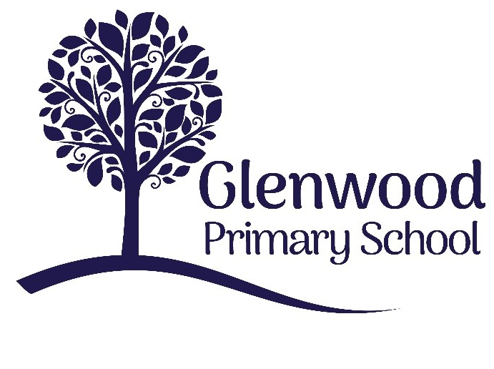

Glenwood Primary School
Social Media Policy

‘Together we aim to develop confident, compassionate, and resilient learners who are equipped to thrive in an everchanging world’.

Policy update: | June 2025
Policy to be reviewed by: | June 2028
Signed by Principal: |  | Date:
Signed by Chair of Governors: |  | Date:

Ethos Statement:

Glenwood Primary School is a nurturing & enriching environment where we foster a culture of kindness, empathy & mutual respect. Together we build a safe & caring school where everyone belongs and thrives.

School Vision:

At Glenwood Primary School we are dedicated to fostering an empathetic & inclusive atmosphere where every student is valued, inspired, & challenged to achieve their fullest potential.
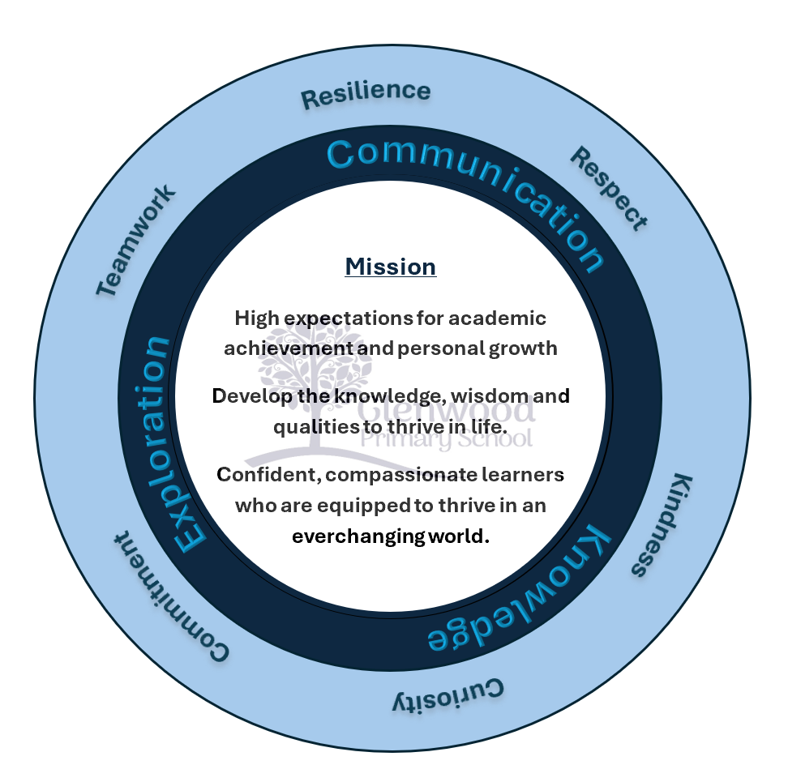

We help live our ethos and vision through the Glenwood Way
Move Calmly - Speak Nicely - Listen Carefully - Act Kindly - Do Your Best
Glenwood WISDOM qualities
TEAMWORK
RESILIENCE
RESPECT
KINDNESS
CURIOSITY
COMMITMENT
Purpose
This policy reflects the school’s values in relation to the use of social media. At Glenwood PS, we believe we could utilise effectively the social media platforms to promote our school more widely and share the learning experiences and achievements of our pupils. We already communicate regularly with our parents through our school website, Class Dojo and school app. Social media will be a means to communicate further with our school community, as well as promoting our school to a wider audience, such as parents who may be considering enrolling their children at the school.

Aims
- Share our children’s successes to the wider community
- Communicate with the school community
- Promote the school more widely
- Model to our pupils how social media can be used appropriately

Roles and Responsibility

Board of Governors
- Take appropriate action to ensure the safety and security of everyone within our school community
- Ensure that the reputation of Glenwood PS is upheld
- Investigate any breaches of the Code of Conduct

Senior Leadership Team
- Implementing the social media policy
- Take on responsibility for overall management of the school’s social media account
- Monitor the social media account(s)
- Store account details securely and privately

Staff
- Contribute to the school’s social media page via the Senior Leadership Team
- Ensure any photos/information passed on for publication has approved permission from parent/carer

Code of Conduct
- When using social media, everyone has a responsibility to treat others within the school community with respect. Individuals must not make any derogatory, defamatory, rude, threatening or inappropriate comments about anyone connected to the school. Offensive language must not be used.
- Permission will be sought from all parents to use their child’s image on social media. If a parent doesn’t grant permission, their child’s photograph won’t be used. Children will not be identified on social media.
- There must not be any postings on social media which might damage the reputation of the school or link the school to any type of inappropriate conduct.
- Confidential information relating to anyone within the school community must not be posted online.
- Photographs or video clips of children taking part in activities in school will only be posted on social media platforms by the teacher responsible for managing social media. The ICT Coordinator will be responsible for updating the website, Class Dojo and app.
- Parents must not identify children by naming them if commenting on specific school posts. The school reserves the right to restrict anyone’s access to its social media outlets if these safety measures are disregarded.
- Parents are responsible for their children’s use of media outside of school. They should be aware of the age restrictions posed by each platform. Snapchat, Instagram, Facebook and Whatsapp all have a minimum user age above that of any child in primary school.
- Staff or volunteers working in the school must not use social media to communicate directly with any pupil in the school.
- The school’s social media account is not an appropriate platform to engage in conversation with others. Comments will not be replied to and if parents/carers/the community have any queries/questions, they should contact the school directly.
- Individual pupils will not be named on any posts. Any means of identifying a single pupil from a post should be removed.

