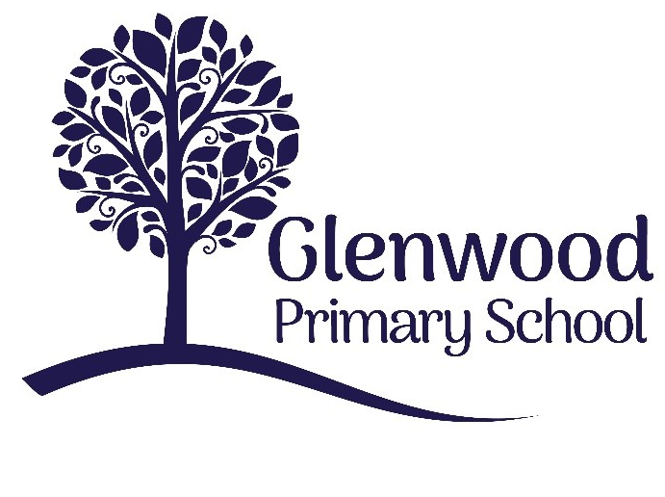

Glenwood Primary School
Transition Policy for
Children with Special Educational Needs

‘Together we aim to develop confident, compassionate, and resilient learners who are equipped to thrive in an everchanging world’.

Policy update: | May 2025
Policy to be reviewed by: | May 2028
Signed by Principal: |  | Date:
Signed by Chair of Governors: |  | Date:

Ethos Statement:

Glenwood Primary School is a nurturing & enriching environment where we foster a culture of kindness, empathy & mutual respect. Together we build a safe & caring school where everyone belongs and thrives.

School Vision:

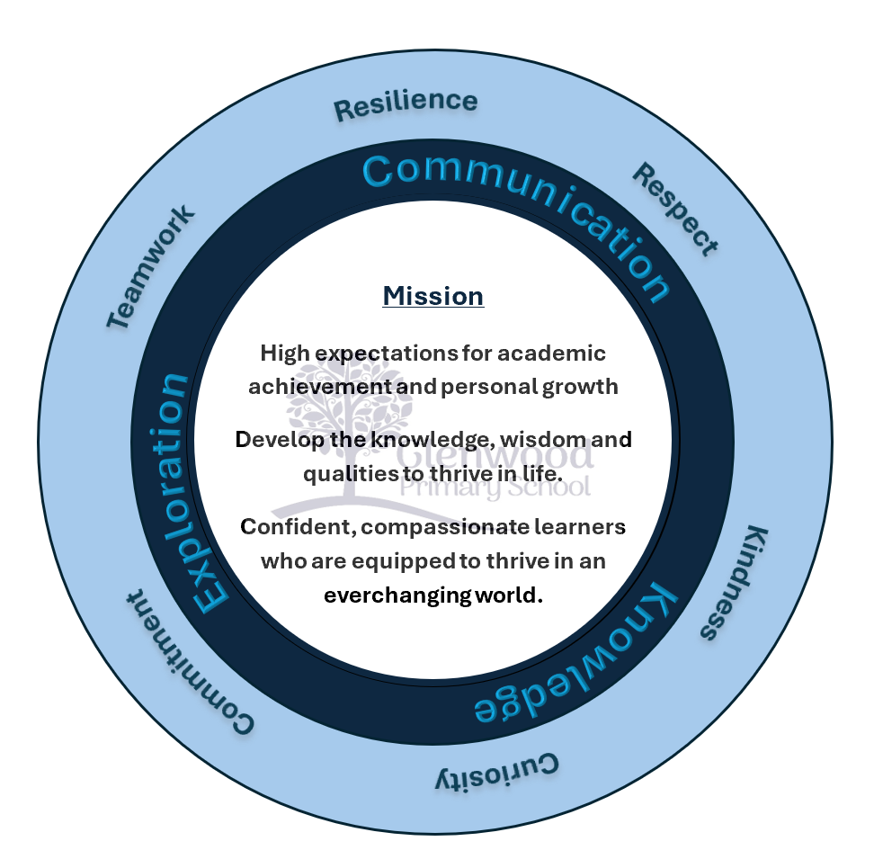
At Glenwood Primary School we are dedicated to fostering an empathetic & inclusive atmosphere where every student is valued, inspired, & challenged to achieve their fullest potential.

We help live our ethos and vision through the Glenwood Way
Move Calmly - Speak Nicely - Listen Carefully - Act Kindly - Do Your Best
Glenwood WISDOM qualities
TEAMWORK
RESILIENCE
RESPECT
KINDNESS
CURIOSITY
COMMITMENT

At Glenwood we are committed to providing an appropriate and high-quality education to all the children attending our school. We believe that all children, including those identified as having Special Educational Needs, have a common entitlement to a broad and balanced academic and social curriculum, which is accessible to them, and to be fully included in all aspects of school life. We seek to encourage all children to reach their fullest potential through a broad and balanced curriculum.

We are committed to inclusion; to develop cultures, policies and practices that include all learners. We aim to engender a sense of community and belonging, and to offer opportunities that promote spiritual, intellectual, social, emotional, physical, cultural, and aesthetic development for all children. We pride ourselves on our positive relationships within school, with external supports and with the wider Shankill community.

Rationale

At Glenwood Primary School, we recognise that transition is a process, not an event. This policy has been devised to ensure that all pupils transfer seamlessly through each phase of their education. Although transitions are a regular process rather than a single event in school life and can be exciting for some pupils with special educational needs (SEN); others will find the experience of moving between the various phases more challenging and will require extra support to enable them to make progress within their education. Therefore, this transition policy will outline the roles and responsibilities involved in ensuring a whole school approach which is designed to support pupils with SEN in adapting to their new learning environment, so that they can show progress in all aspects of their learning.

Definition
For the purpose of this policy, transition will be defined as the “means by which children experience a smooth passage from one setting or stage to another” (Department of Education, 2015).

Policy Aims

This transition policy aims to outline the high-quality teaching, learning and assessment strategies identified through whole school planning and advice received from external agencies where appropriate, to support the unique challenges that may be faced when trying to meet the individual needs of pupils with SEN at the following phases:

      - Home and/ or pre-school to primary one;
      - year group to year group;
      - primary to post primary; and
      - newly-enrolled pupils with SEN throughout the school year.
Each of these transitions is a unique phase which has its own challenges and expectations. A successful experience of transition at each of these distinct stages will help children with SEN to settle well into the routines and organisation of school life at Glenwood PS. The pace and quality of the teaching delivered will ensure that children continue to build upon their prior knowledge and experience so that they can make progress in all aspects of learning and reach their potential.

We encourage all parents to be partners in their child’s education and assist them in helping their child prepare for school and for the transitions they will encounter as they move through the school. We aim to support all children towards independence and develop their confidence and ability to cope with change while giving them a clear understanding of the new expectations ahead of them. We ensure that any relevant information from outside agencies is acknowledged and acted upon, particularly in regard to children with Special Educational Needs or English as an Additional Language.

Equal Opportunities and Inclusion

At Glenwood Primary School, the views of the pupil with SEN, their parents and staff regarding their thoughts and concerns are actively sought, acknowledged, and valued.

We believe a well-planned and co-designed transition process will help to outline what is expected of pupils ahead of transition to the next chapter in their learning. By involving pupils and taking into account their individual needs from their perspective, as well as information obtained from parents, school staff and other agencies we provide opportunities to support independence and develop confidence in the pupil’s ability to manage change within a supportive environment.

Staff at Glenwood Primary School are committed to working in partnership with parents, to support them in preparing their child with SEN for transitions thus facilitating better home-school communication links so that the parents can feel confident about expressing their views and concerns.

Since transition is a process that may pose additional challenges and barriers for pupils with SEN, teachers at Glenwood Primary School use their professional judgement, skills, and expertise in assessing, planning for, and using a range of strategies and activities in the best interests of the child. Relevant information, including medical and/ or external reports, is shared with staff, in a sensitive manner and in the strictest of confidence. Transfer of information will be in line with the school’s Data Protection Policy.

Additional adult assistants are also included in the development of the transition processes and policy as they play a valuable role in supporting the individual needs of pupils with SEN.

Transition Activities

Staff at Glenwood Primary School in conjunction with pupils, parents & other professionals where appropriate, have identified the following activities as the best practice that they can offer to support the transition for pupils with SEN at each of the key phases of transition which are outlined below:

Pre-school to Primary One
Lead responsibility – Ms. Hawthorne & Mrs Leith

This phase of transition is important in creating a positive experience for children with SEN who are starting their primary education at our school. We encourage Parents to talk to their child about their feelings regarding school in a constructive manner and advise them to ensure that their child is well rested each night, setting good routines for getting ready for school in the morning and making sure that they have everything they need for school so that they leave home calm and relaxed each morning.

The following activities put the child with SEN at the centre of assessing and planning to meet their individual needs:

- Primary One teachers and SENco (where appropriate) visit pre-school settings to meet children and discuss individual pupils.
- Pre-school pupils visit Primary setting for P1 Induction afternoons in June & again in August to help the children become familiar with the staff, classroom & playground.
- Parents attend Primary One induction talk in June which is be facilitated by the Principal, Vice Principal, SENCo & P1 teachers.
- The Pre-School Transition Record which is used to record strengths and concerns about individual pupils is forwarded with consent from parents to the Primary school in June.
- “Induction” booklet distributed at P1 parent’s talk to be completed and brought back to school before the end of June- Parents have opportunities to share additional information, new needs etc.
- Ms. Hawthorn, along with P1 Teachers, review the Transition Record and follow up on any concerns regarding SEN. This is shared with the SENco.
- Individual children may also visit the school in August with their parents.
- With consent and in line with our Data Protection policy, services who are already involved with pupils who are enrolled for September may be contacted for information on level of needs if additional information is required.
- Environmental and Risk Assessments are completed which are pertinent to individual pupil needs. Support may be sought from Mitchell House Assessment Centre for more extreme needs. (links with Accessibility Policy & Plan)
- Consideration of staff capacity building and training needs to support SEN pupils.
- There is a phased approach to settling pupils in September- P1 pupils have a staggered intake with a reduced day until the end of September.
- Parent-teacher meetings are held during the first school-term, so that parents can meet the new teacher and discuss the targets for their child’s Personal Learning Plan as well as an outline of work which will be covered during the school year.
- Playground Buddy system between P7 children and P1 children starts in October alongside full days.

Year group to year group
Lead responsibility – Mrs Leith, Ms. Hawthorne, Mrs Parks & Mrs Ritchie

Transitioning to the next class group in September can be a time of anxiety and worry for many pupils with SEN as they need to get used to new routines, change in staff and the increasing level of difficulty in the work provided as well as expectations about how work should be completed or behaviours accepted within the classroom setting.

The following activities aim to build upon the knowledge of the pupil and consolidate their attainments to ensure that they enjoy continued success in their learning:

- A ‘transition’ meeting is held during the summer term between the pupil’s current teacher and the teacher for the following year to discuss support strategies, provision, and individual pupil needs.
- The child’s current class teacher shares “what works” with a child with their next class teacher.
- The current class teacher alerts the next class teacher about potential areas/situations that are concerning for individual pupils e.g. peer relations, classroom layout, seating arrangements, issues with completing tasks, following instructions, lining up etc – Pupil Profile Appendix 1.
- The SEN File is discussed before hand over –includes Personal Learning Plans, medical notes, outside agency plans & reports, Educational Psychology information etc.
- Tracking and assessment data about the pupil’s needs and progress are also shared which helps to inform the next teacher when planning for and setting targets for the following year.
- Pupils visit their new class for short sessions in June and complete ‘About me’ activities to share their views, interests, and strengths with the new teacher.
- Parents are informed about the changes to the daily routine and are encouraged to speak to the new teacher to highlight any concerns that they may have. In August Seesaw & Dojo are set up to facilitate communication.
- Assemblies, buddy systems, Sports Coaching and extra-curricular activities are provided throughout the year so that pupils throughout the school have the opportunity to be included in activities to help familiarise them with other staff and pupils.
- A booklet is provided, as needed, for parents to use over the summer holidays. This includes photographs to familiarise the child with the new class teacher, classroom, cloakroom, toilets, etc. It will focus on what will stay the same and what will be different in September – Appendix 2.
- ‘New’ Pupils with SEN will be invited to visit the school individually in August with their parents to meet the new teacher and to become familiar with new classroom environment. This is supplemented with transition sessions to allow them to meet their new class in a controlled and
- Individual transition plans may be drawn up for children identified as being needing extra support, as determined by class teacher & SENco. In the case of LAC Pupils and Pupils with statements an invitation may be given to visit during the school baker days.

Newly enrolled SEN pupils throughout the school year
Lead responsibility – Mrs Leith, Ms. Hawthorne, Mrs Parks & Mrs Ritchie

Glenwood Primary School offers a warm welcome to pupils with SEN and their parents who choose to join our school throughout the year.

The following activities aim to provide a supportive environment so that the pupil feels included and happy about coming to school and parents will feel confident in the knowledge that their child will be encouraged to reach their potential:

- An initial meeting is held between the principal/ SENCo and parents/ carers.
- Individual tours of the school are offered to incoming parents and children.
- Parents are provided with a copy of the school prospectus.
- Children are given the option of a phased start- e.g. stay until break time, then lunch time
- Children are given time to settle into settle into their new routines. They will be observed and assessed as necessary by the class teacher or SENCo.
- SIMS data passed on from previous school (CTF file)
- A small group of ‘buddies’ are identified to help the new child to integrate.
- Parental permission to access pupil records from previous school and follow-up with any services currently involved with the child is sought.
- Consent may also be sought to make an onward referral for advice and support. Parents will be made aware of the purpose and expected outcome of each request.

Primary to Post Primary
Lead responsibility – Mrs Ritchie & Mrs Leith

At Glenwood Primary School, we recognise that some of our pupils with SEN will face additional challenges during the transition phase from primary to post primary. We have established close links with the range of post primary schools that our pupils transfer to once they finish their primary education at our school.

The following activities aim to guide the pupils with SEN through the process as effectively and efficiently as possible so that any concerns can be addressed in a timely manner:

  - Parents are encouraged to attend open evenings at post primary schools with their child which will be held at various times throughout the year.
  - Applications for post primary placements for most pupils including those with SEN (Stages 1 & 2 of the Code of Practice) are submitted by February of the P7 year.
  - For pupils who are subject to a statement of SEN (Stage 3), and Provision needs to be amended i.e. Mainstream to Specialist Setting/ Special School & vice versa Educational Psychology involvement is requested to seek an updated assessment & report for the transfer review.
  - During October and November, the Annual (Transfer) Review of the child’s statement is arranged by the school on behalf of the EA. It may require input from EPS following consultation with the parent and school will complete the ‘Request for EP Contribution to Annual Review’ form. The Transfer Review Consultation paperwork is completed. via the Online Annual review Portal and submitted to the EA by the beginning of December.
  - Permission requests are sent to all Parents of SEN pupils in May to request consent to send all pertinent information to their chosen Secondary School. This information is collated and sent in August. This will include PLPs, Medical information, SEN reports, assessments etc. as well as information on pastoral care needs and records of safeguarding concerns.
  - Parents and children are typically notified about their allocated placement in May of the P7 year by EA Special Education: Statutory Operations division.
  - A teacher from each of the post primary schools will discuss the child’s needs (by phone, via Zoom or in person) with the class teachers, KS coordinator and SENco to gain an understanding of the needs of each pupil with SEN who is transferring to their school. The school also run Promotional sessions to come and talk to the children about each secondary school.
  - During the summer term all pupils, including those with SEN, will take part in class activities designed to prepare them for what to expect in relation to starting Year 8 in post primary school – collated in their Records of Achievement. This will give pupils the opportunity to discuss their strengths, fears, and concerns about their transition to post primary school.
  - Some pupils with SEN may be invited to attend specialist workshops hosted by EA Pupil Support Services i.e. 99½ top tips AAI Service.
  - Pupils may be invited to the post primary school so that they get the opportunity to familiarise themselves with the school setting and meet their new teachers. Parents are also invited to attend on the day and will be addressed separately by the principal and other key members of staff. An opportunity will be provided to raise any concerns and issues.
  - A Leavers’ Assembly will be held during the last week in June for all P7 pupils to celebrate the completion of their primary education with their parents and staff.

Link with other policies.
This transition policy links with the following school policies:
  - Accessibility Policy & Plan
  - Admissions Policy
  - Assessment Policy
  - Child Protection Policy
  - Data Protection Policy
  - Pastoral Care Policy
  - Special Educational Needs Policy

Monitoring and Review

At Glenwood Primary School, members of the teaching staff have been allocated key responsibilities for each phase of transition. They will collaborate with Mrs Leith, the School’s SENco, and additional adult assistants, to ensure that the processes are supportive and enable transition for pupils with SEN to be as smooth as possible.

The transition policy will be monitored and reviewed on a 3-year cycle, in line with the School Development plan, by the Senior leadership team to ensure that it reflects examples of best practice in meeting the needs of the pupils with SEN.

Where reasonably possible, the views of the pupil with SEN and parents as well as school staff will be sought to highlight areas that are working well together with those which may need strengthened.

This policy is available on the school’s website. A hard copy or one in an alternative format can be made available upon request by contacting the school office. The contact details are as follows:
Glenwood Primary School, 84 4-22 Upper Riga Street,
Belfast
BT13 3GW

Tel: (028) 90328341

Website: www.glenwoodprimaryschool.org.uk
e-mail: info@glenwood.belfast.ni.sch.uk

Useful Publications/Resources

Glenwood Primary School found that the following publications/resources were useful in the development of this transition policy:

Council for Curriculum, Examinations and Assessment-
- Living. Learning. Together. Personal Development and Mutual Understanding. Strand 2: Mutual Understanding in the wider community. Year 7. Unit 4: Moving On
- Key Stage 2 to Key Stage 3 Transition Guidance (2015)

Department of Education-
- The Code of Practice on the Identification and Assessment of Special Educational (1998)
- The Special Educational Needs and Disability Order (SENDO) (NI) (2005)
- The Supplement to the Code of Practice (2005)
- A Resource File for Schools to Support Children with Special Educational Needs (2011)
- Guidance on Induction and Transition in Pre-School Education and Year One (2015)
- The Special Educational Needs and Disability (NI) Act (2016)
- Graduated Response to SEN in Mainstream Schools (2025)

Department of Education and Health and Social Care Trust- Give Your Child a Helping Hand - Top tips for parents (2019)

Education Authority
Early Years Inclusion Service-
- Transition- Supporting the child with SEN in the Early Years (2016) SEND Implementation team.
- Transition training and resources (2018/19)
- Seeking the Views of the Child (2019/20)

Appendix 1- Pupil Profile

GLENWOOD PUPIL  PROFILE | Why I will need support and your understanding:  I have/do not have an assistant to help me at school. (Delete as appropriate)  My assistant is ______________________________
My strengths | Things I like / My interests: | Friends I play with:
My Challenges: | Things I find difficult/ triggering:
How you can help me with my work | How you can help me calm  Strategies I respond to:
 | Use calm, simple, short phrases. Reassure me. Speak calmly. Give me time out to calm.

Appendix 2 – Transition Booklet example (More available from SENCo)


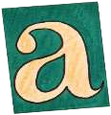





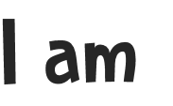





My Transition Booklet

My name is .
I am years old.

Things I like | Things I don’t like






School begins on

-------------------------
I am going to Year .

I might know some friends in my class but I will also make new friends.

My teacher knows all about me and can’t wait to meet me.


My Transition Booklet

This is my new teacher.
My teacher’s name is .

My teacher’s says;

The teaching assistants who will also work in Year ___ and help me learn are:

Here are some pictures of my new classroom.

This is where I will hang my coat and bag.

This is my new Classroom

These are the toilets

… and my new playground.



In my new classroom I will…








It’s good to go to school because I get to learn and make new friends. Year _______ will
be great!

