

Glenwood Primary School
Volunteers & Visitors Policy

‘Together we aim to develop confident, compassionate, and resilient learners who are equipped to thrive in an everchanging world’.

Policy update: | May 2025
Policy to be reviewed by: | May 2028
Signed by Principal: |  | Date:
Signed by Chair of Governors: |  | Date:

Ethos Statement:

Glenwood Primary School is a nurturing & enriching environment where we foster a culture of kindness, empathy & mutual respect. Together we build a safe & caring school where everyone belongs and thrives.

School Vision:

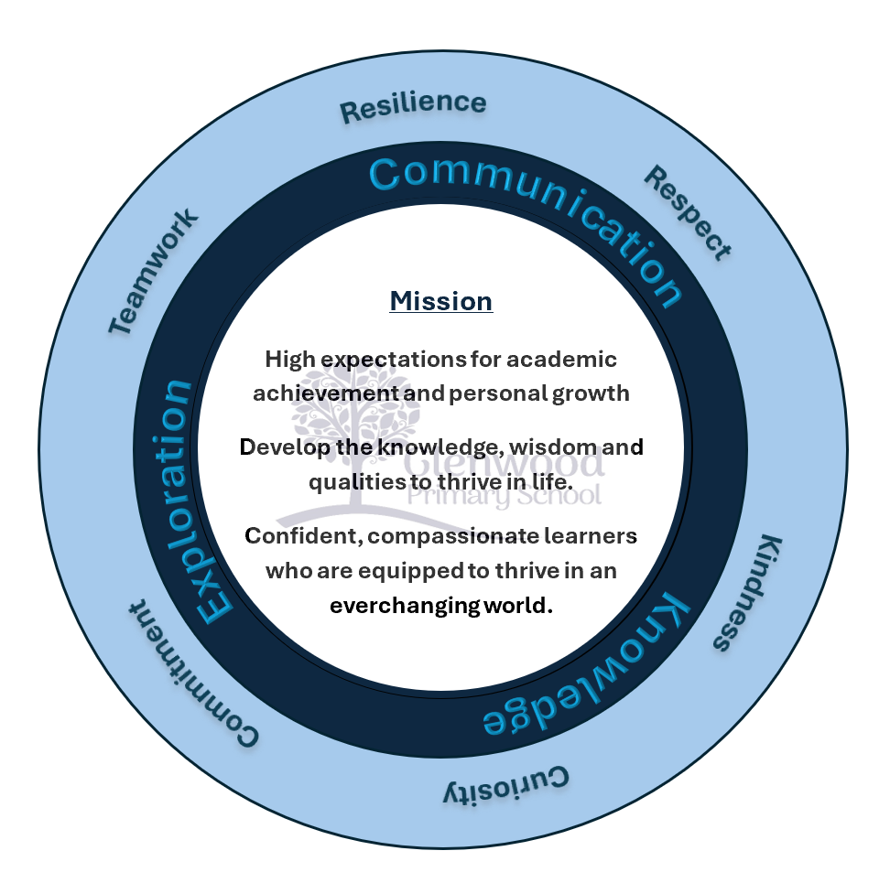
At Glenwood Primary School we are dedicated to fostering an empathetic & inclusive atmosphere where every student is valued, inspired, & challenged to achieve their fullest potential.

We help live our ethos and vision through the Glenwood Way
Move Calmly - Speak Nicely - Listen Carefully - Act Kindly - Do Your Best
Glenwood WISDOM qualities
TEAMWORK
RESILIENCE
RESPECT
KINDNESS
CURIOSITY
COMMITMENT

Volunteers and Visitors Policy

Rights Respecting School
As a Rights Respecting School this policy takes into account the U.N Convention on the rights of the child, including the following articles:

Article 3
“The best interest of the child must be our top priority in all our actions”
Article 19
“Children have the right to be protected from all forms of violence: they must be kept safe form harm: and they must be given proper care by those looking after them”
The aim of this policy and its associated procedures is to:
- Protect the pupils and staff from harm both during and outside of school hours when they ar eon our site and
- Promote effective and meaningful liaison between school staff and the wider school community.
We have a statutory duty under the Health and Safety at Work Act 1974, the Management of Health and safety at Work Regulations 1999, the Disability Discrimination Act 1995 and a common law duty to ensure that, so far as is reasonably practicable, the school premises are safe and that visitors to school come to no harm.
We also have a duty of care to our pupils to ensure that they are safe from harm and therefore expect visitors to comply with the school code of conduct and child protection procedures.
We work closely with the school council to hear their views and opinions as we acknowledge and support Article 12 of the United Nations Convention on the rights of the Child that children should be encouraged to form and to express their views and opinions.
Adult volunteers working with pupils in school or in an after-school club will be checked using the appropriate ACCESS NI vetting form. These will be updated on an annual basis as appropriate and guidance from the Education Authority will be followed.
The objectives of this policy
The key objectives of this policy are to have in place a clear protocol and procedure of the admittance of external visitors to the school which is understood by all staff, governors, visitors and parents/carers and conforms to child protection guidelines and prevents unsuitable people from working with or accessing children and young persons in the school setting.
We have the responsibility for the safety and well-being of all our pupils and staff anywhere on the school site, during normal school hours, during after school activities and on school organised (and supervised) off site activities.
This policy applies to:
- All Teaching and Non-Teaching staff employed by the school;
- All external visitors entering the school site during the school day or for after school activities (including peripatetic tutors, sports coaches etc);
- Governors;
- Parents/Carers;
- Volunteers;
- Children;
- Local Authority Staff;
- Building and Maintenance Contractors.
We encourage parents/ carers and other citizens to visit our school and believe that there are many potential benefits which can result from increased interaction with the public. At the same time, the school must ensure pupils and staff are protected from harm, that the delivery of the curriculum is no disrupted and to protect the school’s facilities and equipment from misuse or vandalism.
A balance must be achieved between the potential benefits and risks associated with the presence of visitors in our school buildings. Achieving the desired balance will lead o increased parent/carer involvement, a better understanding of how the school operates and the challenges facing the school, and an increased sense of collaboration and cooperation between the community and the school.
Access to the school’s premises/particular classrooms or the school may be restricted on recommendation by the principal. The principal, acting on behalf of the Board of Governors, has the authority to determine which visits are to be permitted as well as the discretion to set up any appropriate conditions on the nature and extent of such visits.
The Principal will consider the purpose of any visit, the impact of the visitor’s presence and the relationship of any visitor to the pupils.
School staff shall seek to ensure that parents/carers and other visitors are courteously received and that sincere efforts are made to provide them with information as may be needed to foter a co-operative relationship between home, school and community.

Guidelines
The school has many visitors during the course of any single day. In order to make them feel welcome and to maintain the security of t pupils and staff, the following guidelines must be followed:
- All visitors report to reception on arrival;
- For pre-arranged visits the office staff should be informed of the date and time of any visit, their name, their host and the purpose of their visit;
- Visitors sign in electronically and this provides a record of who is on the premises at any particular time.
- Identification VISITOR lanyards are available from the office and should be worn by all visitors.
- A member of staff will escort all visitors to the appropriate location within the school.
- Visitors should ensure they do not use any photographic devices or video/recording devices whilst in the building without consent;
- Visitors should sign out using the barcode on their visitor pass given to them on their arrival.
The importance of meaningful, regular and positive liaison between parents/carers and staff cannot be over stated – the principle forms the foundation of the school’s policy on liaison with parents/carers.
The means of expressing this working relationship are diverse but parents/carers will appreciate that some guidelines are necessary to ensure communication is as effective as possible.
All exchanges between parents/carers and staff should be conducted in a respectful and tolerant manner.
Parents/carers are asked to adhere to the school’s guidelines when seeking contact with their child’s teacher. The Board of Governors endorses the school’s arrangements for effective parent/carer – teacher communication as set out below.
The contact between parent/carer and teacher will take the form of:
- Meetings to discuss the pupil’s academic progress; (There are two formal opportunities each year for parents/carers to discuss their child’s progress);
- Casual or informal exchanges of information made for routine housekeeping purposes e.g. dental appointments, illness, lost property etc.
- Contact via the Seesaw or Class Dojo app (See Seesaw/Dojo policy and terms of use)
- In the cases of more sensitive matters that are causing concern, an appointment would be made and the issues clarified in advance to enable the parent/carer and the member of staff to make appropriate preparation. If a parent/carer requires a meeting with a member of staff, this should be arranged in advance by letter or phone call. This means the member of staff will be able to allocate quality time for the meeting.
When working on the school premises contractors have a duty to ensure the health and safety of everyone in the school who may be affected by their work activities. Also, they have to cooperate with our health and safety policies and procedures. We have a legal responsibility under the Management of Health and Safety at Work Regulations 1999 to ensure that all contractors when working on the premises act in a responsible and proper manner.
In line with the Education Authority recommendations, the Board of Governors reserves the right to put in place arrangements for addressing the most serious situations where the approach of a visitor might amount to harassment of staff, pupils or other members of the public. These arrangements include the Board of Governors seeking to put in place an injunction to restrain any such person from coming onto the school premises.
Any individual causing disruption to the operation of the school or harassing pupils, staff or members of the public, shall be directed to leave the school premises immediately and the police called if necessary. Thankfully such situations are rare in the school system and we trust unlikely to occur in the context of this school.
The Board of governors, Principal and staff would like to thank parents/carers for their cooperation and support in this matter and look forward to working together to further strengthen the home/school partnership.

