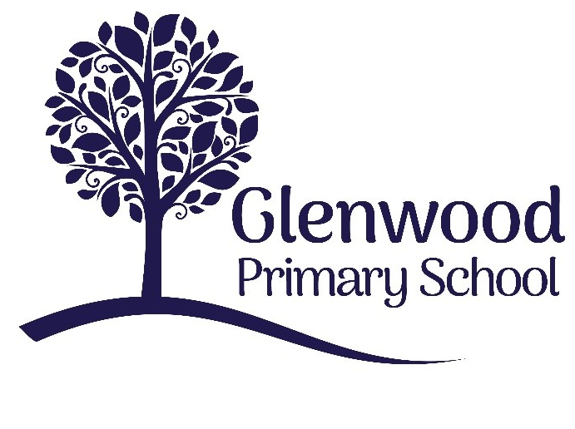

Glenwood Primary School
World Around Us Policy

‘Together we aim to develop confident, compassionate, and resilient learners who are equipped to thrive in an everchanging world’.

Policy update: | Sept 2022
Policy to be reviewed by: | Sept 2025
Signed by Principal: |  | Date:
Signed by Chair of Governors: |  | Date:

Ethos Statement:

Glenwood Primary School is a nurturing & enriching environment where we foster a culture of kindness, empathy & mutual respect. Together we build a safe & caring school where everyone belongs and thrives.

School Vision:

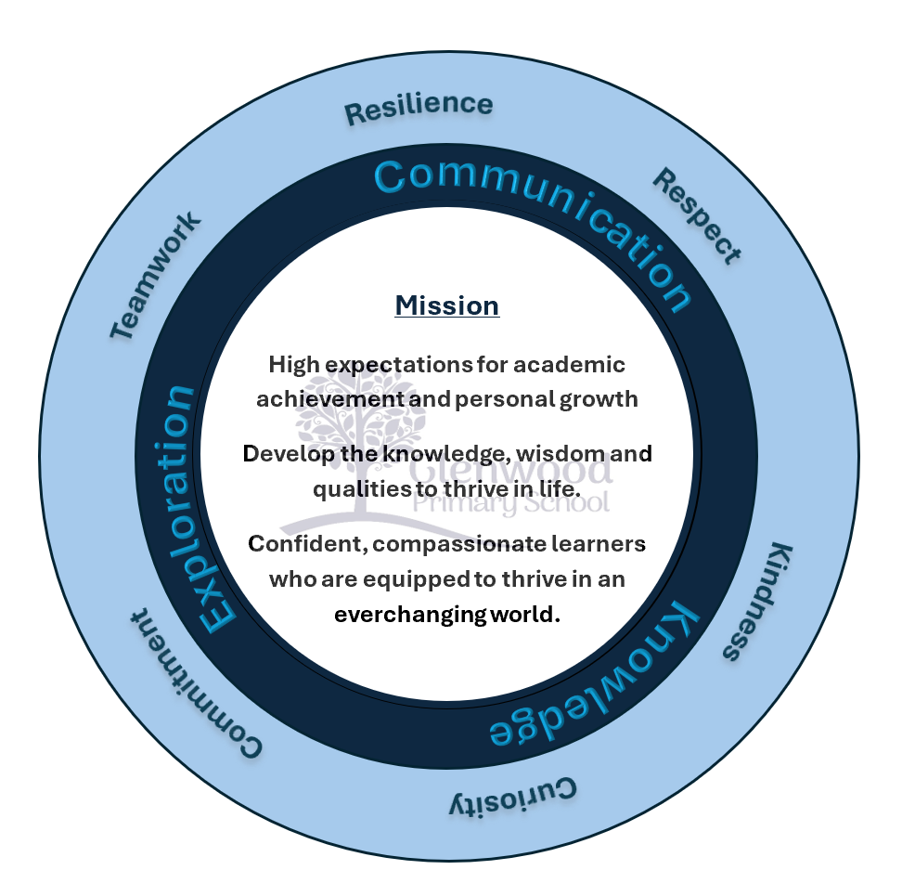
At Glenwood Primary School we are dedicated to fostering an empathetic & inclusive atmosphere where every student is valued, inspired, & challenged to achieve their fullest potential.

We help live our ethos and vision through the Glenwood Way
Move Calmly - Speak Nicely - Listen Carefully - Act Kindly - Do Your Best
Glenwood WISDOM qualities
TEAMWORK
RESILIENCE
RESPECT
KINDNESS
CURIOSITY
COMMITMENT

Policy Statement
This WAU policy is based on the requirements of the Northern Ireland Curriculum document (2007) which is the starting point for planning a school curriculum that meets the needs of individual children. Within these requirements we at Glenwood Primary School aim to provide a broad and balanced curriculum to prepare our children for a rapidly changing world. We seek to encourage the holistic development of those pupils entrusted into our care. We provide a broad and balanced curriculum that meets the demands of the NI Curriculum and offers our pupils rich and varied contexts to acquire knowledge and to develop skills which are essential to learning in all aspects of life.
We are a caring school, where we strive to ensure all stakeholders feel valued and are aware of the important contribution each one must make, thus providing a culture for the development and dissemination of good practice. The whole school community shares this common goal. At St Mary’s we set high standards in respect of attainment and behaviour and we expect our pupils to achieve these. We encourage our children to develop the key personal qualities of self-esteem, tolerance, consideration and respect for others. We provide a safe learning environment where the health, safety and emotional well-being of everyone in our school is of the utmost importance. What is the ‘World Around Us’?
Children are naturally curious and often ask profound questions about themselves and the nature of the world around them. The purpose of this area of learning is to find age-appropriate answers to some of these big questions from the perspectives of geography, history and science and technology. (Page 83 N.I. Curriculum Document)
The World Around Us is one of the six Areas of Learning in the Northern Ireland Curriculum. It focuses on the development of knowledge, skills and understanding in Geography, History, Science and Technology. Glenwood Primary School aims to retain the best of current practice within the three traditional subject areas, while developing a topic/theme-based approach to this area of learning and making relevant connections across all areas of learning, while ensuring breadth and balance.
The statutory curriculum for World Around Us is structured as follows:
Foundation Stage: The World Around Us including Geography, History and Science and Technology
Key Stages One & Two: The World Around Us through the contributory elements of Geography, History and Science and Technology

The World Around Us is presented as four inter-related strands that connect learning.
• Interdependence
• Place
• Movement and Energy
• Change Over Time

Three contributory elements within the World Around Us
Geography explores the relationship between the earth and its people through the study of the environment, place and space. It develops knowledge of places and environments throughout the world, an understanding of maps and a range of investigative and problem-solving skills both inside and outside the classroom Children should develop knowledge and understanding of their place in the world, other places and the processes which affect the people, conditions and life in that place. They should explore ideas about people, jobs, the weather and the environment both locally and globally and begin to consider their part in maintaining a sustainable world.
History is concerned with the concepts of sequence and time and with evidence which allows us to find out what happened in the past. The concepts of chronology, change/continuity, empathy and cause and effect will be developed through investigation of life in the past. Children should gain an awareness of their past and changes which have occurred over time through examining evidence, looking at photographs, watching TV and multimedia clips and listening to stories. Children will recognise the importance of evidence in giving a picture of the past but will understand that there can be different interpretations of this depending on how it is viewed.
Science and Technology aims to stimulate a child’s curiosity in finding out why things happen in the way they do. It teaches methods of enquiry and investigation to stimulate creative thought. Children learn to ask scientific questions and begin to appreciate the way science will affect their future on a personal, national and global level. Children should have opportunities to develop the skills of Science and Technology and to develop awareness of the relevance and importance of Science and Technology in everyday life in finding out about themselves, the environment, the material and physical world.

Aims
- To foster an enjoyment in studying the world around us
- To enable children to develop knowledge, understanding and skills in Interdependence, Place, Movement and Energy and Changes over time
- To develop the pupils' knowledge, understanding and identity with our local area
- To encourage them to develop a sense of care and responsibility
- To progressively extend their knowledge, understanding and awareness of other people and their places near and far
- To have a definite progression and continuity from year to year in the acquisition of skills, concepts, knowledge and understanding
- To recognise the cross-curricular value of World Around Us as a vehicle for: application and development of language in general and technical vocabulary in particular the development of talking and listening, numeracy and ICT skills
- To develop attitudes such as co-operation, independence, tolerance, a sense of curiosity and enquiry, good working habits, perseverance, self-confidence and self-esteem.
- Skills ‘At the heart of the curriculum lies an explicit emphasis on the development of skills and capabilities for life-long learning and for operating effectively in society. Through opportunities to engage in active learning contexts . . . children should develop Cross- Curricular Skills (in Communication, Using Mathematics and Using ICT) and Thinking Skills and Personal Capabilities’ (page 5 NIC).

Within Glenwood Primary School, we also develop Geography, History and Science skills through the World Around Us. (These skills are listed in Appendix 1) While many of the skills will be developed incidentally, we also plan for the development of subject specific skills when appropriate.

Planning Approaches
The WAU programme will be implemented at a level appropriate to the needs of the children in the context of our school and will also provide opportunities for pupils to explore their world in the context of home, school, the local area and the wider world. All planning is based on the statutory requirements of the Northern Ireland Curriculum. We will also use the Ideas for Connected Learning, Thematic Units and other guidance material from CCEA and E.A. in our planning. Whilst initial planning is for the pupils, at all stages children will be encouraged to become active participants in the planning/ learning process.
Planning for Progression and Continuity
Planning for the WAU builds on the earlier experiences of children and continues to help them to explore the world they live in. At Foundation Stage, skills and concepts are developed during play and other planned activities relevant to the children’s interests and experiences. Careful observation informs the planning of future learning experiences within the World Around Us. We ensure that the overall programme of learning in any year group and across the key stages, is broad and balanced and that there is continuity and progression in children’s learning. We are adopting ‘a spiral approach to the World around Us so that concepts, knowledge and skills are introduced without undue repetition or significant gaps and are reinforced in a variety of contexts’

Connected Learning
We emphasise the totality of the children’s learning across the curriculum by making meaningful links across the learning areas. We encourage children to transfer understanding and skills from one context to another, allowing them to practise and apply the skills they have gained.
World Around Us planning aims to promote:
- Good investigations and the development of children’s enquiry skills.
- Good use of ICT to support teaching and learning.
- Effective use of the school/local environment including outdoor learning, educational visits and visitors to the classroom
- Progression in key aspects of geography, history and science and technology.

Learning and Teaching In Glenwood
Learning and Teaching approaches provide suitably challenging opportunities for all pupils to take part in lessons fully and effectively. Learning experiences are active, practical and enjoyable. We make use of a wide range of teaching methods balancing whole class, group and individual activities to engage children in effective learning. There is a clear focus on Active Learning across all year groups in keeping with whole school policy.
In the Foundation stage children experience much of their learning through well planned and challenging play. Children have opportunities to make choices and decisions, developing their own ideas and interests, either as starting points for learning activities or pursuing a topic in more depth. They are supported in taking risks in their efforts to succeed and are actively involved in planning, carrying out and reflecting on their work within the World Around Us Learning Area.

Assessment
Assessment in WAU, as in all areas of learning, will be used to promote, enhance and deepen the children’s learning. It involves all methods normally used to appraise the children’s learning, either individually or in groups. The outcomes from these assessments can then be used to identify the progress which pupils make in relation to the processes, skills, understanding and knowledge outlined in the NI Curriculum. We take account of Assessment for Learning strategies and allow this formative assessment to help and guide planning.
The key reasons for assessment within WAU will be to:
- enhance performance, self-esteem and self-confidence
- promote greater resilience when faced with challenges
- increase independence
- develop a positive climate for learning

Inclusion
Within our school the World Around Us forms part of the school curriculum policy to provide a broad and balanced education to all children. Through our teaching we provide learning opportunities that enable all pupils to make progress. We do this by setting suitable learning challenges and responding to each child’s different needs. Children will be helped to access this Learning Area using a range of learning styles, visual, auditory and kinaesthetic. They are able to record and demonstrate their learning in a variety of ways according to their learning needs and preferences. Children with exceptional ability will have access to more demanding aspects of the WAU and increased resources may be required.
Learning in the Outdoors
We use our school grounds to provide the pupils with an outdoor environment in which to learn. Our pupils have opportunities to develop skills and concepts in an outdoor learning environment where they will:
- Become more aware of, more observant in and more responsive to their surroundings
- Develop an approach to careful observation, accurate recording and thoughtful analysis
- Encourage an interest in environmental issues
- Foster a sense of wonder and discovery
Children will have the opportunity to study aspects of their own immediate world, including different features of town and countryside and make comparisons between local and wider world issues.
Health and Safety
We enable pupils to have access to the full range of World Around Us activities. Where children are to participate in activities outside the classroom, we carry out a risk assessment prior to the activity, to ensure it is safe and appropriate for all pupils. There will always be elements of risk and uncertainty as children engage in active learning. The NI Curriculum document states: ‘All activities must be taught within a safe environment and children must be made aware of safe practice at all times’ (page 84, NIC). For WAU activities, we assess and manage risks with reference to the EA Guidance.

