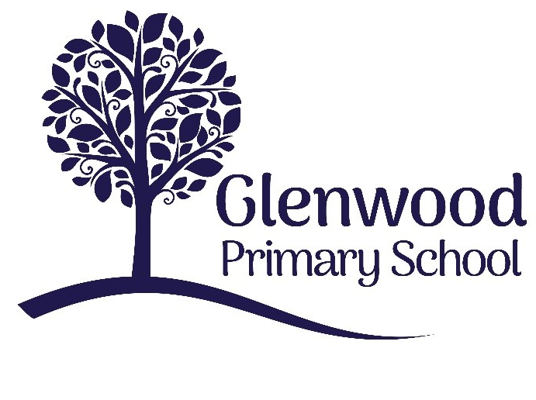

Glenwood Primary School
Accessibility Policy & Action Plan

‘Together we aim to develop confident, compassionate, and resilient learners who are equipped to thrive in an everchanging world’.

Policy update: | March 25
Policy to be reviewed by: | September 28
Signed by Principal: |  | Date:
Signed by Chair of Governors: |  | Date:

Ethos statement
Glenwood Primary School is a nurturing and enriching environment where we foster a culture of kindness, empathy and mutual respect. Together we build a safe and caring school where everyone belongs and thrives.

Vision
At Glenwood Primary School we are dedicated to fostering an empathetic and inclusive atmosphere where every student is valued, inspired, and challenged to achieve their fullest potential.
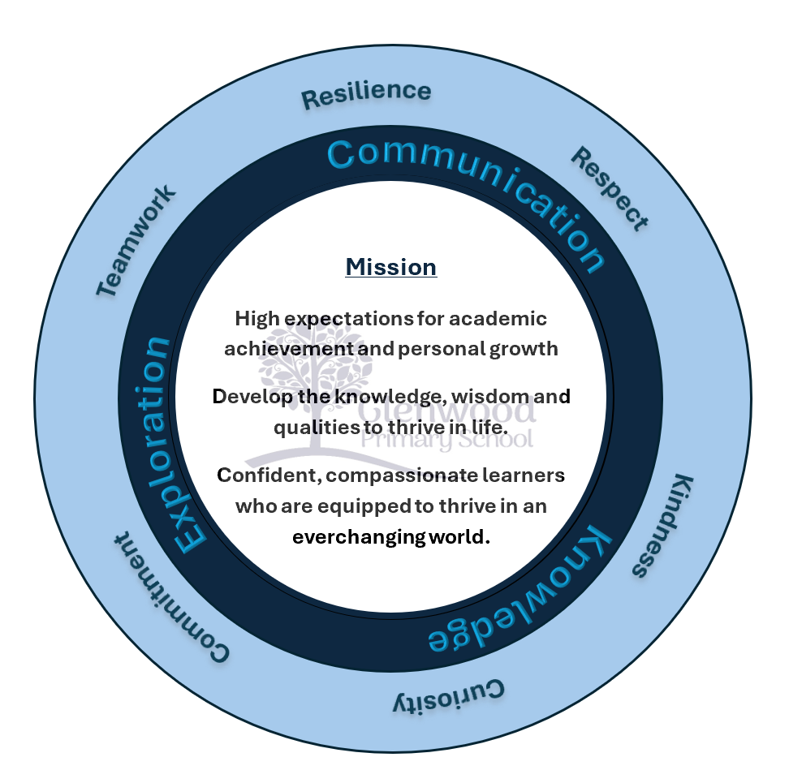

We help live our ethos and vision through the Glenwood Way

Move Calmly - Speak Nicely - Listen Carefully - Act Kindly - Do Your Best

Glenwood WISDOM qualities

TEAMWORK
RESILIENCE
RESPECT
KINDNESS
CURIOSITY
COMMITMENT

Our Values
In Glenwood Primary School we are dedicated to fostering an empathetic and inclusive atmosphere where every student is valued, inspired, and challenged to achieve their fullest potential. We aim to provide an inclusive, welcoming and rights-respecting environment which embraces all pupils regardless of their ability and aptitude. Our values are reflected in our school vision and our pledge to deliver a high-quality education to every child.

Through our dedication to openness, respect for all, reflecting on our policies and practices, taking responsibility for our actions and reaching for excellence in all that we do we are fully committed to providing access and opportunities for all pupils without discrimination of any kind. We promote an ethos of care and trust where every member of our school community feels that they truly belong and are valued.

Our school has established and continues to maintain strong partnership workings with local cross-community initiatives and actively seeks training and shares examples of good practice and resources with other schools.

School Profile (*please note we are breaking ground on a new build in 2025 which will impact accessibility- The plan will be amended to reflect this when all works are completed)

Glenwood Primary School was established 1928 to serve the growing needs of children and young people within the Belfast area. Located in Upper Riga Street, North Belfast, it is a co-educational mainstream school, for pupils aged 4 years to 11 years old, and supports approximately 500 pupils who come from a diverse range of backgrounds.

Glenwood PS a two–storey school with B1 listed status and retains many of its original features. The main teaching areas form an open internal courtyard which has had a small extension to house an assembly hall which divides the remaining space into two smaller play areas. An additional extension was added in 1950 to support the growing numbers attending. There are 3 play areas and a separate building in the lower playground that facilitates a kitchen and dining area.

The school has entrances on both the Shankill Road and Tennant St which results in ease of access to most public transport routes.

At present, the school delivers a holistic and innovative educational experience to its pupils, and caters for all abilities, with 4 dedicated Specialist Provision classes and 1 KS 1 Nurture class as part of the continuum of provision offered by the school. It is also fully committed to providing high standards and access to a quality educational experience for pupils with a range of disabilities, and to ensure that visitors can access our premises and avail of information as well.

Background Legislation

At Glenwood Primary School, we work within the current legislation and requirements to carry out our duties to support both attending and prospective pupils with a disability.

Following the introduction of the Special Educational Needs and Disability (Northern Ireland) Order 2005, we endeavour to proactively avoid the potential for discrimination on the grounds of disability
in our admission arrangements, education and associated services provided or offered and suspension and expulsion arrangements, by strategically planning to:

- not treat pupils ‘less favourably’ for a reason related to their disability (unless it can be shown that this is justified);
- make reasonable adjustments to ensure pupils with a disability are not placed at a substantial disadvantage compared to a non-disabled pupil; and
- increase the access for current and prospective pupils to all aspects of school life, education and the associated services we provide.

Schools’ Planning Duty under schedule 10 of the Equality Act 2010 and the Department for Education (DfE) guidance for schools on the Equality Act 2010 mandates that schools have Accessibility Plans.

The Equality Act 2010 replaced all existing equality legislation, including the Disability Discrimination Act. The effect of the law is the same as outlined in the DDA; a pupil with a disability is considered to be a person who has a physical or mental impairment which has a substantial and long-term adverse effect on his or her ability to carry out normal day-to-day activities., meaning that “schools cannot unlawfully discriminate against pupils because of sex, race, disability, religion or belief and sexual orientation”.

Under the 2010 Equality Act;

“A person has a disability if they have "a physical or mental impairment that has a substantial and long-term adverse effect on their ability to carry out normal day-to-day activities".

The Board of Governors is responsible for ensuring the implementation, resourcing, and review of the plan every 3 years (or earlier if needed).

Since SENDO does not require us to either alter physical features or provide auxiliary aids or services, this ‘Accessibility Plan’ should be viewed alongside our current Special Educational Needs (SEN) policy for those pupils, with a disability, who may require additional provision to be made to support their needs in line with the graduated approach as set out by the Code of Practice.

The SEN policy for Glenwood PS outlines the graduated approach in line with the Code of Practice and shows what additional provision we can offer to support pupils with SEN. The definition of SEN includes;
- pupils with significantly greater difficulty in learning than the majority of children of the same age, or
- a disability which means that a pupil cannot make full use of the educational facilities generally provided for children of their age in ordinary schools, or
- they have not attained the lower limit of compulsory school age and is, or
- would be if special educational provision were not made for them, likely to fall within either of these positions when they are of compulsory school age.

It is important to remember that some children with a disability will have a special educational need and conversely, not all children with SEN will have a disability.

Accessibility Plan

Under Article 18 of SENDO, the aim of the accessibility plan for Glenwood PS is to outline in writing how we will allocate adequate resources to, implement, review and revise the plan over a period of three years in order to:

- increase the extent to which disabled pupils can participate in the school’s curriculum
- improve the physical environment of the school for the purpose of increasing the extent to which disabled pupils can take advantage of education and associated services provided or offered by the school; and
- improve the delivery to disabled pupils within a reasonable timeframe, and in ways which are determined after taking account of their disabilities and any preferences expressed by them or their parents, of information which is usually provided in writing for pupils who are not disabled.

In carrying out these duties, we have taken into consideration the ‘Disability Discrimination Code of Practice for Schools’, which was produced by the Equality Commission for Northern Ireland in 2006. We also draw upon guidance set out in the document ‘Accessibility Planning: Information for Schools’, which was issued by the Education Authority (2021).

It is anticipated that by making reasonable adjustments to overcome the barriers in each of the three planning areas identified above, that neither current nor prospective pupils who are disabled will be treated ‘less favourably’ or placed at a ‘substantial disadvantage’ compared to non-disabled pupils in accessing all aspects of school life.

Our objectives are detailed in the Action Plan below. However, this Accessibility Plan is not a standalone document, but should be considered alongside the following school policy documents:

- Inclusion & Equality | - Pastoral Care Policy
- Curriculum policies i.e Literacy/ Numeracy | - Intimate Care Policy
- Special Educational Needs & Disabilities (SEND) Policy (& Information Report - BOG report and Provision Mapping) | - Safe Handling
- Administering medication policy
- Assessment
- School Development plan | - Child Protection
- Positive Behaviour policy | - Anti Bullying
- Safeguarding Policy  - Health & Safety Policy  - General Data Protection | - Staff related policies, e.g. risk assessments, school trips etc

This plan will also be used to advise and inform future planning documents and policies.

Information Gathering
We aim to ask about medical and special educational needs, as well as any concerns parents may have through early communication with new parents and carers. For parents and carers of children already at the school, we collect information on disability on a regular basis through discussions with them and related, outside, agencies

Pupils with a disability, their non-disabled peers, parents, and staff will all have unique knowledge and experiences of both the effect of the disability on the capacity to carry out normal, everyday activities, as well as any barriers they may face such as attitudes, ability to navigate the environment and communication. Views were sought via surveys using questionnaires and discussion groups.

Data capture forms were used to collect information about pupils coming into our school and from their previous educational setting. This information will be treated in the strictest confidence. Parents were encouraged to make us aware of any changes to their child’s disability. Arrangements were made to support pupils who wished to give their views. Continuous assessment data including attendance etc. were also collated to inform this plan.

Advice obtained and training delivered from across a range of the Education Authority’s Support Services have helped to prepare our plan. Some of the Services which have either been involved, are currently involved or may potentially be involved, in supporting children within the school include:

Local Impact Team
- Autism Advisory and Intervention Service
- Behaviour Support Service & Provisions
- Language and Communication Service
- SEN Inclusion (Learning and Medical Needs) Service.
- Sensory support Service (visual or hearing needs)
- Educational Psychology Service
- EA External Support agencies – Literacy service/ Harberton Outreach etc.
- Parent Partnership Service
- Social Services CLA (Children Looked After)
- Integrated Services -Family Intervention support

Health Provision delivered in school
- School Nurse
- Speech and Language Therapy – RISE NI Team/ Community SLT
- Occupational Therapy – RISE NI Team
- Physiotherapy – RISE NI Team
- CAMHs (Child and Adult Mental Health)
- Counselling

The school’s governors, teachers, teaching assistants and supervisors have a wide range of training and experiences that allow for effective support throughout the day in the following areas:

- Hearing impairment
- Physical disability
- Visual impairment
- Specific medical conditions including asthma, eczema, diabetes, epilepsy etc.
- Specific learning difficulties including dyslexia, dyspraxia and dyscalculia
- Autism
- Speech, language and communication needs
- Profound and multiple difficulties including specific genetic disorders, e.g. Down’s Syndrome, Sickle cell
Disease, Hypochondroplasia, Spina bifida, Cerebral Palsy etc.

Input and training regarding the implications and management of medical issues and disabilities within the school environment, provided by the NSEW Health and Social Care Trust has also contributed to the identification of reasonable adjustments across the three areas of the planning duty.

Current Position

We aim:

- To be at the heart of our community by working in partnership with families and external supports.
- To be a learning community which fosters creativity, independence and a passion for learning.
- To enable our children to develop the essential skills for a happy and fulfilled life.
- To deliver first quality teaching, with high expectations for all, that enables children to succeed and achieve their potential.
- To provide a nurturing and stimulating environment that supports and celebrates learning
- For all members of the school community to model positive, respectful relationships.

Although the intention of an accessibility plan is to identify a series of actions to increase access to
our school for disabled pupils, the information gathered and access audit carried out by the Board of Governors, revealed examples of good practice in each area:

    - Curriculum

Glenwood PS delivers the broad and balanced Northern Ireland Curriculum which aims to empower young people to develop their potential and to make informed and responsible choices and decisions throughout their lives.

In recognition of SENDO, reasonable adjustments are made to differentiate the curriculum, considering the preferred teaching and learning styles of pupils across a range of disabilities. Specific access arrangements, adjustments for homework completion, gross and fine motor skill programmes and resources needed such as coloured overlays, pre-printed handouts with key vocabulary, sloped writing board, and a ‘Time Out card’, are all available to help a pupil access the curriculum.

A range of break and lunchtime supports and other options are available for pupils who may have trouble with navigating the playground. Pupils with a disability are encouraged to participate in all extra-curricular activities on offer.

Risk assessments are carried out ahead of organising school trips and accessible transport is used as appropriate.

N.B. Some pupils with a disability may have specific needs and they will be provided with support which is additional to or otherwise different from that which is widely available. These pupils will have their support outlined in a Personal Learning (and/ or Health Care) plan and appropriate targets set according to their priority areas of need. Their progress in meeting these targets will be monitored and reviewed to ensure that the reasonable adjustments being made are effective. For some children, a classroom or general assistant may be funded by the EA to support the learning and care needs of the disabled pupil, so that they can access the curriculum.

With the support of parents and outside agencies, areas of the curriculum, for example PE, are adapted to the needs of children in school with physical impairments. The school is aware that other issues may affect the participation of disabled pupils, for example: bullying, peer relationships, policies on the administration of medicines, the provision of personal care, the presence or lack of role models or images of disabled people and follow school policies and procedures to ensure that these are all dealt with effectively.

Where appropriate, pupils will have the necessary equipment in classrooms to enable them to be a part of the class and physically access the curriculum. Equipment may include writing slopes, different chairs/seats, use of laptops etc.

At Glenwood we have close working relationships with our ‘feeder’ nurseries and pre-schools and ensure that transition arrangements are organised throughout the summer term before the child starts school. This may include multi-agency meetings with parents/ professionals and/or visiting the child in their current settings.

The school SEND Policy ensures that staff identify, assess and arrange suitable provision for pupils with special educational needs and/or disability, working with the SEND Team, outside agencies (Mitchel House Assessment Centre), Health Professionals and Educational Psychology Services.

The SENCo & assistant SENco manage the Statutory Assessment process, ensuring additional resources, including staffing, are allocated where appropriate. We have strong systems in place to ensure that we meet the needs of all of our pupils including Provision Mapping, which identifies and tracks areas of need and appropriate interventions. These are produced and reviewed annually alongside whole school tracking systems.

All staff work together as a team to ensure strategies for improving pupils’ behaviour and access to learning is effective.

    - Physical School Premises

The school is situated on the Shankill Road and is comprised of one two-storey building with an additional large kitchen and dining facility located on the lower playground. The site has additional features such as 3 outdoor play areas and a carpark with disability parking. There is also on street parking in Riga street.

Due to the age and listed status of the main school building it is not possible to install a lift; therefore, not all the facilities on the upper level are accessible for those with a disability. As a result of this, arrangements are made for pupils with mobility issues to ensure their classrooms are located on the ground floor.

Ramps lead to the side entrance where automatic doors have been widened to increase wheelchair access. An electronic information display is also situated at this location. All corridors are wide and all steps/ stairs have handrails, we also have an accessible toilet on the ground floor with a ‘Sven’ balance rail. The school has internal signage and exit routes are clearly marked.

    - Information

The use of ICT with a range of accessible features, is encouraged, and promoted throughout the school to enhance all aspects of teaching and learning. Staff and pupils at Glenwood PS have access to a range of software and resources on C2k which are designed to support the delivery of written information.

Work is provided in different formats in advance of lessons or within a suitable timeframe so that the pupil can become familiar with key vocabulary and concepts. Font size and colour can be adjusted. Different forms of communication are made available to enable all disabled pupils to express their views and to hear the views of others. Access to information is planned, and can be accessed in different ways on request, should this be needed.

A website has been developed so that information regarding school life can be shared with pupils, their parents, and the wider community. We also maintain open communication with parents/ guardians via the Seesaw & Dojo apps.

- Medical Information

Information that is required to ensure the health and safety of pupils with a range of medical conditions is shared with staff and can be found on the main office noticeboard, the staffroom, individuals classroom board, dinner hall, the medical register on SIMS, the class SEN Folder and the principal’s office.

We have three members of staff who are trained First Aiders and hold current First Aid certificates which are updated as necessary in accordance with guidelines. Staff are appraised of this annually.

All medication is kept in a central safe and secure place, as appropriate, within the SENco’s office and/ or the main office.

Inhalers for those diagnosed with asthma are kept in individual classrooms in locked drawers with additional (emergency*) inhalers stored in the main office. These are available for use when required. *Emergency inhalers are available for use by those children who have an inhaler and their parents have completed a consent form.

For some pupils with a disability, a care plan (HCP) is provided by the NSEW Health and Social Care Trust which details the procedures to follow to meet the needs of the pupil. These are maintained in the class SEN folders and on file in the SENco’s room. Staff receive regular and appropriate training as required.

Consent forms are completed by parents for any medication that is required to be taken in school by pupils because of their disability. These are maintained in line with the school’s GDPR policy. All medication that is given is recorded. (See First Aid & Administering Medication Policy)

School Accessibility Action Plan

Glenwood PS acknowledges that there is a requirement to build upon the current good practice which exists, by continuing and reacting where necessary, to take steps that are reasonable to avoid discrimination by placing a disabled pupil at a substantial disadvantage to non-disabled people within all aspects of school life.

Article 18 of SENDO places a responsibility on our school to plan strategically to find ways to overcome barriers that pupils with a disability may experience in accessing education and associated services provided by the school.

Efforts to improve accessibility to all aspects of the curriculum will include:

- high-quality teaching strategies as the starting point to meet the needs of pupils with a disability;
- identification of adjustments, resources and provisions that are available for pupils with a disability at whole school level;
- effective deployment of additional adult assistance;
- training for all staff;
- a review of all school policies and procedures
- promotion of the presence of disability e.g., through displays, information on notice boards and hosting events throughout the school to celebrate World Autism Day, and;
- use of Rights Respecting Schools award to teach pupils about inclusion.

The following areas for improvement have been identified to enhance the accessibility of the physical environment:

- reduced clutter in classrooms and external areas. Identify somewhere to store equipment;
- the selection of appropriate furniture and equipment;
- a review of the use of indoor/outdoor space in consideration of pupils who are visually and/or hearing impaired;
- independence of access to rooms;
- creation of a sensory garden; and
- development of an emergency alarm system to cater for those with a hearing impairment.

Improvements to the provision of information that is normally provided in written form will include:

- clear, straightforward, and simple communication with pupils, parents, and the community;
- ensuring staff awareness in the use of Widgit symbols (See ASD Policy - visual supports)
- increased signage around the school; and
- continue to develop the school websites accessibility features.

Review & Implementation

The Board g Governors & Principal of the school have the overall duty to implement the accessibility plan. They will monitor the school’s success in meeting the targets by reviewing and reporting on it annually, or earlier if necessary. It will be made available for consideration by the Department of Education, Education Authority, or the Education Training Inspectorate, in a timely manner if required.

Revising the plan

This accessibility plan is valid for a period of three years and will be revised at the end of the three-year cycle which coincides with the duration of the school development plan.

Glenwood Primary School acknowledges that it may not be possible for all changes to be completed within the lifecycle of this accessibility plan and if so, these actions may be taken forward into following plans. (*This is particularly relevant in light of the ‘New Build’)

Due to new knowledge arising from changes in legislation regarding their statutory duties, improvements in methods of teaching and learning, advances in technology and increased awareness of the effect of disabilities additional access audits may be required and will inform the reasonable adjustments which can be made for any new targets.

Confidentiality

The school respects the right of the pupil with a disability to have privacy. A pupil (if the school believes that they have sufficient understanding of the nature of the request) or a parent may request that the nature and existence of the disability is treated as confidential.

At Glenwood Primary School, we will treat all information provided with respect and in line with our GDPR policy. We will take any such request into consideration when deciding whether an adjustment is reasonable and discuss with parents and the pupil as appropriate to identify what can be reasonably expected for the school to offer without infringing upon the request for confidentiality.
However, both parents and the pupil with a disability must be made aware of circumstances (such as child protection, health and safety), in which it may be necessary for confidential information to be disclosed to maintain the best interests and safety of the child. They will be informed of when such information needs to be shared.

A summary copy of the accessibility plan has been placed upon the school’s website. All efforts have been made to ensure that the accessibility plan is as jargon-free as possible and is presented in a clear design and layout.

Appendices

Completed action plans for increasing the access for pupils with a disability to the:

- Curriculum (Aim 1);
- Physical environment (Aim 2); and
- Delivery of information (Aim 3).

Glenwood Primary School Accessibility Plan 2025-2028

1. Improving access to and participation within the curriculum
To increase the extent to which disabled pupils can participate in the school curriculum
Our aim at Glenwood is to reduce and eliminate barriers to access to the curriculum and to ensure full participation in the school community for pupils, and prospective pupils, with a disability.
Target/Issue |  | Strategy/Action | Timescale | Responsibilities | Success Criteria
S  H  O  R  T | To comply with the Equality Act 2010. | Review all statutory policies to ensure that they reflect inclusive practice and procedure. | On-going | SLT  All coordinators BOG | All policies clearly reflect inclusive practice and procedure
S  H  O  R  T | To identify pupils who may need additional provision to ensure smooth transition. | Liaise with pre-school providers to review potential intake for September. Liaise with SENCo’s to ensure clear transfer of records/information. Arrange multi-agency meetings where necessary to ensure the provision is suitable.  Transition days arranged in Summer term.  Any changes in pupil’s needs identified within progress meetings – termly and PLPs to reflect any needs identified  Meetings arranged with parents – information sharing/needs of the child. Link with Parent Teacher meetings | Summer Term for transition and Autumn Term follow-up each September | SLT  SENCo  Assistant SENCo  FS Coordinator | Procedures, resources/equipment and strategies in place  Parents are kept informed of provision and consulted
S  H  O  R  T | To ensure all staff are fully aware of the needs of all pupils who have an EHCP/additional SEND support (PLPs) | Transition meetings in the summer term  Transfer of records / meetings with teachers and relevant staff & SEND Folders up-dated and to include all relevant documents/info. shared  Create and up-date provision maps showing the overview for each year group and individual pupil’s need | End of year class transition meetings.  On-going meetings with SENCo | SENCo  Assistant SENco  All staff | All staff are clear about their responsibilities in meeting pupil’s needs  Personal Learning Plans identified and linked to provision maps and Heath Care plans where needed
S  H  O  R  T | To access outside agency advice and on-going support for pupils with health needs. To improve access to the curriculum through the use of specialised equipment and resources following advice and support from outside agencies. | Referral/consult to specialist support services, Educational Psychology, Health Care Services, RISE NI etc. for additional support and advice where needed · Consult regularly with parents for information sharing and discussion on targets/needs  Additional needs (ASD/ DLD/ ADHD) met through access to specialised support services and resources –regular support for identified children.  OT/Physio and SLT programmes identified on provision maps and staff training taken place to deliver any specialised interventions/use of equipment | On-going updates and regular input throughout the year from outside agencies Meetings SENCo and EP/SLT/ RISE | SENCo  Assistant SENco  All staff working with pupils with additional needs Specialist teachers and Psychology Services | Pupils needs being met.  Advice, strategies and targets given by outside agency- advice & support implemented and evidence of positive impact on pupils and school in ensuring needs are met  Staff feeling supported in meeting the needs of all pupils · Range of equipment integrated into practice  Parents feeling confident about the provision

AIM 1

Target/Issue |  | Strategy/Action | Timescale | Responsibilities | Success Criteria
S  H  O  R  T | To review the attainment of pupils with SEND regularly through whole school tracking systems. | Discussion to take place at pupil progress meetings on the attainment of all pupils on SEND support/EHCP  Attainment of SEND children over the year to be analysed annually and through PLP meetings (SENCo and Assessment Co.)  Track progress with PLPs used to reflect needs of pupils based on progress made | 2x PLP meetings annually  Progress Meetings –On-going | SLT  SENCo  Assistant SENco  Class Teachers | Analysis shows that expected progress has been made by all pupils  Progress towards the PLP targets has been achieved.  Provision has been reviewed and amended based on needs of pupils
S  H  O  R  T | To ensure parents & pupils (where appropriate) are fully involved in the PLP/ EHCP process. Ensure parental understanding so they can offer support at home. | Biannual meetings for PLP reviews/discussion on progress, targets and parent views sought & considered.  Targets to be clearly identified on PLPs for parents to support on at home.  Staff to complete parent meeting notes – Parent/ Teacher Meeting forms in shared folder. | Biannual meetings with class teacher. Open door policy with SENco re meetings | All teachers  SENCo  Assistant SENco  Parents | PLPs reviewed with parents and new targets shared. Review SEN needs.  Parents understand targets and know how to support their child at home.  Evidence/tracking of meetings held with parents – P/T forms etc. Used to monitor parent views and feedback  Parental & Pupil views recorded
S  H  O  R  T | To attend EA/ SEND team meetings to ensure up-to-date with current legislation and EA guidelines | Attend training  Disseminate to staff/SLT where appropriate  Involve parents where appropriate | Ongoing | SLT  SENCo  Assistant SENco  BOG | Course/meetings attended and disseminated to SLT/ staff where needed  Governing Body kept up-to-date with any changes – BOG report annually.
M  E  D  I  U  M | Appropriate use of intervention and their success and impact on progress. Employing high quality teaching strategies to meet the needs of pupils with a disability | Track intervention success annually  Strategically staff interventions to allow for optimum outcomes for pupils with SEN. Have intervention groups/ cohorts across classes/year groups to give more children opportunities to attend interventions.  Improve gross and fine motor skills interventions at FS/KS1. Improve sensory interventions. Access External Services for training and additional interventions i.e RISE NI/ Harberton/ Sensory service etc. | On going annually.  Updated Provision mapping for interventions biannually | SENCo  Assistant SENco  All staff | All staff are clear about their responsibilities in meeting pupil’s needs.  Additional supports across year groups.  Personal Learning Plans identified and linked to provision maps and/or EHCPs where needed
M  E  D  I  U  M | SEND and Medical  register and information  on children with  additional needs updated annually (and as needed throughout the year) | Ensure SEND register reflects current pupils being supported. Update SEND register with relevant  developments. Ensure Medical register and Care plans are up-to-date. Ensure SEND and medical needs are clearly recorded in teachers’ and LSA’s SEN Folders. Meet with parents of children whose care plans/documentation needs updating. | Autumn term 2025/ ongoing annually | SENCo  Assistant SENCo | SEN and Medical needs will be up-to-  date. Teachers and LSAs will be aware of the needs of children in their class.  SEND register and paperwork for individuals on file and on SIMs  PLPs & HCPs in place  Provision Mapping in place.

Target/Issue |  | Strategy/Action | Timescale | Responsibilities | Success Criteria
M  E  D  I  U  M | To audit, and where necessary, improve/ purchase quality resources and specialised equipment. To continue to train staff according to the needs within the school on the use of specialised equipment and understanding/ meeting pupils’ needs | Audit of resources and training needs  Up-date and invest in any new resources which offer greater access to the curriculum for identified children across the school  Staff training identified – internally and externally  AAIS Training Tier 1 & 2 all staff/ RISE NI training as needed for identified children | Ongoing basis | SLT  SENCo  Assistant SENco  All staff | Access to the curriculum improved through the use of good quality resources, interventions and adaptations
M  E  D  I  U  M | To review ‘After Schools’ provision and develop/ ensure reasonable adjustments are made to increase accessibility for all pupils. | Monitor club members  Meet with club Leaders  Ensure accessibility and improve where possible | On-going | SLT  Club Leaders Curriculum Leaders  SENco  Assistant SENco | All after schools activities are organised to be accessible to all pupils in school
L  O  N  G | To evaluate and review procedures in place in ensuring participation of disabled pupils. | Evaluate and review the Accessibility Plan short and medium term targets and set new targets  Produce new plan based on changing needs of the school/pupils | Annually | SLT/ SENCo  Assistant SENco  BOG  Pupil & Parents | Increased access for disabled pupils  Pupils feeling successful at school  Quality interventions and resources in place
L  O  N  G | To continue to audit, review and develop staff expertise based on the needs of the school. | Identify training needs · Seek out appropriate training (internally/externally) and prioritise who, what, when etc. | Annually | SENCo  Assistant SENco  SLT | Long term training needs identified and prioritized.
L  O  N  G | Training for staff on  increasing access to the  curriculum for all  learners and removing  potential barriers | Audit Staff strengths/gaps in knowledge.  Internal and external training from outside agencies- AAIS, SLT, EP and OT etc  LSA training on adapting lessons for the pupils they support  Staff meetings addressing inclusive practice and SEND procedures (as needed). | Ongoing | All Staff  SENCo  Assistant SENco | Staff confidence in adapting the curriculum is improved.  Children’s participation  in the curriculum is more broad and  effective.  LSA training  External agency  training

AIM 1

2. Improving access to the physical environment
To improve the physical environment of the school to increase the extent to which disabled pupils can take advantage of education and associated services.
Target/Issue |  | Strategy/Action | Timescale | Responsibilities | Success Criteria
S  H  O  R  T | To continue to maintain the physical environment of the school in order to maintain accessibility for all pupils | Indoor  Identify needs of new in-take and make reasonable adjustments to the physical environment/ Assess needs of pupil and plan for smooth transition  Plan classrooms accordingly  Involve Mitchel House Assessment Centre & ES Inclusion Service to support with transition and any specialist equipment  Outdoor  Maintain good up-keep of all areas to allow easy access  Pupil questionnaire - Seek pupil views through School Council on improving play areas  Fire Routes – continue to follow procedures to ensure all disabled pupils and staff are aware of safe routes | On going | All Staff  SENCo  Assistant SENco  SLT  BOG | The environment is suitable for disabled children entering school  Classroom environment is clutter free/ accessible and meeting the needs of pupils wherever possible Physical accessibility of the school increased for those with mobility issues/ use a wheelchair.
S  H  O  R  T | To ensure risk assessments are in place for key pupils | Access Mitchel House Assessment Centre for Environmental Risk Assessment.  Up-date Risk Assessments for all pupils and share with staff  Monitor risk assessments and adapt if needed to meet children’s needs | Annually/ as needed | SLT  SENCo  All staff  External Service | All staff aware of risks and pupils safely accessing the curriculum and school grounds · Risk Assessments are understood and followed up
M  E  D  I  U  M | To ensure classroom environments meet the needs of pupils- ensure appropriate furniture and equipment is available. | Establish pupils needs - SENCo, teachers and assistants discuss the layout of the room and the appropriateness of furniture such as tables and chairs. Environment monitoring to take place on a regular basis. Ensure environments meet the needs of the children by being stimulating but not overtly through learning walks, drop-in sessions, mini observations etc. Classrooms adapted accordingly. Resource room appropriately. Access Advice & training as needed from HSCT. Seek views of children | Annually/ As needed/ ongoing | SLT  SENCo  All staff  External Service as needed | Access to the curriculum improved through the use of good quality resources, interventions and adaptations  Appropriate equipment in place.  The pupil is accommodated within the class setting.
M  E  D  I  U  M | To develop the play environment so it is safe and suitable for all children | Ensure the space is gated off to keep children safe  Invest in new equipment for the children  Trip hazards identified and addressed, with support from the Sensory Team where applicable | Ongoing (in light of new building works) | SLT  SENCo  Assistant SENco  BOG | The children are enclosed and safe during unstructured times and play outside. Hazards highlighted to increase safety for visually impaired people. All areas monitored and maintained. Children are happy and enjoy play times

AIM 2

Target/Issue |  | Strategy/Action | Timescale | Responsibilities | Success Criteria
 | Maintain safe access around interior & exterior of school | Ensure all areas are safe and cleared to ensure children are safe and walkways and other areas are clear  Communication with parents through  letters/newsletters/website/1:1 discussion. School staff Safety improved with appropriate parking.  Ensure that pathways are kept clear of vegetation | In place & ongoing | SLT/ SENCo  Assistant SENco  Caretaker/ Building Supervisor  BOG | People with disabilities can move unhindered along exterior pathways and interior corridors.  There is safe access throughout the school
 | To make effective use of the Sensory room. | Children will be encouraged to use the Sensory room for regulation. All Staff to be aware of available equipment in the sensory room, LSA’s will be aware of how to access the sensory room and appropriate activities to do while there with children. The sensory room is on the ground floor and accessible to all pupils. | In place &ongoing | SLT/ SENCo  Assistant SENco  All Staff | Children will be aware they can use sensory equipment & room to self-regulate. Children will be calmer and able to have calming breaks, with LSA support, at appropriate intervals.
L  O  N  G | To continue to develop indoor/ outdoor facilities for all children.  Ensure pathways are appropriate for wheelchair access.  Consideration given to visually impaired pupils | Ensure outdoor space is safe from slipping/ falling hazards ie. Resurfacing and repainting. Redo painting and edging on the edges of steps.  Regular checks and maintenance  Care Taker/ Building Supervisor to report any problems  Involve the School Council  Maintenance of blinds across the school. Replace blinds and repair cords especially when the whiteboard is difficult to see. Consider décor and colour-contrasting paint schemes | Ongoing | SLT  SENCo  Assistant SENco  BOG  Care Taker/ Building Supervisor  Pupil & Parents | Hazards highlighted to increase safety for visually impaired people.  Increased use of indoor and outdoor spaces by those with a disability.  All areas monitored and maintained.  Inclusive child-friendly play areas.  Wheelchair access maintained around the school grounds
L  O  N  G | To provide a wider range of play resources for lunchtimes to support a range of different play types and ensure all children have the same opportunities to them | Invest in new resources which promote play opportunities  Outdoor Play and Learning to support with the school’s new venture of changing the opportunities we provide children | Ongoing over the next year | SLT  SENCo  Assistant SENco  BOG | All children will enjoy their playtimes by engaging in a wide range of play opportunities  Resources are used and are accessible for all

AIM 3

3. Improve the access and delivery of written information
To improve the delivery of information for disabled pupils and parents
Target/Issue |  | Strategy/Action | Timescale | Responsibilities | Success Criteria
S  H  O  R  T | Maintain up-to-date records to ensure school staff are fully aware of any disabled children/parents and their needs. | Office staff aware of parent’s needs as notified and adapted material on request. The school will make itself aware of the services available for converting written information into alternative formats. Health Care Plans kept up-to-date – access to all and kept in the same place. Up-date Medical forms regularly – all classrooms to have medical records and one page profiles in their green folders. Up-date SEND forms in line with guidance | Annually | SLT  SENCo/ Assistant SENCo  FS Coordinator  Office team  All staff | All staff aware of the needs of the school  Records up-to-date  The school will be able to provide written information in different formats.
S  H  O  R  T | To ensure disabled parking is marked and available for disabled staff and disabled pupils only. | Care Taker/ Building Supervisor and office staff to ensure correct use of the disabled parking space  Parents made aware of ‘rules’ for using the parking space | On going | SLT  SENCo/ Assistant SENco  BOG | Parking fully accessible to meet the needs of pupils and parents
S  H  O  R  T | To ensure that the school environment offers further information to pupils and visitors. | Photographs of all staff on display board with names  Classrooms labelled  Environmental print  Displays offer visual and written support/adapted where needed * School for Sanctuary  Photographs/images for visual support on display.  Monitored through learning walks | On going | SLT  SENCo/ Assistant SENco  BOG  All Staff | Visual and written environment offers support and is consistent around the school
M  E  D  I  U  M | Review documentation on website to check accessibility for parents etc. | Ensure documents are accessible to everyone using commonly known vocabulary. Office to be aware of parents who may need support in accessing materials and assisting with this. Website redesigned/developed and improved over time. Ensure parents are fully aware of the information available on the website | On going | SLT  SENCo/ Assistant SENco  ICT & school leaders | All parents will be able to be aware of what is happening at school via the website. Website up-dated regularly  Friendly/easy to access website  Website used by parents
M  E  D  I  U  M | To use class Dojo/ Seesaw to communicate with parents regularly, share information and send over specific files when needed | Connect all pupils to class dojo and Seesaw with relevant staff to each class  Share specific files and information to parents through the messaging tool  Ensure questions are answered through the app when needed | Ongoing annually in  Autumn term | SLT  SENCo/ Assistant SENco  All staff | Parents and teachers are connected through class dojo/ Seesaw  All parents are connected and use the app to communicate with relevant staff

AIM 3

Target/Issue |  | Strategy/Action | Timescale | Responsibilities | Success Criteria
M  E  D  I  U  M | Ensure written materials are available in alternative formats | Ensure office staff are able to use google translate to translate any written letters and newsletters and ensure parents know this is available.  Ensure parents with visual impairments can access policies through either a braille service or enlargement of papers  Invite parents in who may need support completing forms. | Ongoing | SLT  All Staff SENco  Assistant SEnco | Parents are able to access all information
L  O  N  G | Ensure documents are accessible for pupils & Parents with visual impairment | Seek and act on advice from sensory support advisor on individual pupil requirements  Use of magnifier where appropriate  Ensure large, clear font used in documentation | Ongoing | SLT  All Staff SENco  Assistant SEnco | Pupils able to access all school documentation
L  O  N  G | Improve use of pictorial communication systems (Widgit) | Purchase Widgit to improve picture communication support.  Use Widgit to make classroom resources (eg.word mats, visual timetables, social stories).  Training on most effective ways to use Widgit – disseminate to all staff | Ongoing | SLT  All Staff SENco  Assistant SEnco | All school staff aware of disabilities of children in their classes
L  O  N  G | To continue to meet any specific future needs of pupils/families within school | Assess needs and plan accordingly  Identify any specialised support needed and seek advice  Add to provision maps/risk assessments etc.  Staff awareness and training where needed | Ongoing | SLT  All Staff SENco  Assistant SENco | Needs of all pupils met whereever possible

Curriculum Access:
- Clear Inclusion & Diversity policy (linked to SEN & Disability policy)
- Clear system of communication for SEN provision : SLT, SENCo, Teachers, LSAs
- Strong links with outside agencies eg Ed. Psychology, Speech & language, Health Service – RISE NI, Sensory Service, AAIS, School nurse etc
- EHCP, PLPs, Individual Risk assessments & Evacuation plans (if needed)
- Staff meetings, inset, training

Physical Access:
- Occupational Health, Sensory Service, Mitchel House Assessment Centre
- Caretaker/ Building Supervisor
- Health and Safety officers/ Fire Safety Marshalls

