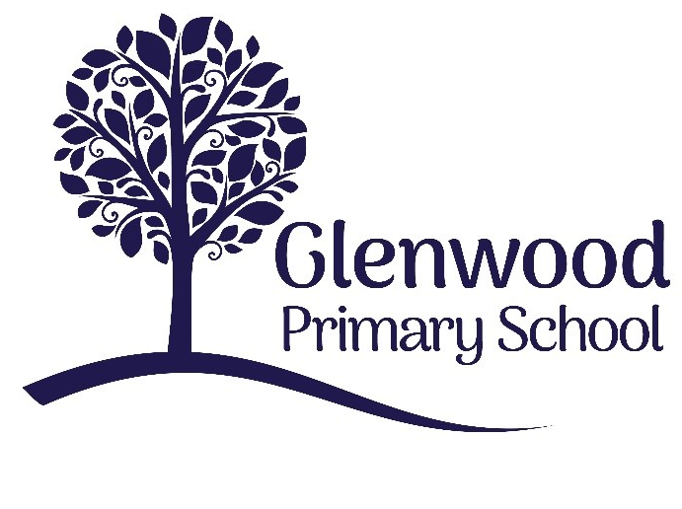

Glenwood Primary School
Anti-Bullying Policy

‘Together we aim to develop confident, compassionate, and resilient learners who are equipped to thrive in an everchanging world’.

Policy update: | Apr 2022
Policy to be reviewed by: | April 2024
Signed by Principal: |  | Date:
Signed by Chair of Governors: |  | Date:

Ethos statement
Glenwood Primary School is a nurturing and enriching environment where we foster a culture of kindness, empathy and mutual respect. Together we build a safe and caring school where everyone belongs and thrives.

Vision
At Glenwood Primary School we are dedicated to fostering an empathetic and inclusive atmosphere where every student is valued, inspired, and challenged to achieve their fullest potential.

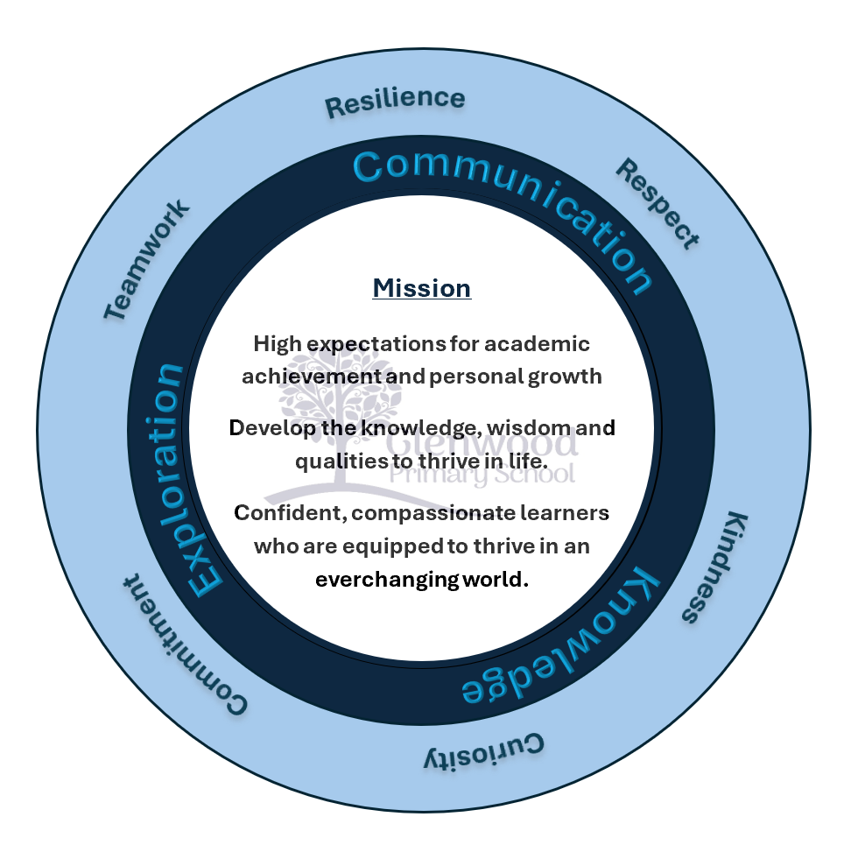

We help live our ethos and vision through the Glenwood Way

Move Calmly - Speak Nicely - Listen Carefully - Act Kindly - Do Your Best

Glenwood WISDOM qualities

TEAMWORK
RESILIENCE
RESPECT
KINDNESS
CURIOSITY
COMMITMENT

Introduction
At Glenwood Primary School we believe all forms of bullying behaviour are unacceptable. We believe that all pupils have the right to learn in a safe and supported environment.

Context
Our policy has been reviewed and developed in the following context:

The Legislative Context:
- The Addressing Bullying in Schools Act (Northern Ireland) 2016
- The Education and Libraries Order (Northern Ireland) 2003 (A17-19)
- The Education (School Development Plans) Regulations (Northern Ireland) 2010
- The Children (Northern Ireland) Order 1995
- The Human Rights Act 1998
- The Health and Safety at Work Order (Northern Ireland) 1978

The Policy & Guidance Context
- The Addressing Bullying in Schools Act (Northern Ireland) 2016 Statutory Guidance for Schools and Boards of Governors (DE, 2019)
- Pastoral Care in School: Promoting Positive Behaviour (DE, 2001)
- Safeguarding and Child Protection in Schools: A Guide for Schools (DE, 2017)
  - Co-operating to Safeguard Children and Young People in Northern Ireland (Dept. of Health, Social Services and Public Safety, 2016)
  - Safeguarding Board for Northern Ireland Policies and Procedures (SBNI, 2017)

The International Context
- United Nations Convention on the Rights of the Child (UNCRC)

The key points to note are:
- The Addressing Bullying in Schools Act (Northern Ireland) 2016:
- Provides a legal definition of bullying.
- Places a duty on the Board of Governors to put in place measures to prevent bullying behaviour, in consultation with pupils and parents.
- Requires schools to record all incidents of bullying behaviour and alleged bullying incidents.
- Sets out under which circumstances this policy should be applied, namely:
- In school, during the school day

- While travelling to and from school
- When under control of school staff, but away from school (eg. school trip)
- When receiving education organised by school but happening elsewhere (eg. in another school in the ALC)
- Requires that the policy be updated at least every four years.
- The Education and Libraries Order (NI) 2003, requires the Board of Governors to:
- ‘Safeguard and promote the welfare of registered pupils’ (A.17)
- The United Nations Convention on the Rights of the Child (UNCRC) sets out every
child’s right to:
- Be protected from all forms of physical or mental violence, injury or abuse, maltreatment or exploitation. (A.19)
- Be protected from discrimination. (A.2)
- Express their views, in a supported and accessible way, on issues that affect them, and to have their opinions taken seriously. (A.12)
- Education. (A.28)

Ethos and Principles
At Glenwood Primary School we aim to equip children with the skills, knowledge and understanding necessary to be able to make informed choices about the important things in their lives. Central to creating an atmosphere conducive to effective teaching and learning is the need to have a stable and happy learning environment free from any form of intimidation. We are committed to a preventative, responsive and restorative anti- bullying ethos across he school.
The anti-bullying policy reflects the School’s vision with a view to maintaining a safe, secure and happy environment for all our children and staff. It makes it explicit that the school will not accept bullying of any kind and will prevent, as far as humanly possible, bullying in any form.
We feel that the most important thing our school can do to prevent bullying is to have a clear anti-bullying policy that the whole school community believes in and to which staff, pupils and parents are actively committed.

Our approach at Glenwood
We believe that every pupil at Glenwood has the right to enjoy his/her learning and leisure time within the school environment free from intimidation.
BULLYING IS NOT TOLERATED and reported incidents are taken seriously and thoroughly investigated.

This anti-bullying policy is seen as part of our Pastoral Care System and reflects the aims of our Positive Behaviour Policy and respects the UN Convention on the Rights of the child. Specifically, we aim:
- To maintain a safe, friendly, caring and happy learning environment for all children and staff.
- To prevent bullying in any form and to have a consistent approach for dealing with incidents of bullying.
- To create a ‘climate’ within the school, in which children feel able to ‘tell’ and to
support each other by reporting all incidents of bullying.
- To ensure that all pupils, staff and parents are aware of this policy and their responsibilities.
- To ensure that the strategies we use to prevent or deal with bullying are supportive to both the bullied child and the child displaying bullying behaviour.
- To celebrate the diversity in all of our pupils.

Code of Conduct
Glenwood Primary School has a clearly defined code of conduct set out in its Positive Behaviour Policy. This code has implications for the entire school community. With respect to bullying behaviour we feel that the following rights and responsibilities should be highlighted.

Individual Rights
Taken from the UN Convention of the Rights of the Child

Article 12
Every Child has the right to say what they think in all matters affecting them, and to have their views taken seriously.

Article 14
Every child has the right to think and believe what they want and also to practise their religion, as long as they are not stopping other people from enjoying their rights. Governments must respect the rights of parent to give their children guidance about this right.

Article 15
Every child has the right to meet with other children and young people and to join groups and organisations, as long as this does not stop other people from enjoying their rights.

Article 19
Governments must do all they can to ensure children are protected from forms of violence, abuse, neglect and mistreatment by their parents or anyone else who looks after them.

Article 27
Every child has the right to food, clothing, a safe place to live and to have their basic needs met. Children should not be disadvantaged so that they can’t do many of the things other Kids can do.

Consultation and Participation
This policy was developed with the input of all of our pupils:
- Foundation and Key Stage One children took part in a paper questionnaire
- Key Stage Two pupils completed an online survey
- Our School Council discussed their views of bullying in Glenwood Primary School This policy was developed via consulting with parents/carers:
- An online questionnaire was shared to all of our parents and carers
All members of the school community including teachers, classroom assistants and ancillary staff where consulted in the development of this policy:
- An online survey was shared with all adult members of the school community

What is Bullying?
The Addressing Bullying in Schools Act (NI) 2016 provides a legal definition of bullying:
1.—(1) In this Act “bullying” includes (but is not limited to) the repeated use
of—
- any verbal, written or electronic communication,
- any other act, or
- any combination of those, by a pupil or a group of pupils against another pupil or group of pupils, with the intention of causing physical or emotional harm to that pupil or group of pupils.
- For the purposes of subsection (1), “act” includes omission.

Glenwood Primary School strongly believes that:

Bullying is behaviour that is usually repeated, which is carried out intentionally to cause hurt, harm or to adversely affect the rights and needs of another or others.
We also believe that, whilst bullying is usually a repeated behaviour, there are instances of one-off incidents that we as a school will consider as bullying.
When assessing a one-off incident, to make a decision on whether to classify it as bullying, the school shall consider the following criteria:
  - severity and significance of the incident
  - evidence of pre-meditation
  - impact of the incident on individuals (physical/emotional)
  - impact of the incidents on wider school community
  - previous relationships between those involved
  - any previous incidents involving the individuals

Any incidents which are not considered bullying behaviour will be addressed under the Positive Behaviour Policy.

The following unacceptable behaviours, when repeated, targeted and intentionally hurtful, may be considered a bullying behaviour:

  - Verbal or written acts
  - saying mean and hurtful things to, or about, others
  - making fun of others
  - calling another pupil mean and hurtful names
  - telling lies or spread false rumours about others
  - try to make other pupils dislike another pupil/s
  - Physical acts
  - Hitting
  - kicking
  - pushing
  - shoving
  - material harm, such as taking/stealing money or possessions or causing damage to possessions
  - Omission (Exclusion)
  - Leaving someone out of a game
  - Refusing to include someone in group work
  - Electronic Acts

  - Using online platforms or other electronic communication to carry out many of the written acts noted above
  - Impersonating someone online to cause hurt
  - Sharing images (e.g. photographs or videos) online to embarrass someone

The above list is not exhaustive and other behaviours which fit the definition may be considered as bullying behaviour.

There are many motivations behind bullying. These include, but are not limited to:

  - Age
  - Appearance
  - Breakdown in peer relationships
  - Community background
  - Political affiliation
  - Gender identity
  - Sexual orientation
  - Pregnancy
  - Marital status
  - Race
  - Religion
  - Disability / SEN
  - Ability
  - Looked After Child status
  - Young Carer status

Bullying is an emotive issue, therefore it is essential that we ensure we use supportive, understanding language when discussion these matters. For that reason, we will not
refer to a child as ‘a bully’, nor will we refer to a child as ‘a victim’. Instead, we will
refer to the situation surrounding that child, for example:
    - A child displaying bullying behaviours
    - A child experiencing bullying behaviours
We encourage all members of the school community to use this language when discussing bullying incidents.
In determining ‘harm’ we define:
  - Emotional or psychological harm as intentionally causing distress or anxiety by
scaring, humiliating or affecting adversely a pupil’s self-esteem.

  - Physical harm as intentionally hurting a pupil by causing injuries such as bruises, broken bones, burns or cuts.

Preventative Measures
Glenwood Primary School will implement a number of key actions with the aim of preventing bullying and creating a safe learning environment. Examples of these actions will include:
  - Raising awareness and understanding of the positive behaviour expectations, as set out in the Positive Behaviour Policy
  - Promotion of anti-bullying messages through the curriculum e.g. inclusion of age- appropriate material specific to individual subject areas related to bullying, positive behaviour and inclusion
  - Class teachers will display the schools Anti-Bullying Charter (Appendix A)
  - Addressing issues such as the various forms of bullying, including the how and why it can happen, through PDMU/PD/LLW (e.g. sectarian, racist, homophobic, transphobic, disablist, etc.)
  - Involvement in meaningful and supportive shared education projects, supporting pupils to explore, understand and respond to difference and diversity.
  - Through the preventative curriculum actively promote positive emotional health and wellbeing (e.g. mindfulness training)
  - Participation in the NIABF annual Anti-Bullying Week activities
  - Engagement in key national and regional campaigns, e.g. Safer Internet Day, Anti- Bullying Week, etc.
  - Development of peer-led systems (eg. School Council) to support the delivery and promotion of key anti-bullying messaging within the school
  - Development of effective strategies for playground management, e.g. training for supervisors, zoning of playgrounds, inclusion of specific resources (buddy benches, play bus stops) and provision of a variety of play option to meet the needs of all pupils.
  - Focused assemblies to raise awareness and promote understanding of key issues related to bullying.
  - Development of effective strategies for the management of unstructured times (eg. break time, lunch)
  - Provision and promotion of extra- and co-curricular activities, aimed at supporting the development of effective peer support relationships and networks. For example sporting activity, creative arts, leisure and games, etc.

Whilst many of the measures outlined above will support the development of an anti- bullying culture, Glenwood Primary School will try to build upon these specifically on the journey to and from school. These will include:
  - Development of a culture where pupils take pride in their school and are viewed as ambassadors for their school within the community. This includes regular reminders of the positive behaviour expectations of pupils whilst travelling to and from school.
  - Measures to empower pupils to challenge inappropriate and unacceptable behaviour of their peers during the journey to and from school. This may include encouraging pupils walking to and from school to feel comfortable reporting incidents of bullying behaviour to school.
  - Promotion of key anti-bullying messages and awareness of behaviour expectations of pupils amongst the local community (eg. local shops, cafes, service providers, residents, etc), including information on how to raise any concerns with the school.
  - Appropriate deployment of staff to support the transition from school day to journey home (eg. staff duty at school gate/bus stops, where appropriate)
The Addressing Bullying in Schools Act (NI) 2016 gives schools the authority to take steps to prevent bullying through the use of electronic communication amongst pupils at any time during term, where that behaviour is likely to have a detrimental impact on the pupil’s education at school. Glenwood Primary School will endeavour to raise awareness of the nature and impact of online bullying and will support pupils to make use of the internet in a safe, responsible and respectful way. Strategies may include:
  - Addressing key themes of online behaviour and risk through PDMU/PD/LLW, including understanding how to respond to harm and the consequences of inappropriate use.
  - Participation in Anti-Bullying Week activities.
  - Engagement with key statutory and voluntary sector agencies (eg. C2k, PSNI, Public Health Agency, Safeguarding Board for NI e-Safety Forum) to support the promotion of key messages.
  - Participation in annual Safer Internet Day and promotion of key messages throughout the year.
  - Development and implementation of robust and appropriate policies in related areas
e.g. Mobile Phone Policy, UICT Policy.

Responsibility
Everyone in the school community, including pupils, their parents/carers and the staff of Glenwood Primary School are expected to respect the rights of others to be safe.

Responsibilities of School Staff:
  - Demonstrate by example the high standards of personal and social behaviour we expect from our pupils
  - Foster in our pupils, self-esteem, self-respect and respect for others
  - Use the curriculum to promote opportunities to discuss the issue so that every pupil learns about the damage it causes to both the child who is bullied and to the child accused of bullying, and importance of TELLING a teacher when it happens.
  - Be alert to signs of distress and other possible indications of bullying
  - Listen to children who have been bullied, take what they say seriously and act to support and protect them
  - Deal with observed instances of bullying promptly and effectively by following consistent procedures when an incident occurs
  - In line with agreed procedures, give feedback to all concerned
  - Celebrate good behaviour
  - Know how to seek support, both internal and external

Responsibilities of Children:
  - To avoid any behaviour which could be considered bullying
  - Not to suffer in silence, but to have the courage to speak out, to put an end to their own suffering and that of other potential targets
  - Report to a member of staff any witnessed or suspected instances of bullying, to dispel any climate of secrecy and help prevent further instances
  - Intervene to protect the pupil who is being bullied by reporting the incident to an adult
  - To follow the School Code of Behaviour

Responsibilities of Parents/Carers:
  - Watch for distress or unusual behaviour in their children
  - Reassure the child that something will be done to stop the bullying
  - Advise their children to report any concerns to a member of staff as soon as possible and to explain to their children the implications of allowing the bullying to continue unchecked, for themselves and other pupils
  - Check all facts before determining whether bullying has occurred, i.e. was the behaviour deliberate, hurtful, targeted and repeated over a period of time
  - Inform the school of any suspected bullying
  - Fully support the school’s ‘anti-bullying’ policy whether their child is the victim or the
child accused of bullying
  - Stress to their children the importance of good behaviour

  - To discourage any tendency towards bullying behaviour or retaliating to any form of bullying

Reporting a Bullying Concern Pupils Reporting a Concern
In Glenwood Primary School, our pupils are encouraged to report a bullying concern in a variety of ways:
  - Verbally- talking to a member of staff
  - By writing a note to a member of staff (eg. in a homework diary)
  - By sending an email to a member of staff or to a dedicated email address
  - By posting a comment in a ‘worry box’
Glenwood Primary School will emphasise to pupils that ANY pupil can report a concern about bullying behaviour, not just the pupil experiencing the behaviour. Our message to our pupils will always be ‘get help’ and that this is not ‘telling’.

Parents/Carers Reporting a Concern
In Glenwood Primary School our parents/carers can:
  - In the first instance, all bullying concerns should be reported to the Class Teacher
  - Where the parent is not satisfied that appropriate action has been taken to prevent further incidents, or where further incidents have taken place, the concern should be reported to the Vice-Principal
  - Where the parent is not satisfied that appropriate action has been taken by the Vice- Principal to prevent further incidents, or where further incidents have taken place, the concern should be reported to Principal
Where the parent/carer remains unsatisfied that the concern has not been appropriately responded to, the complaints procedure of Glenwood Primary School should be followed. This needs to be included
All reports of bullying concerns received from pupils and/or parents/carers will be responded to in line with this policy and that feedback will be made to the person who made the report. However, it must be noted that no information about action taken in relation to a pupil can be disclosed to anyone other than the pupil and his/her parents/carers.

Responding to a Bullying Concern Recording Procedures
If bullying occurs in the playground or while the class is with another teacher the member of staff, to whom it has been reported, must inform the class teacher.
An Alleged Bullying Concern Form will be used by the class teacher for recording any incidents of bullying that arise involving his/her pupils (Appendix B).
Serious or ongoing incidents will be reported to the Vice-Principal who, in liaison with the class teacher will record detailed, cataloguing accounts.
Parents of the children involved (bullied child and the child who has been bullying) should be kept informed in order that they may support their child and the school.
In the first instance parents should contact their child’s teacher concerning any
incidents of bullying that they know about.

Procedure for Dealing with an Incident of Bullying
A parent/pupil/witness informs a member of staff that an incident of bullying has taken place.
STAGE ONE (immediate action)
The member of staff will intervene to correct the situation or behaviour, making it clear which aspect/aspects of the incidents was inappropriate.

STAGE TWO
Report the incident to the class teacher.
Hold discussions with those involved (the bullied child, the child who has been bullying, and any witnesses) to ascertain what happened. These would usually be held separately but in some circumstances the children may be seen as a group and would be with a view to establishing agreement between parties.
Sanctions imposed are in line with those outlined in the school’s Positive Behaviour Policy. A report should be filled in, detailing action taken – see appendix A

STAGE THREE
If bullying persists the designated teacher must be informed. The designated teacher in Glenwood is the Vice-Principal. Detailed, written reporting should now be taking place.

STAGE FOUR

Following discussion between the teacher involved and the Vice-Principal, the decision may be taken to involve the parents of both the bullied child and the child who has been bullying.

STAGE FIVE
Contact and/or referral are made to an outside agency e.g. Behaviour Support Team, Educational Psychologist. Parents will be informed at this stage.

TYPES OF BULLYING
In terms of pupil behaviour bullying covers a wide range of activities as set out below.
We are fully commited to identifying and denial of the rights of a child that bullying inflicts. The rights of the child (shortened version) are shown below each type of bullying and this reiterates why tolerance of these types of bullying is unacceptable.
- Physical Aggression
This involves pushing, shoving, kicking and punching.
ARTICLE 19 – Every child has the right to be protected from being mistreated, in body or mind.
- Verbal assault
Here the voice is used as a weapon to humiliate, hurt or insult.
ARTICLE 19 – Every child has the right to be protected from being mistreated, in body or mind.
- Intimidation
This is based on the use of very aggressive body language and tone of voice where the bullied child may be pressurised to do something that he/she does not want to do. The bully’s facial expression or ‘look’ can convey aggression and/or dislike. Threats are consistently used to undermine the bullied child’s confidence.
ARTICLE 19 – Every child has the right to be protected from being mistreated, in body or mind.
- Exclusion
This is where the bullied child is purposely isolated, excluded or ignored by some or the entire class group.

ARTICLE 15 – Every child has the right to meet with other children and young people and to join groups and organisations, as long as this does not stop other people from enjoying their rights.
- Extortion
Money/sweets may be demanded and the bullied child threatened if he/she does not pay up promptly. Bullied child’s lunches, dinner or snack money may be taken. The bullied child may be coerced into stealing property for the child who is bullying.
ARTICLE 27 – Every child has the right to food, clothing, a safe space to live and to have their basic needs met. Children should not be disadvantaged so they can’t do many of the things other kids can do.
- Damage to Property
The child who is bullying may focus attention on the bullied child’s property and as a result clothing, school books and other personal property may be damaged, stolen or hidden.
ARTICLE 27 – Every child has the right to food, clothing, a safe space to live and to have their basic needs met. Children should not be disadvantaged so they can’t do many of the things other kids can do.
- Text Messaging/Emailing/Online chat
The child who is bullying intimidates through text, email or online messages, which may
be aggressive or undermine the bullied child’s confidence.
ARTICLE 19 – Every child has the right to be protected from being mistreated, in body or mind.
When responding to a bullying concern, school staff shall implement interventions aimed at responding to the behaviour, resolving the concern and restoring the wellbeing of those involved. Where appropriate, school staff may implement sanctions for those displaying bullying behaviour.
Any action taken regarding a pupil cannot be disclosed to anyone other than that pupil and his/her parents/carers.

Recording
The school will centrally record all relevant information related to reports of bullying concerns, including:
- how the bullying behaviour was displayed (the method)

- the motivation for the behaviour
- how each incident was addressed by the school
- the outcome of the interventions employed
Records will be kept on the online SIMS Behaviour Management Module, which is part of the C2k system in schools. Access to these records will be restricted and only provided to those members of school staff with a legitimate need to have access.
Completed Anti-Bullying Concern Forms will be stored in a locked filing cabinet accessible only to the Principal/Vice-Principal.

Personal Development of Staff
Glenwood Primary School is committed to ensuring that there is adequate training for all staff, including teaching and non-teaching. The school will ensure that staff are provided with appropriate opportunities for professional development as part of the school’s ongoing CPD/PRSD provisions. The school will note the impact of training on both policy and procedures.
Glenwood Primary School will also ensure that opportunities for safeguarding training are afforded to Governors and all staff – teaching and non-teaching. CPD records will be kept and updated regularly.

Monitoring and Review of Policy
To appropriately monitor the effectiveness of the Anti-Bullying Policy, the Board of Governors shall:
- maintain a standing item on the agenda of each meeting of the Board where a report on recorded incidents of bullying will be noted
- identify trends and priorities for action
- assess the effectiveness of strategies aimed at preventing bullying behaviour
- assess the effectiveness of strategies aimed at responding to bullying behaviour
This Anti-Bullying Policy shall be reviewed as required, in consultation with pupils and their parents/carers, on or before the [date 4 years from now].

Links to Other Policies
In the development and implementation of this Anti-Bullying Policy, the Board of Governors has been mindful of related policies, including:

- Positive Behaviour Policy
- Pastoral Care Policy
- Safeguarding and Child Protection Policy
- Special Educational Needs Policy
- Health and Safety Policy
- Relationships and Sexuality Education
- E-Safety Policy & Acceptable Use of Internet Policy
- Mobile Phone Policy
- Educational Visits
- Staff Code of Conduct

Appendix A
ANTI BULLYING CHARTER
Bullying of any sort is unacceptable and will not be tolerated in Glenwood Primary School. The following steps are undertaken to ensure that bullying should rarely happen and is stopped immediately.
- Recognition: Bullying is, ‘deliberately hurtful behaviour, repeated over a period of time, where it is difficult for the victim to defend him or herself’.
(Pastoral Care in Schools: Child Protection (DENI) – Circular 1999/10)
- Caring atmosphere: Children are reminded regularly of the importance of working together in harmony and all reports of bullying are taken seriously. Those who are bullying are made aware of the total unacceptability of their actions.
- Positive anti-bullying procedures: Every opportunity is used to reinforce the anti-social nature of bullying and the consequences in terms of suffering.
- The atmosphere in school is such that bullying is seen as unacceptable and all incidents of it are dealt with promptly.
- Supervisors and teachers look out for children not playing with others and identify the reasons.
- Assemblies are used to reinforce the importance of looking after younger children and of reporting any incidents of bullying promptly.
- A list of instructions is displayed in prominent locations in the school corridors informing children what to do and who to speak to if they are unhappy in school.
We are continually working with staff, pupils and parents to create a school community where bullying is not tolerated.
Our school community:
  - Discusses, monitors and reviews our anti-bullying policy on a regular basis. Good practice suggests the policy should be reviewed on average every two years and approved by the Board of Governors.
  - Supports staff to promote positive relationships and identify and tackle bullying appropriately.
  - Ensures that pupils are aware that all bullying concerns will be dealt with sensitively and effectively; that pupils feel safe to learn; and that pupils abide by the anti-bullying policy.
  - Seeks to learn from the anti-bullying good practice elsewhere and utilises the support from the Education Authority and other relevant organisations when appropriate.

Chair of Governors: Principal:
Chair of School Council:
Vice-Chair of School Council:

18 | P a g e


Appendix B Alleged Bullying Concern Form

Name of Child(ren) and class: | Name of staff member referring:
Date: Time: Place:
Circumstances:
Suspected motivation for the alleged bullying behaviour:
Method of alleged bullying behaviour:
Description of alleged concern:
Details of others involved – conversations/witnesses etc…
How the matter has been addressed (behaviour identified as bullying and addressed through the Anti-Bullying Policy or otherwise through the Positive Discipline policy?)
Isolated incident or part of a pattern?
Any parent consultation?
Signed by Staff Member: __________________________ Date: ___________

19 | P a g e

