GLENWOOD PRIMARY SCHOOL
(Whole school including Autism Specific and Learning Support Units)

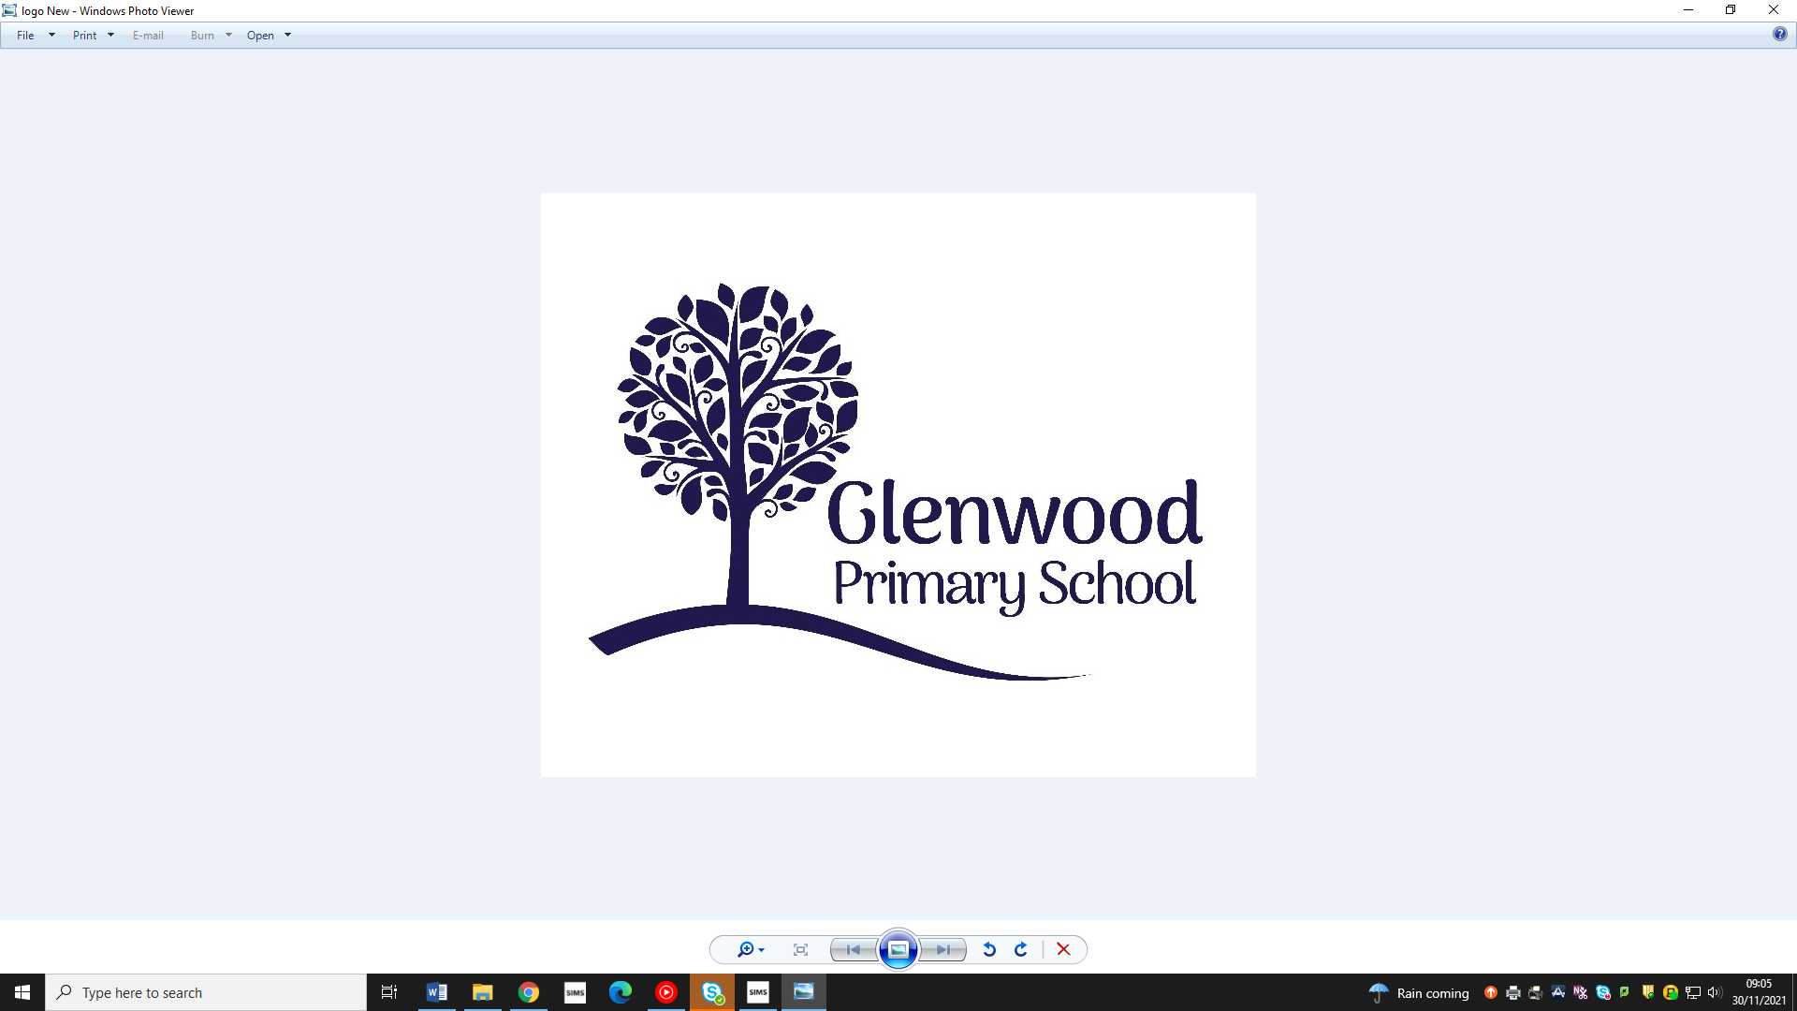

Glenwood Primary School
Policy for the Teaching & Learning of Children with ASD

‘Together we aim to develop confident, compassionate, and resilient learners who are equipped to thrive in an everchanging world’.

Policy update: | May 2025
Policy to be reviewed by: | May 2028
Signed by Principal: |  | Date:
Signed by Chair of Governors: |  | Date:

Ethos statement
Glenwood Primary School is a nurturing and enriching environment where we foster a culture of kindness, empathy and mutual respect. Together we build a safe and caring school where everyone belongs and thrives.
Vision
At Glenwood Primary School we are dedicated to fostering an empathetic and inclusive atmosphere where every student is valued, inspired, and challenged to achieve their fullest potential.

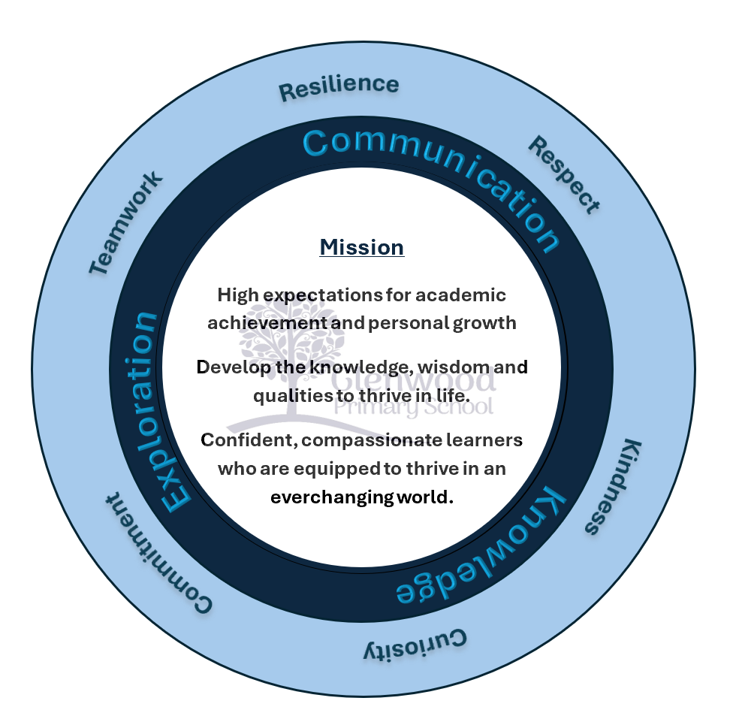

We help live our ethos and vision through the Glenwood Way
Move Calmly - Speak Nicely - Listen Carefully - Act Kindly - Do Your Best
Glenwood WISDOM qualities
TEAMWORK
RESILIENCE
RESPECT
KINDNESS
CURIOSITY
COMMITMENT

Introduction:
The purpose of this policy is to ensure inclusive, consistent practice throughout the school and all members of staff as well as outlining the expected practices in supporting pupils with ASD.
This policy includes:
- A Definition of Autism Spectrum Disorder (ASD)
- Our Underlying Values, Principles, Ethos
- Aims of ASD provision
- Our approach to teaching and Learning for ASD pupils
- Our School Environment
- Objectives

Throughout this Policy the term ‘autism’ will be used to refer to the range of terms across the spectrum including: Classic Autism, High-Functioning Autism, Asperger’s Syndrome and Autistic Spectrum Disorder/Autism Spectrum Disorders (ASD).

Autism Spectrum Disorder – Overview & Definition

Autistic Spectrum Disorder (ASD) is defined as a lifelong complex developmental disability that typically appears during the first three years of life and affects a person's social interaction, communication, interests and behaviour. It is a behaviourally defined disorder, with a restricted range of interests and often stereotyped repetitive behaviours and mannerisms.

The National Autistic Society define autism as:

“Autism is a lifelong, developmental disability that affects how a person communicates with and relates to other people, and how they experience the world around them.” (National Autistic Society, 2016, para.1)

Although it is a condition with wide-ranging degrees of severity, all those affected have a triad of impairments (Wing 1996) in:

- Social Interaction
- Social Communication
- Social Imagination & Flexible Thinking

In addition to this triad, repetitive behaviour patterns are a notable feature.

High Functioning Autism (HFA)
Due to autism being so wide ranging, this term is often used by professionals but is not officially found in the diagnostic criteria. It was used to describe people whose Social Communication, Social Interaction and Social Imagination is affected by autism, but whose IQ is within the normal range or are cognitively able.

Asperger Syndrome (AS)
Asperger Syndrome is a type of autism characterised by social and communication skill deficits, relatively normal language and cognitive development, and the presence of idiosyncratic interests. Individuals with AS often interpret things literally, they can appear socially awkward and have milder symptoms of autistic disorder. Often not understanding conventional social rules, people with AS appear to demonstrate a lack of empathy by making limited eye contact, appearing to be unengaged in a conversation and being confused by the use of gestures. Building and maintaining positive relationships can sometimes be difficult due to their difficulties in social communication and interaction.

Asperger Syndrome is typified by:
• Severe and sustained impairment in social interaction
• Restricted, repetitive patterns of behaviour, interests and activities
• Significant impairment in social, occupational or other aspects of functioning

It is vitally important to remember that these are general definitions and each child with autism will have varied and unique needs in relation to their Diagnosis. Children with Autism may have additional conditions/ diagnoses that need to be considered as part of our educational response. These may include:

- Moderate, Severe or Specific Learning difficulty
- Attention Deficit Hyperactivity Disorder
- Epilepsy
- Developmental Co-ordination Disorder
- Obsessive Compulsive Disorder

Although Autism is often characterised in terms of difficulties and challenges, it is essential to acknowledge and identify the skills, strengths and abilities that children with Autism have. It is stated in The Autism Toolbox: An Autism Resource for Scottish Schools (2009) that:

“Autism Spectrum Disorder (ASD) is part of the story of who the child is… as a person with a unique profile that includes their personality, strengths, challenges, likes and dislikes.” (Dunlop et al; 2009, p 29)

In Glenwood PS we acknowledge this and understand that every child with ASD will require bespoke and individual interventions to nurture these strengths and skills and support their learning and future development.

Underlying Values and Principles: from ‘Evaluating Provision for Autistic Spectrum
Disorder in Schools’ (DENI, 2005)

- Children and young people with autism are children and young people first.
- Children and young people with autism have a right of access to education services that best suit their needs.
- Learners with autism have a right to a programme designed to meet their unique needs and provide access to the curriculum of their peers.

AIMS:

Our ASD Aims are to:

- Provide a supportive and autistic friendly school environment that meets the needs of all pupils.
- Raise awareness of ASD throughout the school and ensure inclusive practice.
- Create an environment that supports independence and social & emotional wellbeing by developing learning, social, communication, play and behaviour competencies in children with ASD.
- Ensure collaborative working with parents and professionals.

OUR APPROACH & OBJECTIVES:

At Glenwood we provide a curriculum based on inclusivity, best practice, experience, innovation & research and our approach acknowledges the variety of strategies and interventions needed to support successful learning throughout a child’s education i.e. support within the mainstream class, small group settings and/ or 1:1 intervention or integration within the Autism Specific classes.

Our objectives are to:
- Create inclusive & co-operative learning opportunities, focussing on a wide range of experiences and shared interests & strengths.
- Provide an autism friendly environment, that is safe, nurturing & supportive of a child with Autism.
- Develop our knowledge and understanding of autism through comprehensive and on-going training programme.
- Develop each child’s potential through structured programmes, educational targets & intervention strategies and ensuring full access to the NI Curriculum.
- Ensure Support integration with peers at a level that is appropriate and meaningful to each child’s needs and ability.
- Develop working partnerships with families and external agencies to develop good links with parents and other support agencies.
- Ensure transitions are prepared and planned for.

Inclusion:
Every child within the ASD classes has the opportunity for inclusion in a variety of forms
- Mainstream inclusion with support where this is appropriate and relevant to the child’s learning and SEN. (Each child in the ASC will have a link class in the mainstream school)
- Reverse inclusion (where peers from their mainstream link class spend time with pupils from the ASD classes) where this is appropriate and relevant to the child’s learning and SEN.
- Daily through school assembles, play based learning sessions with link classes, break & Lunchtimes (where appropriate) in the hall, the nurture room and outside with the rest of the school and participation in whole school activities (where appropriate).

THE ASD ENVIRONMENT

‘The school maintains an appropriate environment designed to reflect the learning needs and support the social inclusion of children with an ASD’ (DENI, 2005 p 4).

‘Intervention should focus on the development of strategies which structure the environment to provide the child with a sense of security conducive to learning appropriate behaviours in a range of settings’ (DENI, 2002).

In Glenwood the school environment is designed to optimise, safety, security, learning and behaviour management for children with ASD. It consists of 4 fundamental components, the Sensory, Physical, Symbolic & Social Environment.

SENSORY ENVIRONMENT
‘Teachers and others should understand the sensory difficulties which children may experience as a consequence of ASD and set appropriate targets to address each child’s sensory needs’ (DENI, 2005)

This addresses the sensory and perceptual sensitivities of children with ASD. Sensory needs are identified and personalised support is given, this may be achieved through additional assistance, specialist equipment, agreed sensory strategies and implementation of outside agency recommendations. Flexible use of space, lighting, specific areas to fulfil sensory needs or offer respite (e.g. sensory rooms & equipment)

PHYSICAL AND SYMBOLIC ENVIRONMENT
The class layout and structure is designed to minimise overload and over stimulation with clearly defined areas for activities such as group work, play/ leisure and transition. The ASC classrooms, in particular, will be low distraction and clutter free with minimalist, eyelevel noticeboards and displays. Visual schedules will be displayed on the walls as well as desktops (where appropriate) and will vary in complexity and detail depending on the child’s age. Individual workstations will be available for children who need them with easily accessible materials, visual schedules/ guidance and communication systems. ASC teachers will be trained in PECs for children who require specialist visual and communication strategies.

SOCIAL ENVIRONMENT
Opportunities for the development of communication and social interaction skills will be built into the school day and created through play-based learning activities, sensory play and co-operative activities and, in the case of the ASC’s & LSC’s re-integration with link classes. The focus is on social communication, helping children become competent, confident and active participants in a social world by providing visual and sensory strategies to support the child’s capacity for self-monitor and self- regulate.

APPROACHES TO TEACHING AND LEARNING- Creating an ASD Friendly School

In Glenwood we use a variety of approaches within our ASD/ Social Communication curriculum, and we use a combination of evidence-based strategies and interventions. Specific strategies are used to reduce anxiety, promote feelings of well-being and to modify unwanted behaviours and promote more appropriate ones.

Structured Teaching- To maximise the cognitive strengths of each child staff:
- make use of each child’s response to structure and routine
- provide for a range of structures and systems in accordance with individual needs
- recognise that some children with ASD require additional or alternative strategies (e.g. auditory strategies).

Physical Structure- This includes provision for:
- Clearly defined areas for activities including group work, play/leisure, and transition.
- Daily activities which are consistently associated with specific areas of the room.
- Utilisation of materials and furniture so that boundaries are clear.
- Individual workstations for children who need them
- Materials, schedules and communication systems which are easily accessible to the children.

Work Systems- This includes provision for:
- Work areas which are designed and individually tailored to help children complete tasks independently.
- Systems that communicate the following information to the child:
  - ‘what do I have to do?’
  - ‘how much do I do?’
  - ‘what do I do when finished?’
  - ‘what happens next?’

Visual Schedules
- For many children schedules will be used to help overcome difficulties in planning and organisation.
- The schedule visually tells the children what activities will occur and in what sequence.
- The schedules will vary in complexity and detail depending on the child’s age, ability and need.
- Typically a schedule may be represented by one of the following:
– Object/Object sequence
– Line drawing and word on strip
– Checklists (picture & word or word only)
– Reference only daily timetable
– Weekly timetable
– Written Schedule
* For children who are unable to follow a visual schedule, an option which is more appropriate to the individual child’s learning will be consider (e.g. choice board, single symbol approach)

Dealing with Change
- Preparing children for the possibility of change, as well as the procedures that will be followed when change occurs, are important components in the physical classroom design.
- Change and transition throughout the day are seen as an integral part of each child’s daily schedule (e.g. using a visual cue to highlight change).

Staff-Pupil Ratio- The school will ensure appropriate levels of staffing to meet the needs of each child, where:
- Staffing will depend on the needs of individual children
- Teaching will include direct one-on-one as well as small group working arrangements
- Efforts will be made to avoid the possibility of a child becoming overly prompt-dependent and ensure greater opportunities for independent learning and development of problem-solving skills.

Classroom Assistants
The classroom assistants make a very valuable contribution to the ASD classroom team. They implement all teaching methods under the direction of the teacher. They carry out the following activities:
- Group/1:1 work
- Facilitating integration in the playground
- Take charge of play activities
- Help to create the necessary resources and plans
- Implement behaviour management plans
- Assist with the review of the pupil’s progress
- Carry out any other activities at the discretion of the teacher and as the needs arise.

Staff Training
‘The staff of the school demonstrates an appropriate understanding of ASD and have sufficient expertise to meet the needs of children with an ASD’ (DENI, 2005 p7).

Glenwood is committed to ensuring that staff take up appropriate and relevant training in relation to understanding and meeting the needs of children with ASD. All staff members will undertake an online introduction to Autism via Tier 1 & 2 ASD Awareness Training during their induction. Supplementary to this, Glenwood School offers continuing CPD to all staff during their employment including in-house and external opportunities. A record of training in held by relevant Coordinators etc. and staff maintain their own records of CPD. Core competencies will be developed through the following:
- INSET
- Whole school training
- Specific training via:
- Children & Young Peoples’ Services
- STRIVE NI SBEW
- RISE NI
- Health Service
- SSSST – SEN Specialist Setting Support Team (TEACCH, PECS etc.)
- Reading and Research
- PRSD (teachers)
- Cluster group meetings (ASD)
- Training and advice sought from Middletown Autism Centre and the Autism Advisory Service AAIS

ASSESMENT & MONITORING ARRANGEMENTS

‘The needs of the child with ASD should be comprehensively and systematically assessed so that teaching can be matched to their needs’ (DENI, 2005 p10).
‘The learning strengths and weaknesses of children and young people should be identified to
ensure effective differentiation of provision’ (DENI, 2002)

Procedures for assessing, recording and reviewing progress are discussed and agreed upon by staff. Assessment and Monitoring will be dependent on the individual pupil’s capacity for engagement and will take a variety of forms:
These include:
- Initial observations
- Observations over time
- Direct measurement, standardised assessments etc
- Data collection (e.g. from behaviour charts)
- Qualitative data (e.g. interview, ratings, logs, samples of work, photographic/video records).

*At any time staff may consult with the Autism Advisory and Intervention Service in requesting Teacher advice or putting appropriate autism-specific assessment procedures in place e.g. PEP-3.

Teachers keep a record of class assessments, observations etc. and data is also stored centrally on the SIMs system. The progress of children with ASD is monitored and evaluated across 7 main areas of autism*. These relate closely to autism ‘differences’ as described within literature, and the impact of these on the pupil’s social, emotional and learning needs, their independence and community participation:
• Social Communication
• Social Interaction
• Social Imagination / Flexibility
• Sensory processing
• Emotional understanding and self-awareness
• Learning
• Independence and community participation.

IEP/PLP/ BSP
- Staff use the information from assessments to inform each child’s Education Plan (EP) which is the main assessment and monitoring tool.
- The Education Plan (EP) is the basis for developing an inventory of a child’s skills, difficulties and individual learning style. The Education Plan assists the teaching process, choice of methods and monitoring arrangements.
- Where necessary, Behaviour support plans are in place; Behaviour support plans aim to incorporate the child’s special interests and individual communication skills and needs. These are reviewed and updated biannually, with parental input, and link in with the whole school behaviour policy. A ‘home/school’ diary is also used to share information and maintain good communication with home.

THE CURRICULUM

‘The organisation of the curriculum is sufficiently flexible to meet the needs of children with autism’ (DENI, 2005)

Access to the curriculum is provided through strategically designed intervention programmes that are differentiated and tailored to the individual needs and strengths of the child. These are adapted to account for age and level of development with additional support (Outreach, Counselling etc.) sought to supplement this. The emphasis is placed on further developing the 7 main areas of Autism*

‘Social skills training should be provided as an essential element of intervention programmes for children and young people with ASD’ (DENI, 2002)

‘Intervention programmes should address the issues of anxiety and stress as a normal consequence of ASD’ (DENI, 2002)

The school adopts a combined skills approach, including the use of behavioural, communicative, social-learning and interactive based strategies as no single method will effectively address the myriad of impairments associated with ASD. (Advice can also be sought from the Autism Advisory & Intervention Service and Middletown Autism Centre to enhance provisions for These may include:

- Structured teaching taken from the TEACCH Model
- SCERTs approach - Social Communication, Emotional Regulation & Transactional Support
- Sensory Play and awareness
- Counselling Therapy
- Visual Communication systems -PECs
- Speech Therapy - community
- Occupational therapy - community
- Social Learning Approaches – social stories
- ICT

- TEACCH- Treatment & Education of Autistic and related Communication Handicapped Children

The values:
Teaching – sharing autism knowledge and increasing the skill level of professionals and practitioners.
Expanding – increasing own knowledge to provide high-quality services to autistic people & their
families.
Appreciating – appreciating the strengths and uniqueness of autistic culture.
Collaborating and cooperating with colleagues, other professionals, autistic people and their families.
Holistic – adopting a holistic approach, looking at the person, their family and community.

The Priorities:
- The focus is on the child, their needs and special interests
- Understanding the ‘culture’ of Autism. Identifying differences through individual assessments.
- Using visual structures/ cues to organise the teaching environment and tasks
- Broad basis – supporting social communication and leisure skills as well as learning
- Being flexible & teaching flexibility

- SCERTs – Social Communication (SC), Emotional Regulation (ER) and Transactional Support (TS)

An educational approach for working with children with ASD. It is designed to enable families, educators & therapists to work cooperatively and consistently to maximise progress. It focuses on building competence in social communication, emotional regulation and transactional support; Improving pupil confidence and preventing behavioural difficulties that could interfere with learning and the development of relationships.

The core domains are:
Social Communication: Goals to help the child be a competent, confident and active participant in a social world.
Emotional Regulation: The capacity to self-monitor levels of physical arousal and emotional states in terms of Self-
Regulation and Mutual Regulation.
Transactional Support: This includes the adjustments made to the environment to foster positive learning
outcomes.

- Sensory Play & Awareness – a developmentally based approach using play to establish relationships through spontaneous communication, mutual engagement and enjoyment. It is child-focused recognising sensory play as a necessity for learning, communication and engagement.

- Counselling Therapy – a variety of therapeutic supports; Art, Play & Talking therapies support social development, self-awareness and help manage the mental health difficulties that can be associated with autism i.e. anxiety & depression.

- Visual Communication Systems – Visual timetables, schedules and cue cards; First/Then, Now/Next, Choice and change boards, key rings, countdown strips, Helping hand, Pec’s etc. all support transitioning and help reduce child’s anxiety levels.

- Speech Therapy – Speech therapy can address the wide range of communication challenges children with autism face. It can help children develop their functional and spontaneous communication, social & play skills and improve peer & adult interactions therefore enhancing the ability to form relationships and function in daily life.

- Occupational Therapy – Movement breaks with proprioceptive activities are used to help address sensory seeking behaviours, especially in terms of movement. Proprioceptive input is the performance of tasks that involves heavy resistance and input to the muscles and joints and is essential in helping our bodies assimilate and process both movement (vestibular) and touch (tactile) information. It helps increase attention and modulate arousal.

- Social Learning approaches - Social Stories and Comic Strip Conversations. These support the child’s understanding of new and/ or difficult situations. It assists in preparing the child for transitions and written in the child’s own language with illustrations, allows them perspective and insight into situations they encounter.

- Use of ICT – This can be an integral Teaching & Learning tool to support children with Autism. It can be used to access the curriculum, support understanding of language through visual support, facilitate organisation and promote independent learning. It can be used to engage the child, capture attention and enhance the interactive nature of activities.

Each pupil at Glenwood PS has access to a broad and balanced curriculum, however, to ensure we meet the needs of all learners this is carefully differentiated and considers the unique aspects of the child’s behaviour and learning needs. We achieve this by identifying each pupil’s sensory, learning, communication and behaviour profiles and use this to plan and deliver effective education in the classroom.

INCLUSION

The school has a clear understanding of what it means to be an inclusive school and is committed to ensuring this. We aim to:

- Have a clear vision and ethos of inclusion, led by school managers who are willing to adjust the cultures, policies and practices of the school to build its capacity to embrace and respond to the diversity of its students.
- seek to identify and remove barriers to access and participation for all students.
- challenge attitudes and behaviour which may lead to social isolation of students.
- ensure training needs are met to provide a cohesive and consistent approach across the whole school.
- Ensure each child is included in the life of the school. It is particularly imperative that the ASC and LSC classrooms are an integral part of the whole school, and a robust integration plan* is in place to ensure there are planned and focused opportunities for collaborative learning and play within peer groups. (*See SEN & Inclusion Policy).

PARENTAL INVOLVEMENT

The school seeks to ensure that parents are kept fully informed of progress, changes in SEN needs etc. and have a fundamental role in the learning and teaching of their child. It is essential Parents are:

‘confident and supportive of the school’s effectiveness on their child’s behalf’ (DENI, 2005).

Parental participation is sought via:
- Direct consultation (e.g. for initial information, specific concerns, support implementation, Parent-Teacher meetings, Annual reviews, PEP Assessment feedback & reviews.
- A home-school diary, seesaw & dojo apps
- Telephone contact/ School text messaging service.
- School events

REVIEW

This Policy will be reviewed on a 3 year cycle and updated with reference to new legislation and current research.

