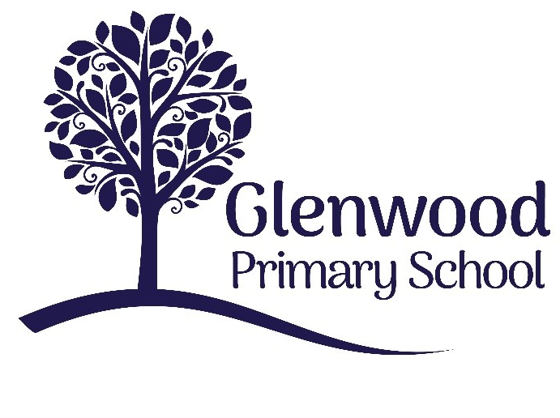

Glenwood Primary School
Assessment Policy

‘Together we aim to develop confident, compassionate, and resilient learners who are equipped to thrive in an everchanging world’.

Policy update: | Apr 2025
Policy to be reviewed by: | Apr 2028
Signed by Principal: |  | Date:
Signed by Chair of Governors: |  | Date:

Ethos statement
Glenwood Primary School is a nurturing and enriching environment where we foster a culture of kindness, empathy and mutual respect. Together we build a safe and caring school where everyone belongs and thrives.

Vision
At Glenwood Primary School we are dedicated to fostering an empathetic and inclusive atmosphere where every student is valued, inspired, and challenged to achieve their fullest potential.
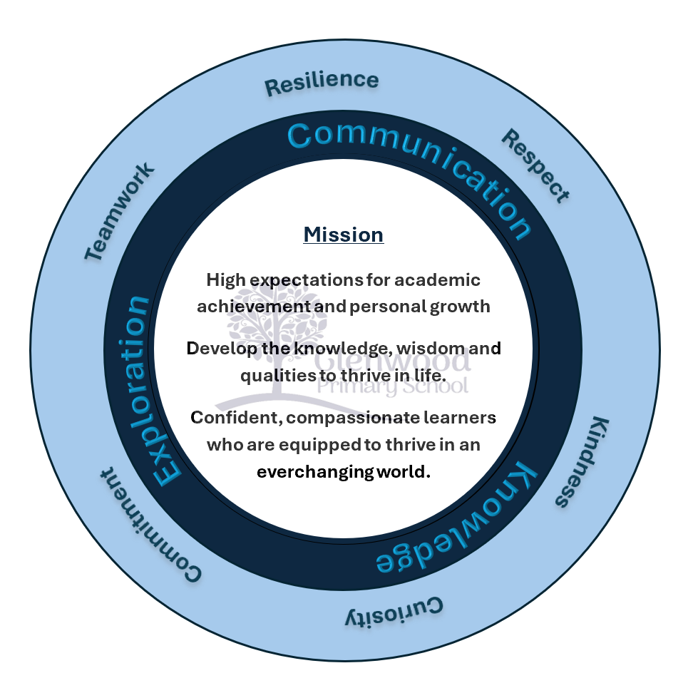

We help live our ethos and vision through the Glenwood Way
Move Calmly - Speak Nicely - Listen Carefully - Act Kindly - Do Your Best
Glenwood WISDOM qualities
TEAMWORK
RESILIENCE
RESPECT
KINDNESS
CURIOSITY
COMMITMENT

Glenwood Primary School - Assessment Policy

At Glenwood Primary School our children have a wide range of abilities, preferred learning styles, experiences, personalities and interests.
Glenwood Primary School is a Rights Respecting School. Article 28 of the UNCRC states that all children have the Right to an Education, and the school believes that thorough and timely assessment of pupil progress is vital to this right being met.
Through a broad and balanced curriculum, our pupils participate in a progression of learning experiences that are carefully structured to suit their needs. Assessment is an integral part of this learning and teaching process. Continuous monitoring of each child’s progress gives a clear picture of each child’s needs, achievements and abilities – enabling planning and delivery to be more effective, thereby raising attainment for every child. The outcomes of assessments will help children to become involved in raising their own expectations, celebrating their own achievements and increasing their self-motivation.
The aim of this policy is to give a clear outline of assessment including all the important dimensions within it (recording, target setting, pupil progress, tracking and reporting techniques) that are used in Glenwood Primary School and to ensure that assessment as a whole is used as a tool to inform planning, to track pupil progress and to raise standards.
Aims of Assessment
Good assessment practice in our school aims to:
- Guide and support the teacher as planner, provider and evaluator;
- Draw upon as wide a range of evidence as possible using a variety of assessment activities;
- Evaluate children’s levels of understanding, confirm judgements and help to identify strengths and weaknesses for individual;
- Enable the teacher to adjust teaching, to take account of assessment information and to focus on how pupils learn;
- Provide each child, the teacher and parents with an indication of achievement and progress in relation to ability;
- Provide information which can be used by parents or carers to understand their pupils’ strengths, areas for focus or improvement and progress;
- Provide information on which to base future curriculum planning and resource decisions;
- Raise standards of attainment and behaviour, and improve pupil attitudes and responses;
- Enable the active involvement of pupils in their own learning by providing effective feedback which closes the gap between present performance and future standards required;
- Promote pupil self-esteem through a shared understanding of the learning processes and the routes to improvement;
- Track pupil performance and in particular identify those pupils at risk of underachievement and/or with special educational needs at both ends of the ability spectrum;
- Provide information which can be used by teachers, the principal and SENCO as they plan for individual pupils and cohorts;
- Provide information which can be used to evaluate Glenwood Primary School’s performance against its own previous attainment over time and against Northern Ireland standards;
- Provide information which can be used by other interested parties;
- Fulfil statutory requirements relating to assessment
Purposes
Diagnostic:
To identify strengths and areas for improvement and to inform next steps.
Formative:
To use assessment information to make specific improvements in learning.
Summative:
To acknowledge, record and report pupil’s overall performance and achievement at a point in time. Evaluative To inform curricular planning and provide information for monitoring and accountability.

Principles
Assessment should:
1. Be complementary to and supportive of, the key aims of the NI Curriculum
2. Be fit for purpose
3. Be manageable
4. Be supported by teacher professional judgements that are consistent and reliable
5. Be appropriate for all levels of system wide accountability
Two distinct types of assessment are identified and used in our school. These are:
Assessment for Learning and Assessment of Learning.

Assessment for Learning (AfL)
Assessment for learning helps to identify the next steps needed to make progress. It takes account of pupils’ strengths as well as weaknesses. Assessment for learning essentially promotes future learning.
“Assessment for learning is the process of seeking and interpreting evidence for use by learners and their teachers to decide where the learners are in their learning, where they need to go and how best to get there.” (Primary Framework, 2007)
In Glenwood Primary School, assessment for learning strategies are employed on a daily basis in every classroom to enhance learning for the pupils.

Assessment for Learning
- Often called formative assessment
- Takes place during the learning
- Makes pupils active participants in their learning and focuses on next steps in learning
- Feeds forward to manage improvements
- Fosters responsibility for & ownership of learning
- Establishes where they are, where they need to go and how to get there
Purposes
Assessment for learning will:
Within the classroom
- Provide insight into pupils’ learning for both pupils and teachers
- Promote success for all
- Support the target-setting process
- Enable continuous reflection on what pupils know now and what they need to know next
- Measure what is valued
- Promote immediate intervention and link judgements to learning intentions
- Raise standards by taking pupils to the edges of their capability

Within the Classroom
Implications for teaching
The teacher will:
- Explain to pupils what they are about to learn and why (IALT)
- Explain how to be successful at attaining the new learning via the sharing of success criteria & teacher feedback. The teacher will provide continuous oral and written feedback which identifies strengths and the next step for improvement
- Teach pupils how to understand quality criteria and use them to self-assess
- Promote pupil involvement in self-assessment and peer assessment
- Act on insights gained to inform curricular targets
- Plan against what children know/can do/understand
- Make standards and objectives explicit to pupils
- Promote inclusion by attending to all pupils’ learning needs, particularly for pupils who are at risk of underachievement
- Demonstrate to pupils how to ask, as well as answer, better questions to deepen their own learning. Use of questioning skills by teacher and pupils and allow ‘wait’ time (time to think)
- Build in time for focused observation of teacher-directed and child-initiated activities
- Be more focused on pupils’ learning
- Be more concerned with the learning than activity or performance
- Be more reflective about their own practice
- Pass more control to pupils

Impact on learning and the learner
The pupil will:
- Know what to do to improve
- Know what standards are required
- Know what has been achieved against known success criteria and what to do next
- Gain confidence, perseverance, motivation, independence and self-esteem as a learner
- Increase their awareness and understanding of their own learning style(s) and of how they learn best Improve their own self-evaluation skills
- Improve in progress and attainment

Assessment for Learning – Practices
Learning Intentions
Learning intentions (IALT) are always verbally shared with pupils. When appropriate, pupils may be asked to record IALT in their books. On occasions IALT may be stuck in instead. This is dependent on the age/ability of the children and the structure/format of the lesson.
Effective Questioning
Rowe (1974) found that teachers leave a very short time before answering an unanswered question. A range of strategies can be used here such as no hands up, talking partners. It is important that questions asked are of a good quality to encourage deep thinking. Teachers need to frame questions properly and also encourage children to come up with their own questions, both closed and open ended.
Self and Peer Evaluation, Feedback and Marking
Missions and the success criteria for meeting those objectives are displayed in the classroom as a point of reference for self/peer assessment. Children will also be given pieces of work written by other children to help them discuss and compare quality. Use of traffic lights or a similar process will also help self-evaluation.
The feedback children receive about their learning from their teacher has a significant impact upon their progress. Being too general or giving broad targets is not helpful. Giving specific feedback helps children to understand how they can improve. Marking should always be meaningful, informative and positive, providing an indication of a child’s achievement for both pupil and parent. Teachers’ professional judgements of children’s abilities, based on informal observations and on formal methods will be an important source of evidence in the monitoring process.

Assessment of Learning (AoL)
Assessment of learning is more associated with judgements based on scores or levels for statutory or summative purposes. Assessment of learning describes and labels past learning.
- Often called summative assessment
- Takes place after the learning
- Focuses on pupils’ achievements
- Is used to provide feedback to parents based on performance evidence
Purposes
Assessment of learning will:
- Provide a summary judgement about what has been learned at a specific point in time
- Establish benchmarks about what children can do and about school performance
- Show what pupils can do without support
- Inform the target setting process
- Promote subsequent intervention(s)

Implications for teaching
The teacher will in progress meetings:
- Provide a periodic summary through teacher assessment and tests
- Identify gaps in pupils’ knowledge and understanding
- Identify weaknesses in the taught curriculum and in specific areas of learning through analysis of performance which guide future planning
- Implement strategies to accelerate progress to meet expectations (narrowing the gap)
- Mark and measure against scores and levels

Impact on learning and the learner
The pupil will:
- Be able to gauge own performance in comparison to others and against previous performance
- Be able to measure own performance against externally agreed criteria and standard
- Have a measure of performance at specific milestones in life
- Know what standards and expectations are required

Assessment of Learning - Summative Assessment Arrangements
Summative assessments are also used to help us to decide what a child can do at a particular time. These assessments are given periodically during the school year. Results of summative assessments should be used to assist teachers with setting criteria and target setting and thereby engage the children in the learning process creating clear expectations. Analysis of standardised tests should also be used as an essential part of pupil progress tracking – to inform future planning for classes, groups and individuals. It can also provide essential information for identification of Special Educational Needs.
This is done through:
- School based assessment for specific tasks – at the end of a topic or after teaching a specific skill or concept
- Weekly assessments/monthly/termly assessments
- Standardised tests
- Annual report to parents in the summer term
In the use of formative and summative assessments, teachers must ensure a balance so that a clear picture of each pupil’s abilities and needs can be established. This information will be used to inform planning and individual / group / class target settings. The information should also be used to engage the pupils in the learning process and move their learning forward.

Using Assessment Outcomes to Inform Next Steps in Planning
At Classroom Level:
1. What level are my pupils now?
2. Where do they need to be next (With appropriate level of challenge)?
3. What are the best strategies to help pupils reach the next steps in their learning?
At Coordinator Level:
- How is my area of responsibility performing compared with recent 3 year trends?
- How is my area of responsibility performing compared with other curriculum areas?
- What are the priorities for improving provision within my area of responsibility?

At Whole School Level:
1. How is our school performing, compared with recent 3 year trends?
2. How is our school performing compared with other schools in similar circumstances?
3. What are our whole school priorities for improving pupil outcomes, especially in Literacy and Numeracy?

Overview of Assessment in the Foundation Stage

Baseline Assessment
Baseline Assessment is no longer a statutory element of the Foundation Stage but our Foundation Stage teachers have taken the best practice from this assessment and use in-school created Baseline Assessment in September each year. It also assists teachers in the establishment of good relations between teacher, child and parents. The main purposes of this assessment are to:
- Identify the children’s strengths and individual learning needs
- Enable programmes of learning to be planned which will meet the children’s needs
- Provide information that will inform parents about their child’s skills and competences on entry to school
P1 begins with an initial meeting with the parents in early September so that parents can provide information about their child. At this meeting parents are encouraged to share information which will assist the teacher in getting to know their child. It is also an opportunity for parents to share any concerns or medical information which is crucial to the child’s health and safety in school.
Children are allowed a settling in period before formal observations and assessments are made by the class teacher and classroom assistant. These assessments are made by observing the children in spontaneous as well as planned classroom activities and in other everyday school situations. Children are observed as they work on their own, play, participate in group situations and relate to adults. Observations and records are kept of children’s skills and competences.
Baseline Assessment observations are collated and a comment recorded. These are shared and discussed with the parents at a second interview around half term. They are also used as a means to plan effective teaching and learning opportunities for the individual needs within a P1 class.
It is important to view learning, teaching and assessment as a continuous cycle, where assessment is not the end point but should feed back into the process to help to improve learning. Since the purpose of teaching and the main purpose of assessment is to help children to learn, teaching and assessment need to be planned together as complementary aspects of the one activity. In turn, the information obtained from assessments should be used to inform the planning process.
During P1 and P2, on-going assessment will be based mainly on teacher observation which will inform the learning programme for each child. Observations are a natural and essential part of good practice for teachers and classroom assistants. Well-planned, regular and skilful observations help teachers gain information about children's progress over time which ensures that all children's needs are being met.
Observation In Play
Play Based Learning is a fundamental element of the Foundation Stage curriculum. On a daily basis, children are given the opportunity to engage in a wide range of practical and exploratory experiences to promote learning in all of the Learning Areas. We value the importance of observing the children during Play Based Learning experiences and through our observations we aim to build an overall picture of each individual child. These regular observations provide us with information on all aspects of the child’s development from social, emotional, physical and intellectual. Observations are used to evaluate, review and shape future planning. Children are observed in different situations including playing as individuals, in pairs or in groups.
Why we assess through play?
- It is a natural means of expression for most children
- It provides a natural and appealing setting for learning
- It allows children to experience a wide number of emotions and situations
- It is child initiated and is a child maintained activity
- It is a key tool for learning as it is natural to children
- It is flexible and should not be intrusive to the child’s pre-school experience
- It helps adults to understand how children approach tasks thereby offering ways of improving their learning
A variety of methods of recording is used according to the teaching style and needs of each class. Observation notes will be made and may be focused, spontaneous or daily. These are recorded for each child under each Area of Learning. This information is used to inform future planning for whole class, groups and individual needs.
Observations are also made and recorded as necessary throughout the day during other areas of the curriculum and during informal social interactions. All observations assist in building a bigger picture of individual children.

Observations in Literacy and Numeracy
In addition to the observation that takes place in play based learning, further observations are carried out in literacy and numeracy to assess progress. In literacy, running records in reading take place.

Testing in the Foundation Stage
Prior to the 2024-2025 academic year, staff used the COMET programme to assess progress in literacy to target appropriate support. From autumn 2025, Foundation Stage staff are using the Talk Boost programme to assess pupil progress in literacy and numeracy. This programme identifies pupils who require extra support. This is delivered by trained withdrawal staff/teachers/classroom assistants over several weeks. The programme provides staff with standardised scores for pupils.
In the Foundation Stage, tests may also be used to consolidate observations made. e.g. phonics tests, simple spelling tests may be used as well as some standardised tests.

Overview to Assessment in Key Stages 1 & 2

Tests/ Assessment:
Periodic assessments are used to monitor children’s progress and to identify strengths and weaknesses in curriculum delivery. Such assessments include weekly spelling, table and numeracy facts tests and occasional end of topic tests. Formal examinations, encompassing core curricular areas, are also undertaken when and where necessary.

Using ICT:
Glenwood Primary School also maintains a Pupil Portfolio for ICT. Teachers in every year group assess and level the children’s knowledge, skills and understanding within the cross-curricular strand of Using ICT (UICT).

Standardised Tests – Key Stages 1 & 2

Evidence is gathered and analysed from the results of the PTE/PTMs standardised tests in the core curricular areas of Literacy and Numeracy for P3-P7 pupils and using CAT4 and GL assessment. These tests are administered in May of each year. The school uses paper copies of the PTE/PTM assessments. All other GL tests are administered electronically. Testing enables teachers to monitor children’s individual progress and identify specific strengths and weaknesses and so plan for future teaching and learning. This evidence may also be used to provide information about the work of a particular pupil in order to ensure that sufficiently challenging goals are set or, conversely, to indicate that the pupil may require additional support by being placed on the Special Needs Register or targeted for underachievement. A PASS test is also carried out biannually for P2-P7 children to assess attitudes to self and school that may assist teachers in planning for nurture provision or pastoral support where required.
Children from P3-P7 also take part in a reading test as part of the GL Suite of Assessments (NGRT).
All data is centrally stored in SIMS (Schools information and Management System).

Records and Record Keeping

Records need to be relevant and record keeping needs to be ongoing, manageable and useful.

At Glenwood Primary School, the purpose of recording is to:

- Help teachers use records to monitor pupils’ progress – many of these will be shared with the children to motivate and celebrate achievement
- Recognise achievement, note strengths and areas of focus and development
- Aid memory
- Document evidence
- Inform planning and set appropriate targets for the future
- Form a basis for reporting to children, parents, other schools, area board and DENI
- Provide a summary for discussion and inform verbal and written reports

At Glenwood Primary School, we record:

- Children’s progress in Literacy and Numeracy
- Children’s progress in other areas of the curriculum – class/topic tests, samples of children’s work
- Strengths and areas for focus and development
- Individual needs identified through assessments to inform teachers about the help and support needed, identification of special needs or setting individual programmes of work
Curriculum Records
Results from standardised tests are recorded onto class progress grids and these are also recorded onto SIMS in June. This information may also be used by teachers when considering differentiation and other aspects of planning. All assessment information is carefully monitored by the principal, vice-principal, SENCO, assessment coordinator and literacy/numeracy coordinators.
Target Setting, Tracking Progress & Bench Marking
Target setting fits into the annual cycle of school review, planning and action. Specific developments in target setting for Literacy and Numeracy are found in the School Development Plan and in coordinators’ action plans.
Throughout the process of identifying targets we try to be objective and evaluate the performance of Glenwood Primary School in comparison to the performances of schools in a similar context of ourselves.
Tracking is used to identify patterns of progress of different children as they pass through the school. The evidence from formal assessment scores, class assessments, withdrawal data and teacher professional judgements are analysed to monitor children’s expected progress. This data is used to identify patterns in progress throughout the school. Performance of those children identified as underachieving is monitored.
During each school year the following cycle takes place:
- PTE/PTM assessments take place in May. Paper copies are posted to GL to be marked. Once scores are returned, the assessment coordinator completes progress grids comparing PTE/PTM against CAT scores to identify those children who are progressing as expected, are underachieving or are progressing better than expected.
- Assessment twilight takes place in June. Staff receive results and complete a rationale for those children deemed to be underachieving. Year groups provide a rationale for those questions identified as being the poorest answered by the assessment coordinator in relation to the Northern Ireland average. Staff complete the Horsforth Quadrant for their class
- In August, staff identify those pupils who would benefit most for withdrawal using combination of data and professional judgement. Assessment coordinator to work alongside withdrawal staff to finalise children who will receive internal support. These pupils are reviewed throughout the year and may change depending on progress made. Targets are set for these pupils.
- Staff use PTE/PTM reports to identify areas of development for individual pupils and their class. These areas are highlighted in medium-term planning.
- Assessment twilight in winter term – staff update data grids and compete Horsforth Quadrant for their class.

Reporting
Assessment scores are recorded on SIMS and the relevant members of staff have access to them. Progress grids are stored electronically on the school intranet and can be accessed by class teachers.
Reporting not only fulfils legal requirements but is also an important part of the school’s relationship with parents and the wider community. Reporting is a whole school process and all staff work to communicate with relevant audiences serving to support and promote children’s learning.
Reporting to pupils on children’s attainment is by means of:
- Teacher comment on class work, both oral and written
- Individual reward schemes
Reporting to Parents
- Governors’ Annual Report to parents
- Parent / teacher meetings for parents twice per year to discuss their child’s progress with the class teacher and discuss targets (Oct and Feb)
- Annual Reviews for children on SEN register
- Comments on written work, including homework
- Annual Pupil Report to parents on their child’s achievements with a further opportunity to discuss the contents
- Meet with parents to discuss targets and review of PLPs
- Discussion with parents is facilitated by an effective home/school liaison link (via Seesaw/ClassDojo, where every effort is made to accommodate parents’ requests for meetings with staff at the earliest opportunity
Reporting to Governors
- The assessment coordinator/principal will report to the Governors on matters relating to assessment
- Subject coordinators will refer to assessment data when reporting to Governors on their action plan targets
Reporting to secondary schools on children’s attainment is by means of:
- Suppling secondary schools with a copy of children’s reports
- Assessment data will be supplied and discussed by P7 staff during transition/handover meetings

Reporting to Outside Agencies
- Where appropriate, staff may be asked to report about the achievement of certain pupils to outside agencies such as reviews, case conferences and other such private matters when requested by the principal
- The children’s achievements and events and items of interest may be reported on the school’s web site, on social media and occasionally in the local press. Photographs are only used with parental permission.

Roles and Responsibilities
In order for this policy to be effective all teaching staff must demonstrate corporate ownership of the policy. This will be demonstrated as follows:
- Pupil assessment is the responsibility of the class teacher
- The assessment co-ordinator, SENCO, subject coordinators and the principal will support each teacher
- Each teacher should ensure that they make proper provision for appropriate recording and for the effective monitoring of each pupil’s progress
- Each teacher should familiarise themselves with the school marking policy and ensure that it is applied consistently
- Each teacher should retain a copy of this document and should familiarise themselves with this policy and specific procedures in each subject policy
- The Principal and the assessment coordinator will have overall responsibility for assessment throughout the school
Role of the assessment co-ordinator
- Formulate the school’s assessment policy
- Review the policy regularly in the light of statutory requirements and the needs of the school
- Provide support and guidance with assessment and keep up to date with current developments in assessment as laid down by CCEA and disseminate these to the staff
- Assist withdrawal staff and subject coordinators in target setting
- Report to Governors on assessment progress and targets
- Resource the school and staff with relevant assessment materials, including order paper copies of PTE/PTM tests and generating assessment codes for those tests completed online
- Organise the recording of relevant data into class assessment grids and to record assessment data on SIMS
- Analyse results to identify attainment and progress made by pupils
- Monitor and evaluate with subject co-ordinators and head of key stages
- Highlight pupils who have made no progress or are working below expectations

Internal Consistency
In Glenwood Primary School, priority will be given to achieving internal consistency (focus on Using Communication, Using Mathematics and Using ICT) in a number of ways:
- Where appropriate and where possible the school’s marking policy will be implemented, thus achieving a standardised marking system which is known to all staff (including Assessment for Learning feedback & scaffolding comments)
- Through induction, internal training initiatives and internal moderation, staff will develop a common understanding of assessment objectives, processes and levels
- The relevant subject leaders will review and monitor samples of work and provide comment and recommendation in relation to content, style, quality, presentation and marking practice throughout the school.
- Through the use of standardised tests

Continuous Monitoring
Assessment must be seen as a continuous process and must incorporate a variety of strategies. It must be a regular feature. At times it will be planned and formal and at times it will be unplanned and informal. In addition to standardised tests and ongoing check-ups, teachers will also make focused and incidental observations. Importance will be placed on evaluating a pupil’s performance in the context of normal classroom activities and in practical situations e.g. structured play, group discussions, topic work, art, drama, PE lessons etc.

Equal Opportunities and Special Needs
It is policy in Glenwood Primary School and indeed the responsibility of all staff to ensure that all pupils, irrespective of gender, ability (including gifted pupils), ethnicity and social circumstances have access to the curriculum and achieve the best progress possible. All pupils, including those in the SPIM classes, will complete standardised tests, unless the professional judgement of the class teacher, assessment coordinator and SENCO decide otherwise.
Procedures which are specifically designed to access and identify special needs as well as teaching arrangements are outlined in the Special Educational Needs Policy.

Reviewing the Policy
In the interests of continuous improvement, in order to evaluate its effectiveness, and to incorporate additional guidance and requirements, it is imperative that this policy is reviewed regularly.

