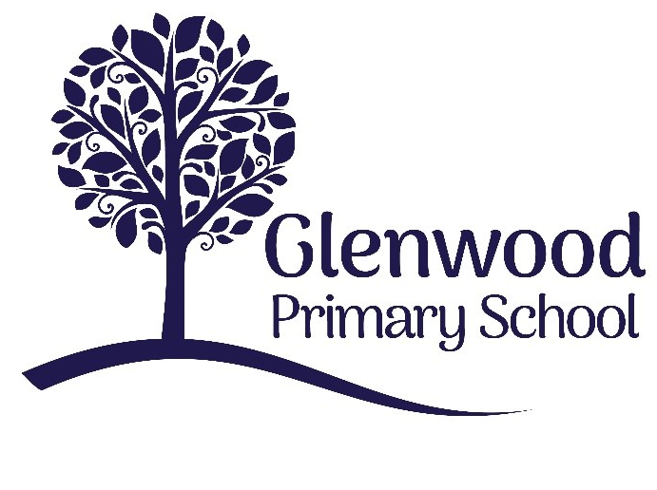

Glenwood Primary School
Child Protection Records Management Policy

‘Together we aim to develop confident, compassionate, and resilient learners who are equipped to thrive in an everchanging world’.

Policy update: | Apr 2022
Policy to be reviewed by: | April 2024
Signed by Principal: |  | Date:
Signed by Chair of Governors: |  | Date:

Ethos statement
Glenwood Primary School is a nurturing and enriching environment where we foster a culture of kindness, empathy and mutual respect. Together we build a safe and caring school where everyone belongs and thrives.

Vision
At Glenwood Primary School we are dedicated to fostering an empathetic and inclusive atmosphere where every student is valued, inspired, and challenged to achieve their fullest potential.

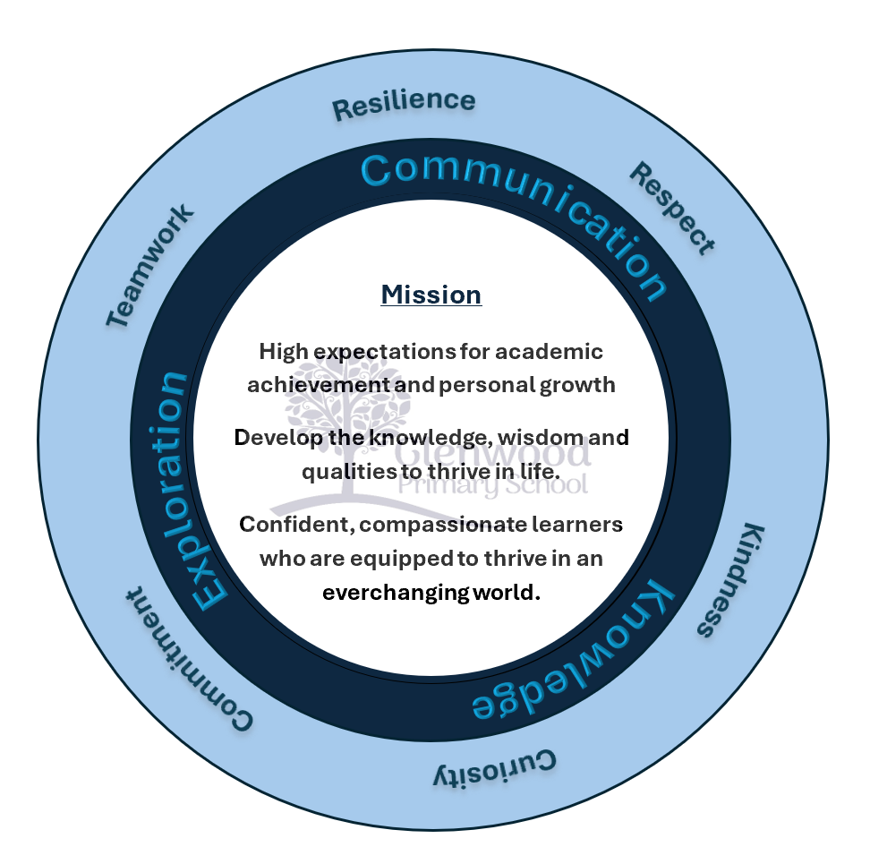

We help live our ethos and vision through the Glenwood Way
Move Calmly - Speak Nicely - Listen Carefully - Act Kindly - Do Your Best
Glenwood WISDOM qualities
TEAMWORK
RESILIENCE
RESPECT
KINDNESS
CURIOSITY
COMMITMENT

Our Values
In Glenwood Primary School we endeavour to create a nurturing, caring supportive and stimulating environment to ensure that pupils feel happy, safe and secure in school and that they are able to develop emotionally, educationally, socially and physically so that they can fully maximise their potential.
Glenwood Primary School is a Rights Respecting School and takes into account the United Nations Convention on the Rights of the Child in all decision making. We believe that every child has the right to privacy (article 16) and the right to be protected from sexual abuse (article 34).
This policy has been developed in line with DE Circular 2020/07 Child Protection Record Keeping in Schools.

Electronic and Online/Cloud-Based Child Protection Record Systems
Glenwood Primary School uses CPOMS to record child protection concerns electronically. The school has been assured that this system is robust, secure and that access is restricted to relevant staff only, for example the Principal, Designated Teacher (DT) and Deputy Designated Teacher (DDT).
Additionally, if records are held on PCs/laptops they should not be held on computers to which other members of staff or pupils can have free access to, including SIMS.net, rather they should be held securely with appropriate password protections. This applies also to portable memory devices. If records are held on C2K it should be within the private folders Principals have access to, and these can be allocated and restricted for use by relevant staff.

Requirement to Keep Pupil Records
Accurate recording of concerns and action taken is essential in helping schools identify causes for concern at an early stage and to help schools monitor and manage its safeguarding practices. School staff should be aware of the need to record and report any child protection concerns and the appropriate procedures to be followed.
Each school has a responsibility to maintain its records and record keeping systems. The Board of Governors (BOG) should ensure that the arrangements operated by the school for the retention, management and release of public records comply with statutory requirements, including data protection legislation, most recently the new Data Protection Act 2018 (DPA) including the General Data Protection Regulation (GDPR).

GDPR provides a legal framework for keeping everyone’s personal data safe by requiring organisations to have robust processes in place for handling and storing personal information based on the following principles:
- Processed lawfully, fairly and in a transparent manner;
- Collected for specified, explicit and legitimate purposes;

- Adequate, relevant and limited to what is necessary;
- Accurate and where necessary kept up to date;
- Kept in a form which permits identification of data subjects for no longer than is necessary for the purposes for which those data are processed; and
- Processed in a manner that ensures appropriate security of personal data.
Professional judgement will be required in assessing a concern and deciding when to
commence a ‘child protection record’. Child abuse includes:
- neglect;
- physical abuse;
- sexual abuse;
- emotional or psychological abuse;
- exploitation (including sexual);
- domestic and sexual violence;
- female genital mutilation;
- children who display harmful sexualised behaviour; and
- honour based violence/forced marriage.

However, a child protection record might be commenced if there is evidence of a safeguarding risk of, for example, self-harm, suicidal ideation or other behaviours that cause concern.
Further detail on categories of child abuse is available in the school’s child protection policy.
Glenwood Primary School will ensure that all volunteers, for example, coaches, music tutors, school photographers who are employed by others, have the necessary clearances in place and a record of these should be maintained by the Principal.

Recording of Child Protection Information
It is essential that an accurate record of all cases of potential child abuse is maintained detailing all actions taken.

Note of Concern/CPOMS Record
Any member of staff, teaching or support staff, who has a concern about the welfare or safety of a child or young person should complete a Note of Concern Proforma (see appendix 1) or record their concern securely on CPOMS. Notes must be made as soon as possible after the incident to ensure an expedient response, and certainly within 24 hours, to maintain the accuracy and content of the report. For some children a one-off serious incident or concern may occur and staff will have no doubt that this must be immediately recorded and reported. More often, however, it is the accumulation of a number of small incidents, events or observations that can provide the evidence of harm being caused to a child.

The staff member should report the concern to the DT (Mr Bradley) or the DDT (Mrs Ritchie) for Child Protection immediately if the concern is of a serious nature, as the DT may be aware of other circumstances which would influence steps to be taken. The Note of Concern and any further details discussed, or action taken should be placed on the pupil’s Child Protection File, either in hard copy or electronically and should be signed and dated by both parties to confirm the information is accurate.

Understanding the Needs of Children in Northern Ireland (UNOCINI)
The UNOCINI is a framework to support professionals in assessment and planning to better meet the needs of children and their families. It enables practitioners and their agencies to communicate their concerns about children using a common format, language and understanding of the levels of need, concern or risk for all children across Northern Ireland.
The UNOCINI assessment framework is intended to be used by all professionals working with children as a tool to help them identify the needs of children at an early stage. UNOCINI guidance includes information about when and how to refer a child to Children’s Social Services.
The UNOCINI referral form will be completed whenever staff have to refer a child or young person to Children’s Social Services for support, safeguarding or a fuller assessment of a child’s needs.
If there are concerns that a child may be suffering, or at risk of suffering significant harm, then an urgent referral to Children’s Social Services through the local Gateway Service must be made. When making an urgent referral by telephone, the Duty Social Worker will advise you that you will be required to confirm your referral in writing on a UNOCINI referral form within 24 hours. For further detailed guidance please refer to the Safeguarding Board for Northern Ireland (SBNI) Procedures Manual https://www.proceduresonline.com/sbni/
Non-urgent referrals i.e. child in need/ family support referrals also should be made in writing using the UNOCINI Referral form.

Please remember that the consent of the parent/carers and/or the young person (if they are competent to give this) must normally be given prior to a referral. An exception can be made when it is considered that a child is in need of safeguarding and to try and gain consent may increase the risk to a child or young person. Decisions taken with regard to consent, including when consent is not forthcoming or is not sought to protect the child, must always be clearly recorded by the DT and be placed on the pupil’s child protection file.

Child Protection File
The DT should store each Note of Concern and copy of UNOCINI documents in the child’s Child Protection File, either in hard copy or electronically and supplement it with all other records created and acquired as the management of the concern progresses. A Child Protection File is separate to the School Pupil/Educational Record and must be stored securely.

The Child Protection File should contain:
- Chronology of events/ action taken;
- All records of concern;
- Any notes initially recorded which should be kept securely with the child protection file;
- Records of discussions and telephone calls (with colleagues, parents and children/young people and other agencies or services);
- Correspondence with other organisations - sent and received;
- Referral forms – both for support and/or specialist services (irrespective of outcome);
- Formal plans linked to the child e.g. child protection plan, child in need plan;
- Risk assessments;
- Risk Management Plans/ Individual Safety and Support Plans;
- School reports to interagency meetings and conferences;
- Minutes of interagency meetings e.g. child in need, strategy, child protection conference; and
- Any other relevant notes/ papers.

Relevant and accurate records are essential to inform effective decision making and assist in the sharing of appropriate information. They should contain factual information or be clearly specified as unsubstantiated and should include all relevant information even if it appears contradictory.
Any significant event or change which has an impact on the child’s welfare must be
included in the Child Protection File and noted on the chronology of events/ action taken,
even if it seems to be contradictory. As a guideline, although not exhaustive, the following
may be relevant:
- Change of circumstances: changes of carer, address, legal status, school, family circumstances and household composition;
- Issues for the child: physical or mental health issues, incidents of abuse, losses, developmental issues, incidents of running away/going missing, incidents of bullying, offending or police involvement;
- Family issues: changes in family composition, loss and separation, domestic violence, financial or housing problems, physical or mental health, substance misuse, homelessness, imprisonment, victimisation; and
- Professional involvement: involvement of other agencies including Social Services, referrals made, assessments, significant decisions or interventions.

Any decisions made must be recorded together with reasons for the agreed action. This will be vital to any future processes, such as retrospective or historical allegations and Case Management Reviews. It is vitally important to record all relevant details, regardless of whether or not the concerns are shared with either the police or social services.
When Social Services inform the school that a child’s name has been placed on the Health and Social Care (HSC) Trusts’ Child Protection Register (CPR), the school must maintain a record of this fact and associated documentation from Social Services on the child’s Child Protection file.

Allegations Against School Staff
Where an allegation is made about possible abuse by a member of staff of the school, the procedures set out in DE Circular 2015/13 should be followed.
As set out in Circular 2015/13, all allegations of a child abuse nature must be recorded in the Record of Child Abuse Complaints book, which must be retained securely. A record of this, signed and dated by the Principal should be placed on the relevant pupil’s Child Protection File.
It is important that all allegations are recorded to ensure a school can monitor allegations made and identify causes or patterns of concern at an early stage. It is also important that the BOG are fully informed of all complaints to ensure they are complying with their statutory responsibilities under the Education and Libraries (NI) Order 2003.
These records should be signed and dated by the Principal. If the Principal is the subject of the concern, as per the Circular 2015/13, the allegation should be reported immediately to the Chair of the BOG, Deputy Chairperson, Designated Governor for Child Protection and the person appointed to be the Lead Individual. As noted above the record should be retained in the school on the child’s Child Protection File and also the file of the member of staff concerned.
If, on foot of a subsequent investigation by one of the investigating agencies, the member of staff concerned is totally exonerated:
- the record on the staff member’s file must be expunged and they should be notified
that this has been completed;
- the entry in the Record of Child Abuse Complaints struck through with an explanation entered; and
- the record on the child’s file should be noted with the outcome of the investigation,
and should stand until the child’s date of birth +30 years.
Given the number of recent historical allegations, unless the member of staff concerned is totally exonerated, the record should be retained indefinitely. If closure or an amalgamation of an educational establishment occurs or when a member of staff retires, leaves or changes post, advice should be sought from the relevant Employing Authority and/or the Information Commissioner’s Office (ICO).

Storage of Child Protection Information
Child Protection information is confidential and should not be kept on the child’s Pupil/ Educational Record. Each school should have a separate secure confidential filing system for Child Protection concerns, ideally in a fireproof filing cabinet for physical records, or securely in an electronic or online/cloud based system with restricted access and appropriate password protections. Other child protection records, including the school’s confidential Record of Child Abuse Complaints should also be stored here. The filing system, whether physical or electronic, should be accessible to only the DT, DDT or Principal. The secure filing cabinet for physical records or secure electronic or online/cloud based system for electronic records is not accessible to anyone else, including administrative staff, the ETI and members of the BOG. The ETI will seek assurance that child protection records are held securely and in a confidential manner.
Physical or electronic Child Protection Records must not be removed from the school premises, except when taken to a case planning meeting in respect of the child, or on foot of a court order. If information needs to be taken out of the school, it must be transported securely and a record should be kept of when it was removed, by whom, for what purpose, and when it was returned. Any computing devices or data storage (including laptops, tablets, USB drives etc.) used to transport electronic Child Protection Records in the circumstances referred to above should be encrypted and password protected.

Access to Records and Sharing of Information
In accordance with the DPA 2018 and GDPR, Glenwood Primary School is a data controller in respect of the personal data it processes and is therefore responsible for its compliance with the legislation.

Sharing Information (Within the School and With Others)
Undoubtedly, schools will face situations where in their judgement it is necessary, in the best interests of a child or young person, and to allow them to carry out their safeguarding role, to share child protection information relating to pupil(s), to both specific colleagues within a school, such as the DT/DDT and Principal and with relevant agencies outside a school, such as the EA’s CPSS, Social Services, a Guardian ad litem or the PSNI.
While it is preferable to do so with the consent of a pupil, the circumstances pertaining on a case by case basis, may not always make this possible or appropriate. When a school cannot be reasonably expected to gain consent from an individual, or if to do so could place a child at risk, the DPA includes ‘safeguarding of children and individuals at risk’ as a condition that allows schools to share information without consent.
Child Protection information is confidential and often highly sensitive and decisions to share, or not to share, must always be made in the interest of protecting the child if at risk of significant harm. All staff should understand the importance of maintaining confidentiality and the consequences of any breach.

Relevant personal information, including Special Category personal data (sensitive and personal) can be shared lawfully if it is to keep a child or individual at risk safe from neglect or physical, emotional or mental harm, or if it is protecting their physical, mental or emotional wellbeing.
ICO guidance advises that in an urgent or emergency situation personal data that is necessary and proportionate can be shared with relevant school staff and outside agencies as appropriate. This will depend on both individual circumstances in each case, the agreed protocols and procedures in place and any statutory duty to do so, both within schools and with relevant outside agencies.
However, information sharing is essential for effective safeguarding and promoting the welfare of children and young people and the extent of the sharing will be a judgement for schools to make. Any undue delays to share relevant information must be avoided in the interests of the individual.
Where it is decided to share personal data within and/or with outside agencies, it must be done so for the purpose for which you are sharing it, in line with data protection principles: necessary; proportionate; relevant; adequate; accurate; timely and secure.

In the interests of accountability and transparency, schools should keep a record of the decision(s) taken and the reasons for it – whether to share information or not. If you decide to share, then record what you have shared, with whom and for what purpose.
While the DPA allows personal data sharing in the circumstances described above, other arrangements to share personal data may require both a Data Protection Impact Assessment (DPIA) to be conducted and a Data Sharing Agreement (DSA) to be in place in advance of the sharing taking place. Guidance on when a DPIA and DSA are required can be found on the ICO website: https://ico.org.uk/
Child protection records created and held by schools should be done so in line with data protection principles: necessary; proportionate; relevant; adequate; accurate; timely and secure.
Access to child protection records should be strictly on a need-to-know basis, and a record should be kept to identify who has requested access, when and for what purpose.

Transfer of Child Protection Records Transfer of Records
Under the Education (Pupil Records and Reporting) (Transitional) Regulations (NI) 2007, the BOG are required to make arrangements to transfer a formal record of a pupil’s academic achievements, other skills and abilities and progress within 15 school days of a pupil transferring schools. The requirement does not include the transfer of child protection records. However, where there have been, or are current, concerns about a pupil the school should consider what information should be shared with the new school.

Past safeguarding concerns and the response to these can be significant, should concerns arise for the child at a later time. The third data protection principle is key in relation to deciding whether to transfer past concerns. If the information, current or historical, is deemed to be relevant then it should be shared.
The DT is responsible for ensuring that copies of relevant child protection records are transferred to the DT of the receiving school in the most secure and appropriate manner to minimise the risk of any data breach. As per para. 2.4, it should also be noted that when schools are transferring child protection records electronically, for example to a receiving school, it should be done so securely using C2K email addresses and with access restricted. The data controller, i.e. the school from which the records are being transferred, is accountable for any data breach during the transfer. Once the receiving school acknowledges receipt of the record they are then responsible for it.
When a child on whom the school holds safeguarding or child protection information leaves the school, and the school is unaware of the new school, they must notify the Education Welfare Service (EWS) at the EA who will then attempt to locate the child.

Social Services must be informed immediately if the child has a Child Protection Plan or is a Looked After Child. The school must retain the child’s child protection records and forward the relevant information to the receiving school when the child has been traced.
When a child whose name is on the Child Protection Register changes school, the school which the child is leaving should inform the receiving school immediately that his/her name is on the Child Protection Register and pass on contact details for the social worker. The school should then destroy all child protection records on the child supplied by Social Services, including records of case conferences, and should inform the child’s Case Co- ordinator in Social Services. The remaining child protection record should be copied, as relevant, to the new school. When considering what information is relevant, advice can be sought from the CPSS. The school to which the child is transferring should contact the child’s social worker for relevant information. The leaving school can retain original copies of their own documents.
It is good practice for the DT from the school the child is leaving to discuss concerns directly with the DT from the receiving school in advance of sending the child protection record.

Closure, Retention and Disposal of Child Protection Records Closure
When a pupil leaves the school or child protection concerns cease to be current or ongoing, and records cease to be of active use other than for reference purposes, the child’s individual Child Protection File should be closed. The DT should consult the School’s Disposal of Records Schedule, review the file and mark the front cover of the file indicating the date on which the file can be destroyed, for example, 30 years from the pupil’s date of birth. Closing a file simply means that no further papers can be added. If new concerns arise a new file can be opened and cross-referenced with the previous file.

Retention of Child Protection Records
In order to determine how long child protection records should be kept, there are a number of guiding principles. The GDPR principles require that personal information should be:
- collected for specified, explicit and legitimate purpose;
- adequate, relevant and limited to what is necessary; and
- accurate and, where necessary, kept up to date.

As a data controller, Glenwood Primary School has responsibility to ensure that data protection legislation is complied with.
Every school must have a Record Retention and Destruction Policy and a Disposal of Records Schedule. Some key questions to be considered in developing a policy for child protection records are set out at Annex F.
The potential for historical allegations to be made should also be considered in determining retention periods for child protection records.

Retention Periods for Child Protection Records
It is recommended that, in general, child protection records, including paper and electronic records, should be retained by the school for the following periods:

Record | Retention Period
Pupil Child Protection Case  Files | D.O.B. + 30 years
The school’s confidential  Record of Child Abuse  Complaints | Indefinitely *
If Social Services inform the school that a child’s name has been placed on the Child Protection Register | Maintain a record of this fact and associated documentation from Social Services on the child’s file while he/she continues to attend. On transfer, the school should inform the new school and destroy all social services records. The record on the Child  Protection File will remain until D.O.B + 30 years
If Social Services inform the school that a child’s name is removed from the Child Protection Register | On transfer to a new school, the school should destroy any child protection records on the child supplied by Social Services, including records of case conferences. The record on the Child Protection File  will remain until D.O.B + 30 years
Complaint against a member of staff  Staff members file  Child’s Child Protection File  Record of Child Abuse  Complaints | Indefinitely* unless totally exonerated  D.O.B + 30 years Indefinitely*
Complaint to be pursued under the school’s disciplinary procedures Staff members file Child’s Child Protection File Record of Child Abuse  Complaint | 7 years  D.O.B. + 30 years Indefinitely*

*As a guide, indefinitely should be minimum of 40 years

Disposal
At the end of the agreed retention period, records should be securely disposed of, for example in the case of physical copies, incinerated or shredded in the presence of a member of the school, or entrusted to a firm specialising in the destruction of confidential material. Information held electronically, either within private folders on the C2k system or held on an online/cloud-based system, should also be deleted within the timescales set. Following deletion, the electronic records will be held securely on the C2K centralised backup for a period of time but in due course will be overwritten and the documents removed. No evidence will remain on the C2k system.
The National Archives has issued guidance based on the Independent Inquiry into Child Sexual Abuse stressing that any information which may be required by the Inquiry should not be destroyed. This principle should be applied in all cases and careful review should be carried out before destruction of documents.
https://www.iicsa.org.uk/news/chair-of-the-inquiry-issues-guidance-on- destruction-of-documents

School Closures and Amalgamations
Where a school is closing and the site is being sold or reassigned for other use, the Employing Authority should take responsibility for the records from the date of the school closure. In such cases the school should contact the Information Manager in the Employing Authority regarding secure transfer of the records. Hand delivery or collection of documents is preferable but where documents are to be posted these must be double-enveloped, marked on the inner envelope as ‘sensitive personal data’ and sent by registered post.
When a school is preparing to close, the DT should identify pupils with a child protection record. Every effort must be made to establish the pupil’s new school and the processes outlined above followed. After the transfer of relevant information has taken place, the child’s file should be forwarded to the Employing Authority for retention until the child reaches the age of D.O.B + 30 years. Child protection records of pupils who have already left the school which are still within the retention period should also be transferred, securely as above, to the Employing Authority for retention and destruction at the appropriate time.
If a number of schools have merged onto one site and then function as one school, it is sensible to retain all records relating to the schools on the one site. These records should be kept in the confidential locked filing cabinet, accessible only by the DT and the Principal.

Appendix 1
Glenwood Primary School – Note of Concern
Confidential – to be given to C Bradley (Designated Teacher) or D Ritchie (Deputy- Designated Teacher)

Name of Pupil:
Year Group:
Date & Time of Incident/Disclosure:
Circumstances of Incident/Disclosure
Nature and Description of Concern:

Parties Involved – including any witnesses to an event and what was said or done by whom:
Action taken at the time:
Details of any advice sought, from whom and when:
Any further action taken:
Written report passed to Designated Teacher/Deputy-Designated Teacher: Yes: No:
If ‘No’, state reason:
Date and time of report to Designated Teacher/Deputy-Designated Teacher
Written note from staff member placed on pupil’s Child Protection file
Yes: No:
If ‘No’, state reason:

Name of staff member making the report: Signature of staff member: Date: Signature of Designated Teacher: Date:

