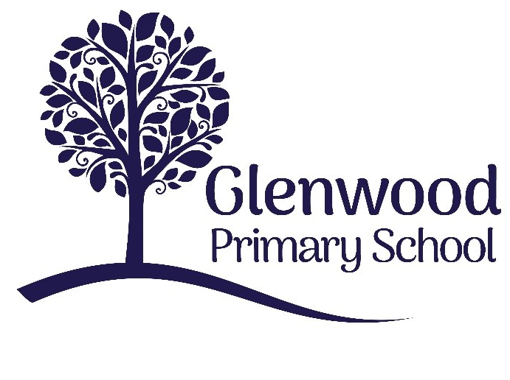

Glenwood Primary School
Disposal of Records Schedule

Implementation Date – 2013

Review Date : 2016
Review Date : 2019
Review Date : 2022
Review Date : 2025

Contents

 |  |  |  | Page
Section 1 |  | Introduction | 5
Section 2 |  | Operation of this Records Disposal Schedule | 7
Section 3 |  | Definitions of Records held by (Name of School) | 9
Section 4  Section 5 |  | Electronic Records  Disposal Schedule | 8  15
Section 6 |  | Model Record Management Policy | 21
Section 7 |  | Signatories | 23

Ethos statement
Glenwood Primary School is a nurturing and enriching environment where we foster a culture of kindness, empathy and mutual respect. Together we build a safe and caring school where everyone belongs and thrives.

Vision
At Glenwood Primary School we are dedicated to fostering an empathetic and inclusive atmosphere where every student is valued, inspired, and challenged to achieve their fullest potential.

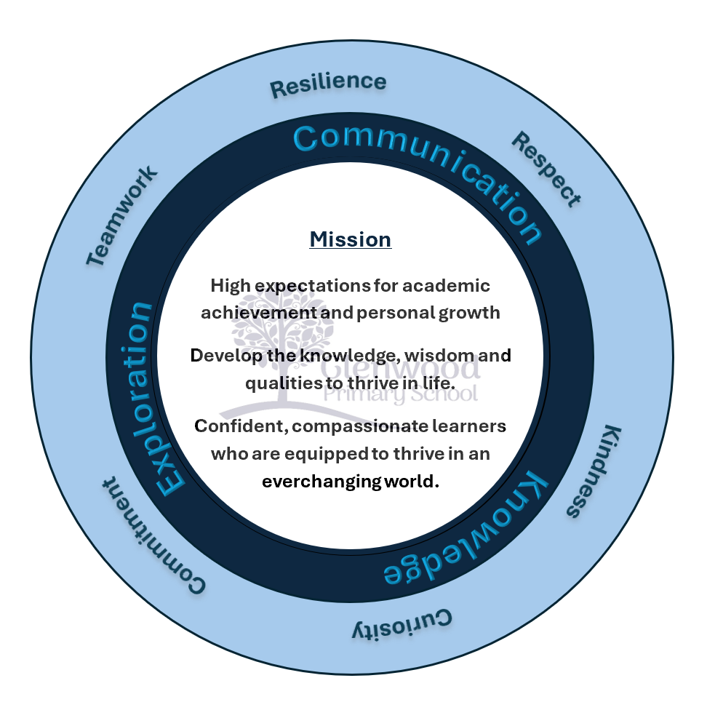

We help live our ethos and vision through the Glenwood Way
Move Calmly - Speak Nicely - Listen Carefully - Act Kindly - Do Your Best
Glenwood WISDOM qualities
TEAMWORK
RESILIENCE
RESPECT
KINDNESS
CURIOSITY
COMMITMENT

Section 1 – Introduction

1. Functions of Glenwood Primary School

Glenwood Primary School provides the children in our care with a quality education that caters for their individual needs, supported by highly professional and motivated staff in pleasant and well resourced surroundings.

2. Purpose of Disposal Schedule

This disposal schedule identifies the disposal arrangements for all manual and electronic records created by Glenwood Primary School. The Schedule complies with the requirements of the Public Records Act (NI) 1923 and the Disposal of Documents Order (S.R.& O.1925 No 167).

3. Categories of Disposal

• Destruction
• Permanent preservation

Section 2 – Operation of this Records Disposal Schedule

1. Closing a file

Manual records should be closed as soon as they cease to be of active use other than for reference purposes. When a file is due to be closed an appropriate member of staff should consult the disposal schedule and mark the front cover of the file, indicating the date on which the file can be destroyed, or whether it should be reviewed by a member of staff. Closing a file simply means that no further papers can be added but the file can be used for reference.

2. Minimum Retention Period

With the exception of pupil files, the minimum retention period required for each type of record is calculated from the point the file/record is closed.

3. Destroy

Where the disposal action states ‘Destroy’ the records should be kept for the period stated and then destroyed securely. A record must be maintained of the files that have been destroyed.

4. Offer to PRONI

Where the disposal action states ‘Offer to PRONI’ the record must be offered to the PRONI when no longer needed for business purposes.

5. Commitment to preserving files/records

Glenwood PS declares that it will take measures to ensure that the records it creates (including electronic records) will be well maintained and protected while they are in its custody.

6. Roles and Responsibilities

The School Board of Governors is responsible for ensuring that the School complies with the commitment laid out in this Policy. The School Principal is charged with operational compliance and will assign any specific staff responsibilities as required in order to help fulfil the School’s commitment to effective records management. All members of staff are responsible for creating and maintaining records in accordance with good records management practice.

Section 3 – Definitions of Records held by (Name of School) in

respect of its Functional Areas.

There are six main functional areas for which Glenwood Primary School keeps records as follows:

1. Management and Organisation

2. Legislation & Guidance

3. Pupils

4. Staff

5. Finance

6. Health & Safety

The records contained within these functional areas provide evidence and information about its business activities and are important for the efficient operation of the school.

1. Management and Organisation

This category comprises records held which relate to the management and organisation of the school. Typical records would include the minutes of the Board of Governors, the Senior Management Team and Parent/Teachers Association meetings which record the major decision-making processes of the school. Also included are records detailing development, planning and curriculum policies as well as those that demonstrate how the school reports to its parents and other organisations. Records include the School Development Plan, the School Prospectus, Curriculum policies, Annual Report, Emergency Planning and Business Continuity Plan along with the records of meetings, minutes, and policies documenting the decisions and actions taken within this business function.

2. Legislation and Guidance from DE, ELBs, ESA, & CCMS

Files maintained under this heading contain papers relating to legislation e.g. the Education (NI) Order, Circulars, Guidance, Bulletins from the Dept of Education and Education & Library Boards, CCMS etc, correspondence in connection with Statistical Returns and documents relating to Dept of Education Inspections and Reports.

3. Pupils

Pupil Files contain vitally important records which, not only capture the progress of the student throughout their time at the school, but also contain personal details and information beneficial to their well being within the school environment. Such records would include admission data, attendance of the pupils at the school, timetables and class groupings, education/progress reports of pupils, special education needs documentation, child protection information, disciplinary action taken, examination results, careers advice, school trip details and medical records (details of medical conditions where medicines are required to be administered at school).

4. Staff

Staff category refers to those records required for the Human Resources Management function within the school. These include staff personnel records (recruitment, interview notes, appointments, training, staff development etc), staff salary records, staff induction, sickness records, staff performance review, substitute teacher records and student teachers on teaching practice etc.

5. Finance

This business function maintains records for a range of financial activities such as annual budgets, budget monitoring, Annual Statement of Accounts, procurement, tender information and prices, reconciliation of invoices, audit reports etc.

6. Health & Safety

The health and safety of children and staff is of paramount importance in the school and such records to support this are kept e.g. Accident/Incident Book, legal/accident/incident forms, risk assessments, fire procedure, CCTV, security system files, health and safety policy statement.

Section 4 – Electronic Records

The legal obligation to properly manage records, including compliance with Data Protection legislation, applies equally to electronic records. The main considerations for the management of electronic records are therefore the same as those for manual records. They include:

- Staff must be able to use and access electronic information effectively
- Adequate measures must be in place to ensure all information is stored securely and only available to authorised persons.
- A school must be able to demonstrate a record’s authenticity by ensuring information cannot be altered when declared a record.
- A system must be in place for disposing of electronic records in line with policy once they are no longer needed.

In addition to the above, sufficient backup/recovery processes must be in place. There must also be a process through which links are created from electronic records to any associated manual records. This is to ensure a full record can be considered when necessary i.e. when decision making, providing access or considering a record for disposal.

The School Board of Governors is ultimately responsible for records management within the School. The decision to move towards electronic records must be taken carefully and the Board of Governors must satisfy itself that the measures identified above can be achieved. Further information and advice on electronic records can be obtained from PRONI http://www.proni.gov.uk the lead organisation on public sector records management. A number of International Standards have also been established to help organisations follow best practice when implementing an electronic records strategy. They include:

ISO 15801:2009 - record authenticity and legal admissibility
ISO 27001 - information security management
BS 10008 - legal admissibility of electronic information standards

SECTION 5 - School Disposal Schedule

1. Management & Organisation

Ref | Record | Minimum Retention Period | Action After Retention
1.1 | Board of Governors – general correspondence | Current school year + 6 years | Destroy
1.2 | BOG Meetings Minutes (master) | Current school year + 6 years | Offer to PRONI for Permanent Preservation
1.3 | Senior Management Team-Meeting Minutes | Current school year + 6 years | Offer to PRONI for Permanent Preservation
1.4 | Staff Meeting Minutes | Current school year + 6 years | Destroy
1.5 | School Development Plan | Retain in school for 10 years from closure of Plan | Offer to PRONI for Permanent Preservation
1.6 | School Policies | Retain while current. Retain 1 copy of old policy for 2 years after being replaced | Destroy
1.7 | PTA – minutes and general correspondence | Current school year + 6 years | Destroy
1.8 | Visitors Book | Current school year + 6 years | Destroy
1.9 | Circulars to Staff, Parents and Pupils | Current school year + 3 years | Destroy
1.10 | School Brochure or Prospectus | Current school year + 3 years | Destroy
1.11 | Comments/Complaints | 5 years after closing. Review for further retention in the case of contentious disputes | Destroy
1.12 | Annual Report | Retain in school for 10 years from date of  Report | Offer to PRONI for Permanent Preservation
1.13 | School Fund | Current financial year + 6 years | Destroy
1.14 | Emergency Planning/Business Continuity Plan | Until superseded | Destroy

- Legislation and Guidance from DE, ELB, ESA, CCMS etc

Ref | Record | Minimum Retention Period | Action After Retention
2.1 | Education (NI) Order | Until superseded | Destroy
2.2 | Circulars, Guidance, Bulletins from DE, ELB etc | Until superseded | Destroy
2.3 | Correspondence re: Statistical Returns to DE, ELB etc | Current financial year + 6 years | Destroy
2.4 | DE Reports, Inspections | Until superseded | Destroy

3. Pupils

Ref | Record | Minimum Retention Period | Action After Retention
3.1 | Pupil Admission Data
3.1a | Applications for enrolment | 3 years after enrolment | Destroy
3.1b | Transfer applications (Transfer Forms) | 3 years after enrolment | Destroy
3.2 | Pupil Attendance Information/Registers | Date of Register + 10 years | Offer to PRONI for Permanent Preservation
3.3 | Pupil Education Records - School/Progress Reports etc | Until pupil is 23 years old | Destroy
3.4 | Pupil Education Records - School/Progress Reports etc (Special Educational Needs) | Until Pupil is 26 years old | Destroy
3.5 | Child Protection Information- Record of concerns where case was not referred to Social Services | 10 years after last entry on file | Destroy
3.6 | Child Protection Information- Social Services investigation outcome was unfounded or malicious | 10 years after last entry on file | Destroy
3.7 | Child Protection Information- Social Services investigation outcome was inconclusive, unsubstantiated or substantiated | Until pupil is 30 years old | Destroy
3.8 | Disciplinary Action (Suspension/Expulsion)/Offences – bullying | Until pupil is 23 years old | Destroy
3.9 | Disciplinary Action (Suspension/Expulsion)/Offences – bullying (Special Educational Needs) | Until pupil is 26 years old | Destroy
3.10 | Timetables + Class Groupings | Retain while current | Destroy
3.11 | Examination Results | Current school year + 6 years | Destroy
3.12 | Careers Advice | Current school year + 6 years | Destroy
3.13 | School Meals returns | Current financial year + 6 years | Destroy
3.14 | Free Meals registers | Current financial year + 6 years | Destroy
3.15 | School Trips – Financial & Administration details | Current financial year + 6 years | Destroy
3.16 | School Trips-Attendance/Staff Supervision etc | Current financial year + 6 years. In the case of an incident/accident involving a pupil, retain until pupil is 23 years old or 26 for a pupil with special educational needs | Destroy
3.17 | Reports of Stolen/Damaged Items | Current financial year + 6 years | Destroy
3.18 | Medical Records – records of pupils with medical conditions and details for the administration of drugs when necessary. | Until pupil is 23years old or in the case of a Special Needs Pupil, until 26 years old | Destroy

4. Staff

Ref | Record | Minimum Retention Period | Action After Retention
4.1 | Staff Personnel Records (including, appointment details, training, staff development etc.) | 7 years after leaving employment | Destroy
4.2 | Interview notes and recruitment records | Date of interview + 6 months | Destroy
4.3 | Staff Salary Records | 7 years after leaving employment | Destroy
4.4 | Staff Sickness Records (copies of Medical Certs) | Current school year + 6 years | Destroy
4.5 | Substitute Teacher Records | Current school year + 6 years | Destroy
4.6 | Substitute Staff Records-non teaching (cover for nursery assistants) | Current school year + 6 years | Destroy
4.7 | Student Records-non teaching (e.g. nursery assistant students & pupils from schools on work experience) | Current school year + 6 years | Destroy
4.8 | Student Teachers on Teaching Practice – student teacher progress | Current school year + 6 years | Destroy
4.9 | Procedures for Induction of Staff | Until superseded | Destroy
4.10 | Staff/Teachers’ Attendance Records | 7 years after leaving | Destroy
4.11 | Staff Performance Review | 7 years after leaving | Destroy

- Finance

Ref | Record | Minimum Retention Period | Action After Retention
5.1 | Annual budget and budget deployment | Current financial year + 6 years | Destroy
5.2 | Budget Monitoring | Current financial year + 6 years | Destroy
5.3 | Annual Statement of Accounts (Outturn Statement) | Current financial year + 6 years | Destroy
5.4 | Order Books, Invoices, Bank Records, Cash Books, Till Rolls, Lodgement books etc | Current financial year + 6 years | Destroy
5.5 | Postage Book | Current financial year + 6 years | Destroy
5.6 | Audit Reports | Current financial year + 6 years | Destroy

- Health & Safety

Ref | Record | Minimum Retention Period | Action After Retention
6.1 | Accident Reporting (Adults) | Date of incident + 7 years | Destroy
6.2 | Accident Reporting (Children) | Until pupil is 23years old or in the case of a Special Needs pupil, until 26 years old | Destroy
6.3 | Risk Assessments – work experience locations/pupils | 7 years | Destroy
6.4 | H & S Reports | 15 years | Destroy
6.5 | Fire Procedure | Until superseded | Destroy
6.6 | Security System File | For the life of the system | Destroy

Section 6 - Records Management Policy Statement

The School recognises that the efficient management of its records is necessary to comply with its legal and regulatory obligations and to contribute to the effective overall management of the school. This document provides the policy framework through which this can be achieved and audited. It covers:

- Scope
- Responsibilities

1 Scope of the policy

This policy applies to all records created, received or maintained by staff of the school in the course of carrying out its functions.

1.2 Records are defined as all those documents which facilitate the business carried out by the school and which are thereafter retained (for a set period) to provide evidence of its transactions or activities. These records may be created, received or maintained in hard copy or electronically.

1.3 A number of identified School records will be offered to the Public Record Office (PRONI) for permanent preservation when no longer required by the School

2 Responsibilities

  - The School Board of Governors has a corporate responsibility to maintain School records and record keeping systems in accordance with the regulatory environment.

  - The School Principal is charged with day-to-day operational compliance and will assign any specific staff responsibilities as required in order to help fulfil the School’s commitment to effective records management.

  - Individual staff and employees must ensure that records for which they are responsible are accurate, and are maintained and disposed of in accordance with the school’s Records Management Policy and Guidelines.



Model Disposal of Records Schedule for schools
Prepared as required by the Public Records Act (Northern Ireland), 1923 and in accordance with the Rules made pursuant thereto, approved by Order in Council dated 20th January 1925.

This schedule was created through consultation with schools and takes cognisance of record retention requirements placed on schools by the Department of Education, Employing Authorities and examples of good practice in records management

The Chief Executive officers of the Education and Library Boards and CCMS, have written to the Department to confirm their endorsement of the schedule, and to enable the Permanent Secretary, Paul Sweeney, to sign the schedule on behalf of the aforementioned educational bodies.

