

Glenwood Primary School
Educational Visits Policy

‘Together we aim to develop confident, compassionate, and resilient learners who are equipped to thrive in an everchanging world’.

Policy update: | May 2025
Policy to be reviewed by: | May 2028
Signed by Principal: |  | Date:
Signed by Chair of Governors: |  | Date:

Ethos Statement:

Glenwood Primary School is a nurturing & enriching environment where we foster a culture of kindness, empathy & mutual respect. Together we build a safe & caring school where everyone belongs and thrives.

School Vision:

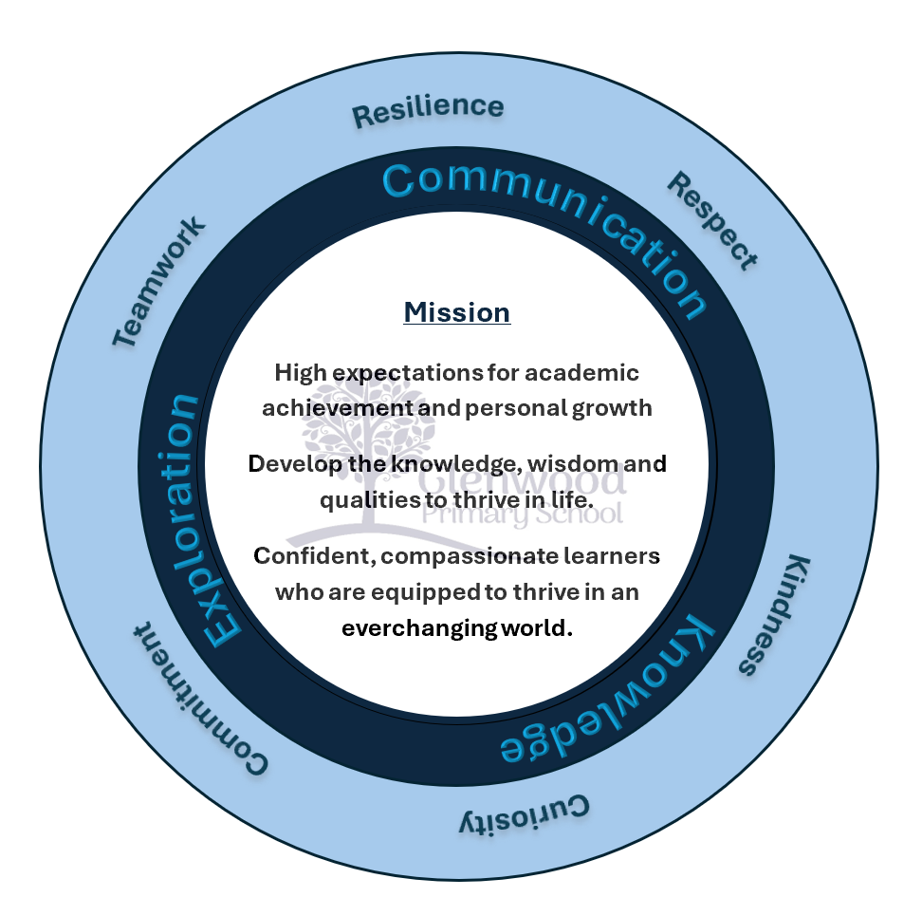
At Glenwood Primary School we are dedicated to fostering an empathetic & inclusive atmosphere where every student is valued, inspired, & challenged to achieve their fullest potential.

We help live our ethos and vision through the Glenwood Way
Move Calmly - Speak Nicely - Listen Carefully - Act Kindly - Do Your Best
Glenwood WISDOM qualities
TEAMWORK
RESILIENCE
RESPECT
KINDNESS
CURIOSITY
COMMITMENT
Educational Visits Policy

All educational visits will be organized according to the agreed procedures within this policy.

The term “educational visits” refers to:
‘all academic, sporting, cultural, creative and personal development activities, which take place away from the young persons’ school, and make a significant contribution to learning and development of those participating’

The policy and procedures are based on the “EA Educational Visits Interim Guidance for Schools 2017”

At Glenwood, our children benefit greatly from educational visits and it is our priority that these visits are carefully planned to ensure maximum safety for all. The pupil’s welfare must always be paramount and careful consideration must be given to pupils who have special educational needs.

Educational Visits Co-ordinator (EVC) is Mrs Kathryn McCorriston who will ensure that the visits meet all requirements and will hold all the relevant paperwork.

Procedures for planning a visit

Details of a proposed visit should be submitted on the EVA form (educational visit approval) to the EVC who will then seek approval from the principal and board of governors. * A risk assessment should be carried out. (checklist)*

Parents should be informed by letter and asked to give consent in writing. Parental consent may be done on a blanket basis for regular visits.

Copies of all forms e.g. EVA, Consent forms and risk assessment checklist, should be given to EVC to be filed at the school.

If there are any accidents, an “Educational Visit Incident Record Form” should be filled in and given to EVC.

A group leader should be assigned who has overall responsibility for the organisation and supervision of the group for the duration of the visit.

Type of Trip
EA have identified 5 categories of visits and the majority of visits in primary school will come under category 1 and 2.
The P7 residential will come under category 3 and 5, thus requiring a completion of the “Educational Visit Proposal Form” (EVP) and all the relevant information should be collated by the group leader on the “Educational Visits Group Details Form.”
A “Post Visit Review Form” should be used to evaluate key aspects of the trip.

Categories of Educational Visits
Category 1: Basic visits which take place on a regular basis and occur largely within school hours e.g. sporting fixtures, swimming pool visits and outings
Category 2: One-off day/evening excursions (non-hazardous) e.g. field study trips, theatre visits, business/education visits, regional sporting fixtures
Category 3: Residential visits of one or more nights within the UK or Ireland. (non-hazardous)
Category 4: Residential visits outside the UK or Ireland (non-hazardous)
Category 5: Hazardous activities – residential and non-residential e.g. Hill walking , Fieldwork, Cycling/mountain biking, Orienteering, Rock climbing/abseiling, Caving and potholing, Kayaking, Open canoeing, Windsurfing, Dingy sailing , Sub-aqua, Skiing/snowboarding, Horse riding, Angling, Water-skiing, Rafting rowing , Surfing, Bouldering/gorge walking, Swimming in open water, Coasteering, Stand-up paddle boarding

Supervision and staff ratios

**Pupil to staff ratios for educational visits are not prescribed by law**

The following adult/pupil ratios are recommended by the EA but they are only guidelines. Those planning visits, on the basis of risk assessment, should decide the ratios.

Foundation Stage: 1 adult for up to a maximum of 10 young people

Key Stages 1 and 2: 1 adult for up to a maximum of 15 young people

When an overnight stay is involved, at least one male and one female leader should accompany mixed sex groups where possible. If this is not possible, parents must be made aware and give consent to the proposed arrangement prior to the visit.

Risk Assessments

Fundamental to the planning process of any educational visit is the process of risk assessment.

The following considerations should be made when making an assessment:
• What are the hazards?
• Who might be affected by them?
• What safety measures need to be in place to reduce risks to an acceptable level?

Group leaders must fully record their risk management decisions on paper and a copy given to EVC. (Glenwood Risk Assessment Checklist)

Risks should be monitored during the visit and where appropriate be modified or curtailed to suit changing circumstances. This is the responsibility of all involved in the visit.

**After carrying out a behavioural risk assessment, the school has the right to refuse any pupil from participating in the visit, whose involvement may be considered to be a danger to him/herself or to the group. **

Preparing pupils (Code of Conduct)
• Before the visit pupils must be told how to avoid specific dangers and why they should follow rules;
• why safety precautions are in place;
• what standard of behaviour is expected from pupils;
• who is responsible for the group;
• what to do if approached by anyone from outside the group;
• what to do if separated from the group;
• emergency procedures;
• how to behave whilst travelling on hired or public transport.

Pupils with mobility difficulties
Access to venue/destinations must be investigated in the planning stage and checks made with the venue /destination about access for pupils with disabilities. These additional measures need to be included on the risk assessment.

Planning transport
The requirement for buses should be made through the school secretaries who have access to reputable bus companies.
Where pupils are to be transported by car, school staff should check with their insurance company that they have the relevant cover. Parents should agree this in writing.
Insurance
The Education Authority covers the legal liability of controlled and maintained schools in respect of personal injury claims within Northern Ireland.
Communicating with parents

An effective, two-way communication process between the school and home is important for all visits. Information to parents may include:

• date of the visit or series of visits
• visit’s objectives and general outline of what has been arranged for the day
• size of group and level of supervision
• times of departure and return – parents must have agreed to meet their child on return if necessary
• the location where the pupils will be collected and returned
• mode of travel
• details on the cost of the visit
• clothing and equipment to be taken
• names of leader, of other staff and of other accompanying adults
• standards of behaviour expected (pupil code of conduct)
• details of provision for special educational or medical needs.
*for residential visits – briefing meeting for parents should be included.

Roles and responsibilities
Principal/Board of Governors - Permission obtained before a visit takes place.
Educational Visits’ Co-ordinator(EVC) – a role designated to a member of the Senior Leadership Team. He/she will have a central role to play in endeavouring to ensure that the best practice, in relation to educational visits, is developed and implemented within the school.
Group Leader – this is a member of staff designated by the Principal or EVC who will have overall operational responsibility for the supervision, discipline and conduct of the participants for the duration of the visit and should be experienced in organising such visits, the supervision of pupils, and all relevant health and safety matters.
Accompanying staff – must accept the authority and follow the instructions of the group leader to assist with the organisation and discipline of the pupils.
Volunteers in a Supervisory Role – to satisfy staffing ratios, it may be necessary to involve persons other than staff members as volunteers, e.g. parents. Prior to any visit they should be clear about their role and responsibilities during the visit. They should not be left in sole charge of group members except where it has been previously agreed as part of the risk assessment. It is required that all adults who accompany groups of pupils under the age of 18 are vetted in line with DE circular 2012/19 with regards to vetting checks for volunteers working in school. The adult in question provides relevant details and gives permission for relevant checks to be carried out.
Nominated contact at School Base – this could either be principal, EVC or another senior member of staff. They should have access to contact details of staff and pupils’ parents, and details of the place to be visited, contact personnel and telephone/mobile numbers.
Parents – should sign consent forms, provide school with an emergency contact number(s), provide the school with relevant medical/dietary details and reinforce the code of conduct for visits.
Pupils – the group leader, when briefing the pupils, should make it clear about the code of conduct and where appropriate, pupils should be fully involved in the planning process.
Employing authority – provides advice and support for governors, principals, teachers and appropriate staff.

Emergency/Contingency Arrangements
The majority of educational visits take place without incident demonstrating the high level of care of those involved in the planning and managing of such visits.
However, in the event of a young person becoming ill or being injured, specialist help must be sought as appropriate and parents informed as soon as possible. Where the illness/accident/injury is serious the principal should be contacted. Responsibility for informing relevant authorities rests with the principal.
First Aid
The group leader should ensure that adequate First Aid provision is available. The group leader should ensure that a first aid kit is taken with the group. There are 3 first aid kits specifically for educational visits that are located in the office. The EVC should be informed if items are used so that they can be replenished as soon as possible.
At time of writing, the Belfast Bus Company and the new Translink buses has a first aid kit on board.

