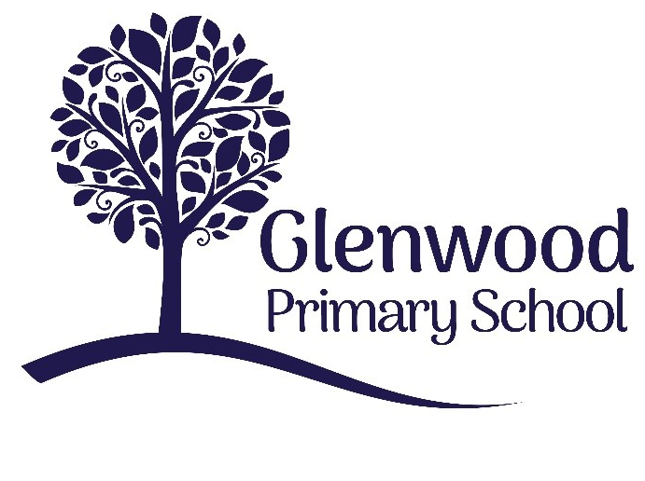

Glenwood Primary School
Equality & Inclusion Policy

‘Together we aim to develop confident, compassionate, and resilient learners who are equipped to thrive in an everchanging world’.

Policy update: | Apr 2022
Policy to be reviewed by: | April 2024
Signed by Principal: |  | Date:
Signed by Chair of Governors: |  | Date:

Ethos statement
Glenwood Primary School is a nurturing and enriching environment where we foster a culture of kindness, empathy and mutual respect. Together we build a safe and caring school where everyone belongs and thrives.

Vision
At Glenwood Primary School we are dedicated to fostering an empathetic and inclusive atmosphere where every student is valued, inspired, and challenged to achieve their fullest potential.

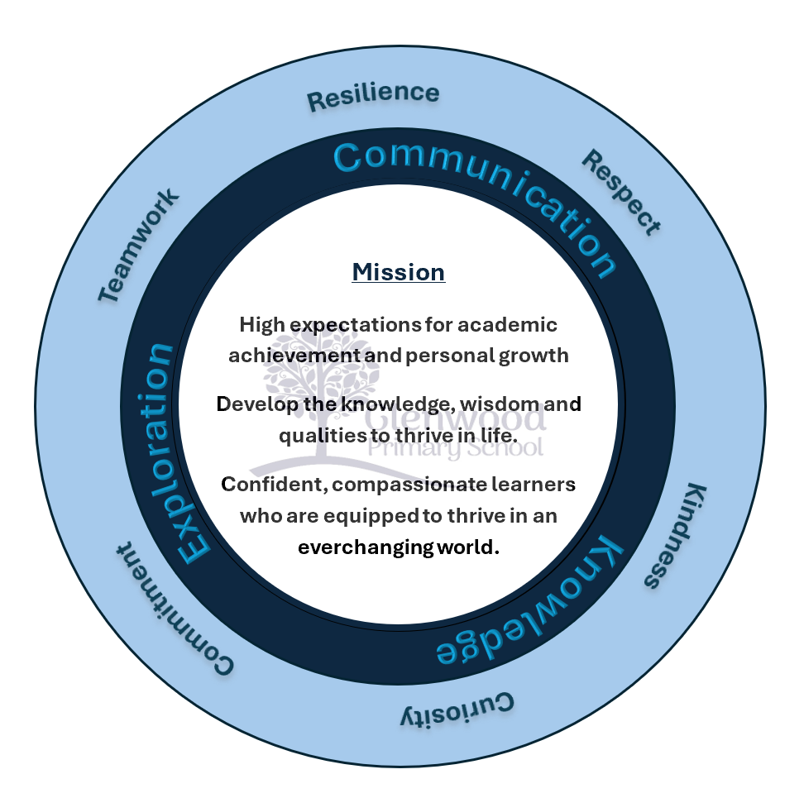

We help live our ethos and vision through the Glenwood Way
Move Calmly - Speak Nicely - Listen Carefully - Act Kindly - Do Your Best
Glenwood WISDOM qualities
TEAMWORK
RESILIENCE
RESPECT
KINDNESS
CURIOSITY
COMMITMENT

Introduction
Glenwood Primary School is committed to equality and inclusion. Our mission statement states that:
‘In Glenwood Primary School we endeavour to create a nurturing, caring supportive and stimulating environment to ensure that pupils feel happy, safe and secure in school and that they are able to develop emotionally, educationally, socially and physically so that they can fully maximise their potential.’

Rights Respecting School
As a Rights Respecting School this policy takes into account the U.N Convention on the rights of the child, including the following articles:

Article 2
“No discrimination – children have the right to be treated fairly”

Article 8
“Children have the right to their own identity”

Article 42
“Everyone should be aware of children’s rights”

We recognise the value of diverse environments and strive to promote a culture in which all pupils, staff and members of the school community are welcomed and supported to fulfil their potential, irrespective of their background or personal characteristics.
We are committed to an ethos and culture of inclusion in our Glenwood Primary School for all pupils, irrespective of race, religion/belief, political views, disability, SEN status, gender, gender identity (e.g. transgender) and/or sexual orientation (LGBTQ+).
Glenwood Primary School is an inclusive school where we focus on the well-being and progress of all our children and young people and where all members of our school community are of equal worth.
We recognise, respect and value difference and understand that diversity is a strength that enriches our lives. We take account of differences and strive to remove any barriers to learning and development.

Over the past decade Glenwood Primary School has seen a change in our school community demographic. Our community is now much more diverse. In particular, there has been a significant increase in the diversity of our pupils’ ethnicity and culturally backgrounds. We want all pupils to feel valued and welcomed in our school.

We oppose all forms of unlawful and unfair discrimination and bullying and harassment. As a school community, we recognise the need to champion equality and ensure inclusion for all pupils in the full life of our school; where appropriate making necessary adjustments to enable everyone’s participation.

Glenwood Primary School believes that education (both formal and informal learning) is fundamental to equality of opportunity. It prepares young people for life and is a powerful influence on access to and advancement in employment. All young people should be able to learn and develop fully in a truly diverse and inclusive environment.
All our policies and practices are fully inclusive and supportive of a welcoming culture for all communities; this is evidenced in our practices and procedures.

Equality and Inclusion - School Policies

Through this policy, and the wider practices within Glenwood Primary School we seek to empower our young people to embrace diversity and challenge discrimination. We equip our Governors and staff to fulfil their legal responsibilities, ensure that our school’s safeguarding procedures are comprehensive and inclusive and enable robust monitoring of our progress as a school.
Inclusion underpins all our school policies.

As part of our overall school policy development, there are a number of policies that we must have in place and regularly review to ensure our school is addressing its statutory responsibilities. These include Anti-bullying Policy, Safeguarding Policy, Curriculum Policies, Positive Behaviour Policy, Uniform Policy and Admissions Policy. Any arising incident will be dealt with by the appropriate policy. There should never be any grey areas when it comes to young people’s safety and well-being.

This is supplemented by a range of other policies that as a school we feel are important to have for our whole school community. It is our belief that equality and inclusion is central to all of our policies and that we maintain an ethos that welcomes diversity and promotes equal opportunities for all, ensuring all our pupils and their families feel valued and supported and making sure that equality and inclusion is evident in everyday school life.

Responsibilities
The Board of Governors of Glenwood Primary School have overall responsibility to:

- ‘Promote equality, good relations and diversity and to comply with education and employment legislation and anti-discrimination, human rights and equality legislation that affect its statutory duties in relation to the school’ ‘Every school a good school – the governors role’ (Department of Education NI, August 2019)

- The Governors have overall responsibility to manage the implementation of equality and diversity in our school.

The Principal is responsible for:
  - ensuring policies and procedures are in place to comply with equality legislation;
  - ensuring the school implements policies and practices in line with the principles of equality and inclusion;
  - following the relevant procedures and taking action in cases of unfair discrimination, harassment or bullying;
  - ensuring appropriate training and awareness raising is undertaken with staff;
  - ensuring that appropriate records are kept of any cases of unfair discrimination, harassment or bullying.
The Senior Leadership Team are responsible for:

- putting the school’s equality and inclusion policies and codes into practice;
- making sure that all staff know their responsibilities and receive the support and training necessary to carry them out;
- following the relevant procedures and taking action where necessary.

- The Safeguarding Team (led by the Designated Teacher and the Deputy Designated Teacher) will manage the implementation of the policy in partnership with the Principal.
- All School Staff (teaching and non-teaching) have a responsibility for the day-to-day operation of this policy and will contribute to an inclusive and welcoming environment within the school.

- Pupils/students are responsible for:
  - respecting others in their language and actions;
  - following all of the relevant school policies and codes of conduct in line with the principles of equality and inclusion.

How do we promote Equality and Inclusion?

Glenwood Primary School promotes diversity and inclusion through the following activities:

School /Centre Practices

- Develop a whole school approach
- Have an inclusive mission statement

- Use a range of resources and teaching approaches
- Use appropriate terminology and language
- Tackle stereotypes
- Challenge homophobic, transphobic or any other type of bullying
- Increase the visibility/ role modelling of minority groups
- Set clear expectations about acceptable behaviour

Facilities/ Services

- Promoting and using interpreting services
- Having an accessible main entrance and building
- Having signage, displays and resources reflecting all languages and cultures throughout the school
- Considering flexible payment schemes when planning trips and extra-curricular activities
- Helping young people to access advice from support organisations including notice boards with clear and accessible information and contacts.

Curriculum
- Examining where and when themes around equality and inclusion might be embedded into topics within each curriculum area
- Holding equality and inclusion themed events on a regular basis and following up on these
- Participating in Shared Education and other programmes such as Schools of Sanctuary
- Ensuring that staff with specific areas of responsibility consider the implications of Equality and Inclusion with their teams.

Monitoring the Success of the Equality and Inclusion Policy
Equality and Inclusion will be monitored in the following ways:
- Safeguarding team meetings to have Equality & Inclusion as an agenda item;
- Governors to report on the successes and challenges in relation to inclusion;
- Number of bullying incidents by equality characteristic to be monitored and appropriate action taken as necessary;
- Embedding of equality and inclusion across curriculum areas to be monitored;
- Number of comments and complaints in relation to equality and inclusion to be monitored;
- a Record of training / information presented to staff/ pupils to be kept;

- Positive stories on equality and inclusion to be highlighted;
- Feedback from pupils, staff, parents and the wider community to be sought

Complaint’s Procedures
The school has a robust and transparent complaints procedure. If a complaint is made regarding equality or inclusion, the Complaints process will be fairly and systematically applied.

Review cycle of policy
The Equality and Inclusion Policy will be reviewed by the Safeguarding Team and, if required, updated every three years in line with our school policy review cycle.

