

Glenwood Primary School

Health Education Policy

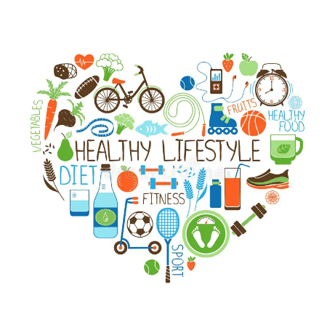
Ethos statement
Glenwood Primary School is a nurturing and enriching environment where we foster a culture of kindness, empathy and mutual respect. Together we build a safe and caring school where everyone belongs and thrives.
Vision
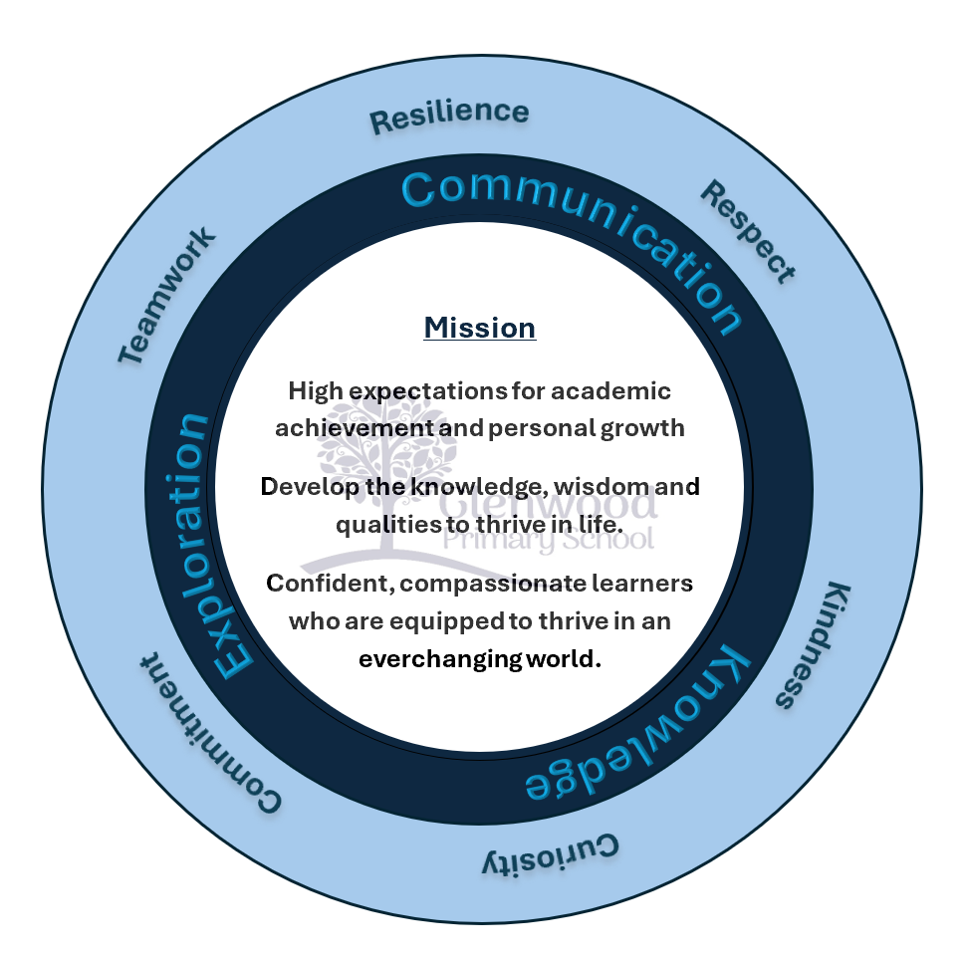
At Glenwood Primary School we are dedicated to fostering an empathetic and inclusive atmosphere where every student is valued, inspired, and challenged to achieve their fullest potential.

We help live our ethos and vision through the Glenwood Way
Move Calmly - Speak Nicely - Listen Carefully - Act Kindly - Do Your Best
Glenwood WISDOM qualities
TEAMWORK
RESILIENCE
RESPECT
KINDNESS
CURIOSITY
COMMITMENT

Health Education Policy
At Glenwood we are aware of our role in helping pupils to develop a healthy lifestyle. We see Health Education as something that should be reinforced in all aspects of school life.
Aims
At Glenwood Primary School we aim to:
- Create an environment, which promotes the health and well-being of all staff and pupils.
- Deliver Health Education within the curriculum in a way that is meaningful and which complies with statutory requirements.
- Ensure that all aspects of school life promote positive health messages.
- Encourage the active involvement of parents, community and health service agencies to advise, support and contribute to the promotion of good health.
- Deliver Health Education as a cross-curricular issue and take every opportunity to address the issue as an integral part of teaching.

Overview
Health Education includes planned and incidental learning opportunities, which can be used to develop behaviour that is conductive to good health.
We strive to equip our children with the skills and knowledge necessary to make informed decisions and responsible choices in matters relating to their health and well-being.
We believe that Health Education must address both physical and mental health.
There are a number of dimensions to Health Education:
- Personal Development
- Physical Fitness, Recreation and Relaxation
- Nutrition
- Drugs and Harmful Substances
- Relationships within the family
- Relationships with Peers
- Relationships with Others
- A Healthy Environment

Personal Development and Mutual Understanding
The children should understand the stages involved and the factors, which govern physical and emotional health.
Strand One – Health, Growth and Change
Key Stage One
Children should have opportunities to explore:
- Recognising and valuing the options for a healthy lifestyle, including the benefits of exercise, rest, healthy eating and hygiene
- Having respect for their bodies and those of others
- Being aware of the stages of human growth and development
- Recognising how responsibilities and relationships change as people grow and develop
- Understanding that medicines are given to make you feel better, but that some drugs are dangerous
- Understanding that if not used properly, all products can be harmful
- Being aware that some diseases are infectious and some can be controlled

Key Stage Two
Children should have opportunities to explore:
- How to sustain their health, growth and wellbeing
- Understand the benefits of a healthy lifestyle, including physical activity, healthy eating, rest and hygiene
- Recognise what shapes positive mental health
- Know about the harmful effects tobacco, alcohol, solvents and other illicit and illegal substances can have on themselves and others
- Understand that bacteria and viruses affect health and that risks can decrease when basic routines are followed
- Know how the body grows and develops
- Be aware of the physical and emotional changes that take place during puberty
- Know how babies are conceived, grow and are born
- Be aware of the skills for parenting and the importance of good parenting
- Recognise how responsibilities change as they become older and more independent
- Know that AIDS is a prevalent disease throughout the world and is a major health issue for many countries
Aspects of this strand are clearly identified and addressed in the following:
- World Around Us
- RE
- Language and Literacy
- Physical Education/Physical Development and Movement

Physical Fitness, Recreation and Relaxation
Pupils should achieve and maintain an appropriate level of fitness. They should understand the role of recreation and the value of relaxation.
This strand is delivered primarily within the PE programme and through the varied programme of after school clubs, which includes different sports, hobbies and topics of special interest.
Pupils are encouraged to practise personal hygiene in relation to physical activities and to acknowledge relevant rules and safety procedures.

Nutrition
Pupils should be given the information and skills to enable them to make responsible decisions about their diet.
They should know and understand the contribution of food to growth and health.
Children will:
- Learn about a healthy diet
- Explore relationships between diet and dental health
- Develop an understanding of and practise the safe handling of food
- Be encouraged to bring a healthy snack for break time including water to drink during class time.
- Be encouraged to eat a balanced lunch, containing fruit and vegetables
Much of this area is delivered through ‘World Around Us.’

Drugs and Harmful Substances
Pupils should develop their knowledge and understanding of the use, misuse, risks and effects of drugs and other potentially harmful substances.

Relationships Within The Family
Through sensitive discussion and study, children should recognise the importance of the family unit and the part each member can play. They will consider the roles and responsibilities of family members.
Relationships With Peers
Children will be given the opportunities to explore friendships, peer pressure and the influence of peer groups. They will be encouraged to develop and practise a sense of fair play, tolerance, sharing and cooperation.
Relationships With Others
Children will come to understand the nature of relationships with others and through recognition of the school ethos will begin to establish responsible relationships within a widening community.
As well as becoming more confident in communicating with adults and handling social relationships, children will be given strategies to protect themselves in potentially dangerous situations.
Personal Safety In The Environment
Children should be able to cope safely and efficiently with their environment.
This involved helping children to:
- Develop an understanding of, and practise principles of Road Safety
- Be aware of the importance of a responsible approach to safety in the home and school environment
- Accept responsibility for the safety of themselves and others
- Acquire a knowledge of and competence in elementary first aid
A Healthy Environment
Children will consider the environmental factors which affect health.
They will have the opportunity to explore how the use of some natural resources can have a harmful effect on the environment.
They will come to understand how improvements can be made in their own locality to maintain healthy surroundings and will be aware of the part that they can play in this.
Roles And Responsibilities
Staff
All staff will actively support, contribute to and be involved in the promotion of good health.
All staff will participate in staff development as and when necessary.
Staff will encourage a healthy break/snack time, drinking of water during class time and especially reinforcing the need after participating in physical activity.
Parents
Parents are asked to support the school in the promotion of good health, particularly in encouraging children to participate in sports and after school activities and in the provision of healthy snacks and lunches.

Governors
The governors will monitor the implementation of this policy and evaluate and review regularly.

Outside Agencies
Advice, information and guidance from the following agencies are used in the forming of this policy and the delivery of Health Education.
- CEA/NI Curriculum
- Health Promotion Agency
- Sure Start
- Cancer Focus NI
- Action Cancer
- Dairy Council
- Dentist Association
- School Nurse
- School based coaching programmes
Internet Addresses
http://www.teachernet.gov.uk/pshe/
http://www.bbc.co.uk/schools/4_11/pshe.shtml
http://www.wiredforhealth.gov.uk/cat.php?catid=842
http://www.thegrid.org.uk/learning/cit-pshe-healthy/

