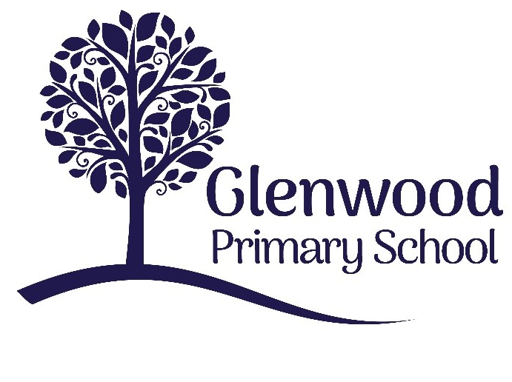

Glenwood Primary School
ICT Policy

‘Together we aim to develop confident, compassionate, and resilient learners who are equipped to thrive in an everchanging world’.

Policy update: | June 2025
Policy to be reviewed by: | June 2026
Signed by Principal: |  | Date:
Signed by Chair of Governors: |  | Date:

Ethos Statement:

Glenwood Primary School is a nurturing & enriching environment where we foster a culture of kindness, empathy & mutual respect. Together we build a safe & caring school where everyone belongs and thrives.

School Vision:

At Glenwood Primary School we are dedicated to fostering an empathetic & inclusive atmosphere where every student is valued, inspired, & challenged to achieve their fullest potential.
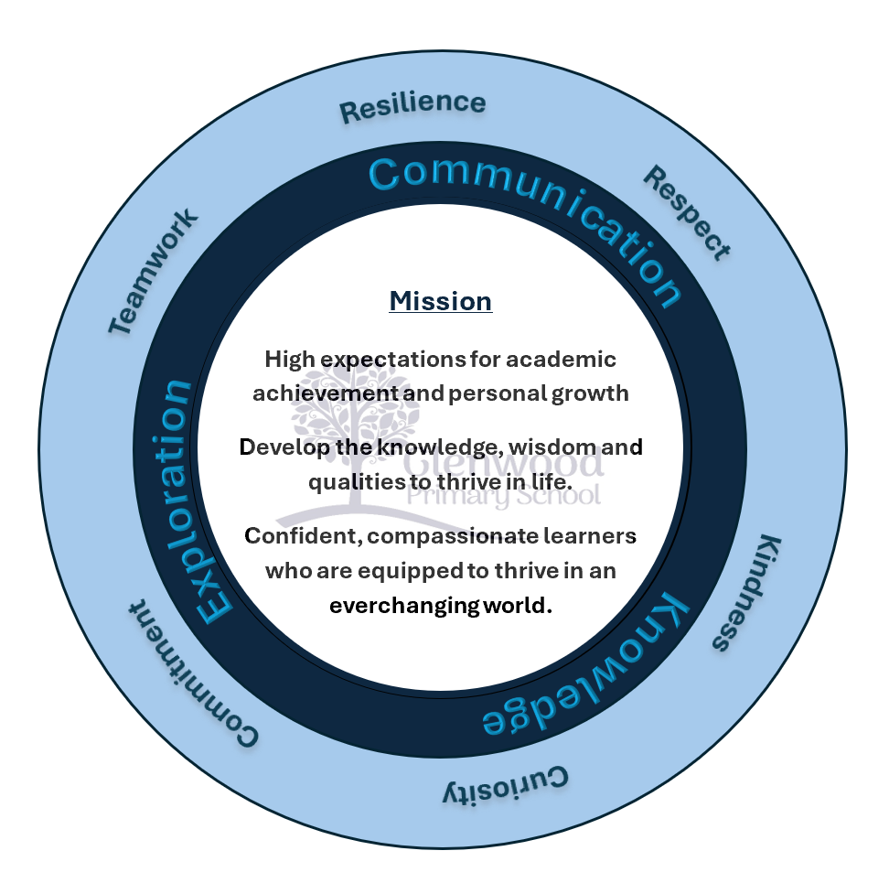

We help live our ethos and vision through the Glenwood Way
Move Calmly - Speak Nicely - Listen Carefully - Act Kindly - Do Your Best
Glenwood WISDOM qualities
TEAMWORK
RESILIENCE
RESPECT
KINDNESS
CURIOSITY
COMMITMENT
Purpose
This policy reflects the school’s values in relation to the teaching and learning of ICT. It gives guidance on planning, teaching and assessment.

Vision
Our vision is for all teachers and pupils in our school to become confident users of ICT so that they can develop the skills, knowledge and understanding which enables them to use appropriate ICT resources effectively as powerful tools for teaching and learning.

Introduction
Information and Communications Technology (ICT) prepares pupils to participate in a rapidly changing world in which work and other activities are increasingly transformed by access to varied and developing technology. We recognise that Information and Communications Technology is an important tool in both the society we live in and in the process of teaching and learning. Pupils use ICT tools to find, explore, analyse, exchange and present information responsibly, creatively and with discrimination.

Rights Respecting School

Glenwood Primary School is a Rights Respecting School. This impacts all aspects of school life, including ICT.
Article 3 states ‘The best interests of the child must be a top priority in all decisions and actions that affect children.’
All planning will take account of the needs and interests of each child.
Article 13 states ‘Every child must be free to express their thoughts and opinions and to access all kinds of information, as long as it is within the law’.
Therefore all children will have the opportunity to access information in school appropriate to enhance their learning.
Article 16 states ‘Every child has the right to privacy. The law should protect the child’s private, family and home life, including protecting children from unlawful attacks that harm their reputation.’
We will ensure appropriate filters and teaching on E-Safety to promote safer internet both in school and at home.
Article 17 states ‘every child has the right to a reliable information from a variety of sources, and governments should encourage the media to provide information that children can understand. Governments must protect children from materials that could harm them.’
Therefore it continues to be our responsibility to protect children from information that is inappropriate and to show children how to behave online. School will take an active part in informing parents of information which will help keep them informed on online safety issues.

Aims of ICT
Using ICT in Learning & Teaching:
- To enable pupils to become autonomous, independent users of ICT, gaining confidence and
enjoyment from their ICT activities.
- To extend and enhance learning across all areas of the curriculum.
- To develop pupil and teaching staff use and understanding of MY-SCHOOL.
- To encourage pupils to select and use ICT appropriate to the task.
- To develop skills in the use of ICT and the ability to apply these skills in a range of curricular contexts.
- To give children access to a variety of sources of information.
- To ensure teaching staff are motivated and skilled in the use of ICT and aware of the contribution ICT can make to learning and teaching.
- To enable pupils to develop the skills of using ICT safely and responsibly in a safe learning environment.

Using ICT in Management
- To develop a whole school approach to ICT ensuring continuity and progression in all strands of the Northern Ireland Curriculum.
- To use ICT as a tool to support teaching, learning and management across the curriculum.
- To engage with parents to help facilitate their input to supporting their children’s learning.
- To support communication with parents and the wider school community.
- To encourage sharing of resources and good practice through ICT.
- To increase professional efficiency through the use of ICT systems for planning, record keeping, reporting and communicating.

Rationale
What our pupils gain from ICT
- ICT can enhance and enrich pupils’ learning across the curriculum.
- ICT provides a vehicle for the development of pupils’ creativity.
- ICT can motivate and enthuse pupils.
- In today’s information society, pupils need to develop ICT skills in order to access relevant information.
- ICT offers potential for effective group work and collaborative learning.
- ICT supports different types of learners – audio, visual and kinaesthetic.

Strategies for use of ICT
- Since the focus of the Northern Ireland Curriculum is now on ‘Using’ ICT skills, ICT is not taught as a distinct subject, but is a tool to be used in a variety of meaningful contexts throughout the curriculum.
- ICT is planned and delivered as an integral part of each curriculum area to support and enrich children’s learning.
- All pupils are given equal access opportunities through management of ICT resources.
- Use of ICT at home will continue to be encouraged through projects, homework and the use of Purple Mash and Espresso Education- online teaching & learning resource, which can be accessed through a home computer system, iPad, portable device or at the local library.

Access
ICT resources are deployed throughout the school to maximise access, to enhance teaching & learning and to raise attainment. Glenwood Primary School is well equipped with networked laptops and PCs in each class and 16 networked PCs and 1 networked laptop in the computer suite & a cluster area outside P2/P3. All teaching staff have been given a Microsoft Surface Pro 7 Plus device to facilitate high quality teaching and learning.

Pupil Access
All children have a unique username and password. P1 and P2 are given simplified logins. They know the importance of keeping their username and password private. Through C2K computers all children have access to software titles appropriate to their curriculum needs and learning needs. Through C2K computers all children have access to the Internet. Children in each classroom have access to printing facilities.

Teacher Access
All teachers have access to the C2K system with a unique username and password.
All teachers are aware of the importance of keeping their username and password confidential. Through C2K computers all teachers have access to software titles appropriate to their curriculum planning needs and classroom practice. Through C2K computers/laptops all teachers have access to the Internet. All teachers have access to laptops available for use on the network and for home use. All teachers have access to ICT equipment such as interactive whiteboard, iPad, digital camera, etc. to facilitate a variety of teaching approaches.

Every class has access to:
- a class PC
- a laptop
- iPads (minimum x10 per room)
- an Interactive Whiteboard
- Microsoft Surface Pro 7 Plus
- Bee-Bot (x10 shared)
- Green Screen (x3)
- Interactive whiteboard

Classroom Management of ICT Resources
Where appropriate, children will have opportunities to use ICT resources to carry out:

- Individual work
- Group activities
- Whole class activities
Children may share in a computer-led activity where an interactive whiteboard is used.

ICT through the networked system in the ICT suite is time-tabled for P2 –P7 classes to use for a minimum of one lesson a week.
All equipment, serial numbers and location are audited regularly.

Inclusion
Glenwood Primary School’s ICT facilities are available for use by all pupils and staff. All children will be given access to ICT regardless of gender, race, physical or sensory disability.
For pupils with learning difficulties and/or physical or sensory disability appropriate use of ICT can often enhance access to aspects of the curriculum. In co-operation with the SENCo we will endeavour to provide, wherever and whenever possible, appropriate software and hardware to enable such access. SENCo will liaise with peripatetic support teachers for children who have sensory or visual impairment.
Concessionary arrangements are employed during assessment testing. Special Needs teachers have access to a networked PC, laptops and iPads as well as an interactive whiteboard to support his/her everyday teaching and learning strategies.

Internet
The school has internet access in every classroom. Any use of the Internet will be strictly in accordance with the school’s Acceptable Use Policy, which has been communicated to staff, pupils, governors and parents. Annual permission is sought from parents for internet use.

ICT and the Northern Ireland Curriculum

Pupils should develop the skills of Using ICT by engaging in meaningful research and purposeful activities set in relevant contexts. They should use ICT to handle and communicate information, solve problems, pose questions and take risks. They should process, present and exchange their ideas and translate their thinking into creative outcomes that show an awareness of audience and purpose. They should also use ICT to collaborate within and beyond the classroom, to share and exchange their work and to exhibit and showcase their learning.

Using Information and Communications Technology is one of three cross curricular skills:
- Communication
- Using Mathematics
- Using Information and Communications Technology

Across the curriculum, at a level appropriate to their ability, pupils should develop their ICT skills to:

Explore
Pupils should be enabled to:
- access and manage data and information;
- research, select, process and interpret information;
- investigate, make predictions and solve problems through interaction with digital tools;
- understand how to keep safe and display acceptable online behaviour.

Express
Pupils should be enabled to:
- create, develop, present and publish ideas and information using a range of digital media;
- create information and multimedia products using a range of assets.

Exchange
Pupils should be enabled to:
- communicate using a range of contemporary methods and tools;
- share, collaborate, exchange and develop ideas digitally.

Evaluate
Pupils should be enabled to:
- talk about, review and make improvements to work, reflecting on the process and outcome;
- consider the sources and resources used
.
Exhibit
Pupils should be enabled to:
- manage and present their stored work;
- showcase their learning across the curriculum.

Using ICT skills across the curriculum

Literacy
ICT is a major contributor to the teaching of Literacy
- Children learn how to draft, edit and revise text.
- Children can create, develop present and publish ideas and opinions visually or orally.
- They learn how to improve the presentation of their work by using desktop publishing and presentational software.
- Explain ideas and offer perspective using Green Screen.

Numeracy
Many ICT activities build upon the mathematical skills of the children.
- Children use ICT in Numeracy to collect data, make predictions, analyse results, and present information graphically.
- They can explore mathematical models e.g. use of Bee-bots, Pro-bots and understand the concept of Coding through sprites in Scratch.
- Many interactive whiteboard activities are used to enhance the teaching of numeracy throughout the school.

Personal Development and Mutual Understanding (PDMU) and Citizenship
ICT makes a contribution to the teaching of PDMU and citizenship as children learn to work together in a collaborative manner.
- They develop a sense of global citizenship by using the Internet.
- Through the discussion of moral issues related to electronic communication, children develop a view about the use and misuse of ICT.
- They also gain a knowledge and understanding of the interdependence of people around the world.
- Understand how to be responsible citizens in the digital world with a specific focus during Internet Safety Week (annually).

Creative and Expressive
ICT offers children the freedom to express their own ideas creatively and to experience the designs of others.
- Children will have the opportunity to develop their creativity through a range of network software and digital technology.
- They can explore the Internet to gain access to a wealth of images and information about world famous pieces.

World around Us
ICT transcends the barriers of distance and opens up the world as an easily accessible global community allowing children to experience the past, present and future of the world they live in.

Planning, Progression Monitoring and Evaluation

Planning
- Planning for ICT ensures coverage of the statutory requirements for ICT as set out under the five ‘E’s – Explore, Express, Exchange, Evaluate and Exhibit.
- All pupils have opportunities to develop a wide range of skills and competencies commensurate with their age and abilities as they progress through the school from P1 to P7.
- Priorities for ICT development will be identified in the School Development Plan year on year.
- All staff are involved in creating schemes of work in ICT which display progression and continuity for children from year 1 to year 7.
- Understanding and integrating different ‘types’ of ICT into our planning ensures that our pupils are experiencing a breadth of experiences in ICT.

Progression
- All children develop and learn at their own pace.
- Staff are currently working towards developing suitable lines of progression for a range of desirable features.
- These will cover all areas of ICT and be embedded in the Northern Ireland Curriculum.
- Tasks are developed in each year group within existing curricular areas, drawing upon CEA UICT Tasks.

Monitoring
- Monitoring ICT will enable the ICT coordinator to gain an overview of ICT teaching and learning throughout the school. This will assist the school in the self-evaluation process, identifying areas of strength as well as those for development.
- Evidence, in the form of children’s work, covering all areas of ICT is stored within each pupil’s folder. Two samples of pupil work will also be saved in the ICT assessment folder.
- It is the responsibility of the ICT co-ordinator to monitor the standard and progress made by each pupil by gathering appropriate evidence during each school year. This is in preparation for the statutory assessment of Using ICT by every teacher from P3-P7.

Assessment
- ICT is assessed both formatively and summatively using the Skills Assessment at the end of each year.
- Formative assessment occurs on a lesson by lesson basis based on the lesson objectives and outcomes. These are conducted informally by the class teacher and are used to inform future planning.
- Electronic portfolios of pupils’ work are saved in the ICT Assessment folder.
- Staff hold moderation meetings, using the summative assessments to assign levels to pupils work at the end of each key stage.

Evaluating
- Teachers routinely evaluate their use of ICT in learning and teaching and the impact on pupil outcomes.
- Teachers maintain records of pupils’ ICT capability year on year showing evidence of progress in the five ‘E’s.
- Children complete self-assessment records at the end of each task, where appropriate (level 3 and above).

School Development Plan
The school’s action planning for ICT forms part of the overall School Development Plan, identifying and prioritising areas for development. This is reviewed on an annual basis, taking into account developments in technology and outcomes of monitoring and evaluation procedures.

Staff Development
We recognise the need for the on-going development of ICT capability to reflect the constantly changing nature of technology. We have a culture of continuing professional development of staff. This will be provided in accordance with the school development plan and based on audits of identified need as well as developments in technology. Where necessary we will enlist the support of external training facilitators.

Roles & Responsibilities

Senior Management
The overall responsibility for the use of ICT rests with the senior management of the school. The Principal, in consultation with staff:
- determines the ways ICT should support, enrich and extend the curriculum;
- decides the provision and allocation of resources;
- decides ways in which developments can be assessed, and records maintained;
- ensures that ICT is used in a way to achieve the aims and objectives of the school;
- ensures that there is an ICT policy, and identifies an ICT co-ordinator.

ICT Co-ordinators
There are two designated ICT Co-ordinators to oversee the planning and delivery of ICT within the school.
The role of the ICT Coordinator may include the following:
- To provide leadership and direction
- To ensure that the use of ICT is managed and organised to meet school aims and objectives
- To play a key role in school policy development in relation to ICT and teaching and learning
- To liaise with principal in order to set priorities and targets to improve ICT provision and include on the School Development Plan
- To support, guide and motivate colleagues - which may require the provision of training for staff
- To contribute to the monitoring and evaluation process
- To keep up to date with recent developments in ICT and advise colleagues appropriately
- To ensure continuing personal professional development
- To model good practice by integrating ICT effectively into curriculum planning, classroom teaching and the assessment of children’s work

The Subject Co-ordinator
There is a clear distinction between teaching and learning in ICT and teaching and learning with ICT.
- Subject co-ordinators should identify where ICT should be used in their subject schemes of work.
- This might involve the use of short dedicated programs that support specific learning objectives or involve children using a specific application which they have been taught how to use as part of their ICT study and are applying those skills within the context of other curriculum subjects.
- Subject co-ordinators work in partnership with the ICT co-ordinator to ensure all Northern Ireland Curriculum statutory requirements are being met with regard to the use of ICT within curriculum subjects.

The Classroom Teacher
It is the responsibility of the classroom teacher to:
- Contribute to whole-school planning for ICT
- Integrate ICT into curriculum planning, classroom teaching and the assessment of children’s work
- Ensure that any ICT resource/software used in the classroom is appropriate to curriculum needs and children’s learning needs
- Ensure health and safety practices are carried out
- Discuss and devise with the children rules for using the computer and have these clearly displayed in the classroom
- Implement the e-Safety Policy

Pupils
It is the responsibility of the pupils to:
- Only use their own login username and password
- Keep their username and password private
- Not access other people’s files without their permission
- Not change or delete other people’s work/files
- Ask permission before entering any website, unless my teacher has already approved that site
- Use the Internet for research and school purposes only
- Not use strong language, swear or aggressive behaviour when using e-mail etc
- Not give their name, address or phone number or arrange to meet anyone from online
- Not enter Internet Chat Rooms while in school
- Let my teacher know if I see anything I am unhappy with or I receive messages I do not like
- Understand that if they deliberately break these rules they could be stopped from using the Internet/E-mail and their Parent/Guardian will be informed

Internet Safety
The school has internet access in every classroom and in shared areas. Any use of the Internet will be strictly in accordance with the school’s Internet Acceptable Use Policy, which has been communicated to and agreed by staff, pupils, governors and parents.
- Internet access is planned to enrich and extend learning activities.
- Although the school offers a safe online environment through filtered internet access we recognise the importance of teaching our children about online safety and their responsibilities when using communication technology.
- All staff should under no circumstances give out their username and password to anyone else. Staff should log off when finished using a machine.
- Whilst Glenwood Primary School acknowledges that we will endeavour to safeguard against all risks we may never be able to completely eliminate them.
- All computers in school are linked to internet via the C2k network which has an Internet & E-mail filtering service and all teachers are encouraged to use the child-friendly search engine ‘squiggle’.
- All iPads are connected to C2K Network filtering service.

School Website

Our school website promotes and provides up-to-date information about the school, as well as giving pupils an opportunity to showcase their work and other aspects of school life. Written parental permission is sought at the start of each school year to cover the use of photographs and videos of pupils on the school website.

Class Dojo
Teachers will use the Class Dojo app to communicate with parents. This app enables teachers to share the children’s learning journey with family members and gives the opportunity for family to see the child’s learning in action, for example through photos. Parents/carers may use Class Dojo to send a message to the class teacher through the inbox option but should be aware that teachers do not use the app on a daily basis. Not all messages will be seen or replied to therefore any urgent or significant communications should be channelled through email or phone call to the school office. No messages will be replied to outside of the teaching day.

Appendix 1


Communication App Acceptable Use Agreement
The widespread availability and use of social media applications bring opportunities to understand, engage, and communicate in new and exciting ways. Our school will be implementing the Class Dojo communication app this year to enhance home-school communication. It is important that we are able to use these technologies and services effectively and responsibly.

Along with reading our school’s Communication App policy which can be found on our school website, users must sign this Acceptable Usage Agreement and a Consent form in order to gain access to a class account. Please note that if the Acceptable Use Agreement is broken in any way, the teacher reserves the right to remove a user from the class app.
Please read the following terms for using the communication apps and sign that you agree to them below.

It will be deemed unacceptable use if one;
-Uses inappropriate or disrespectful language.
-Shares information or pictures on the app with others.
-Shares information or pictures on the app on social media.
-Does not respect a teacher’s quiet hours.
I agree to the terms of using the communication application provided by my child’s class teacher.

Signed : ___________________________ Date: _____________________


Appendix 2

Communication App Consent form

Dear Parents/Guardians,

We are delighted to share with you that this school year our class will be using Class Dojo, a secure online journal where pupils and teachers can document and reflect on what the children are learning in class. This app is a great way to connect to your child’s classroom. It can be used as a way for parents and teachers to communicate and for you to see what your child has been up to in school. You can access your child’s profile via the website or app version on tablet or mobile phone and it is free to download.

I hope that you will enjoy using the app to connect to your child’s classroom and teacher this year. Please sign below and return this permission slip to connect your child to their class app. You will then receive a log in code to connect to the app.

.
————————————————————————————————————

Please sign below and return the form.

I give consent for my child’s photo, classwork, artwork and successes to be shared via our class portfolio on Class Dojo

Pupil Name: ___________________________

Parent Printed Name: ______________________

Parent Signature: ____________________ Date: ____________

Appendix 3

Communication App Policy

Background
Class Dojo provides a student-driven digital portfolio which engages parents with the learning taking place in the classroom. As a home-school communication platform, teachers can instantly message parents with text-based messages, pictures and videos. Teachers may add posts to individual parents or to all parents. Additionally, students can upload content to their own profiles to share their achievements and work with their parents but nothing is shared without teacher approval.
Parents access and set up an account using a unique parent code provided by their child’s teacher. Parents can only view their own children’s profile and whole class story, not those of any other students.

Privacy and Data Protection
Privacy protection is fundamental to both applications. All student, parent and teacher data are private and not shared with any third parties. Both apps are compliant with GDPR regulations regarding privacy.

Aims
- To establish more effective communication links with parents.
- To provide a digital portfolio of student learning.
- To facilitate home-learning.

Responsibilities
Staff
- Teachers are expected to create their own Class Dojo account and also download the free app onto their school ipad.
- Teachers should send out the acceptable use policy and consent form to parents.
- Teachers are expected to send out invitations only to the parents in their class who have signed the acceptable use policy and consent forms, and regularly encourage parents to join up.
- Teachers are encouraged to post regular updates on their class page- the amount is at your discretion.
- Teachers are encouraged to use the apps to send reminder posts and to share important information, including newsletters. In addition, celebrations of work should be shared either individually to parents or via the class page.
- Teachers should not share images of children whose parent have not signed the acceptable use policy and consent form.
- For those members of staff wishing to use the two-way communication function of the app, you are encouraged to set a ‘quiet hours’ on your page, whereby parents are informed that you may not read or reply to messages outside of the designated hours. It is at your discretion which times you choose to set (e.g 4:00pm- 8:30am) as long as you let parents know.

Parents
- Parents are reminded that urgent messages should still be communicated via the office.
- Parents should respect the teacher’s ‘quiet hours’ and not expect a reply during this time.
- Parents should be aware that teachers may not reply immediately, especially when teaching.
- Parents should ensure that children do not use their log in details to access the class app.

Children
- Children are expected to encourage their parents/carers to join Class Dojo or See Saw and they should be given the invitations promptly for their parents to join.

Monitoring of the Policy
It is the responsibility of all members of staff who use Class Dojo to ensure it is used according to this policy.
Misuse and Breaches of Acceptable Use
If the acceptable use agreement is broken in any way, the teacher has the right to remove a user from the class app.

