

Glenwood Primary School
Working With Learning Assistants Policy

‘Together we aim to develop confident, compassionate, and resilient learners who are equipped to thrive in an everchanging world’.

Policy update: | May 25
Policy to be reviewed by: | May 28
Signed by Principal: |  | Date:
Signed by Chair of Governors: |  | Date:

Ethos statement
Glenwood Primary School is a nurturing and enriching environment where we foster a culture of kindness, empathy and mutual respect. Together we build a safe and caring school where everyone belongs and thrives.

Vision
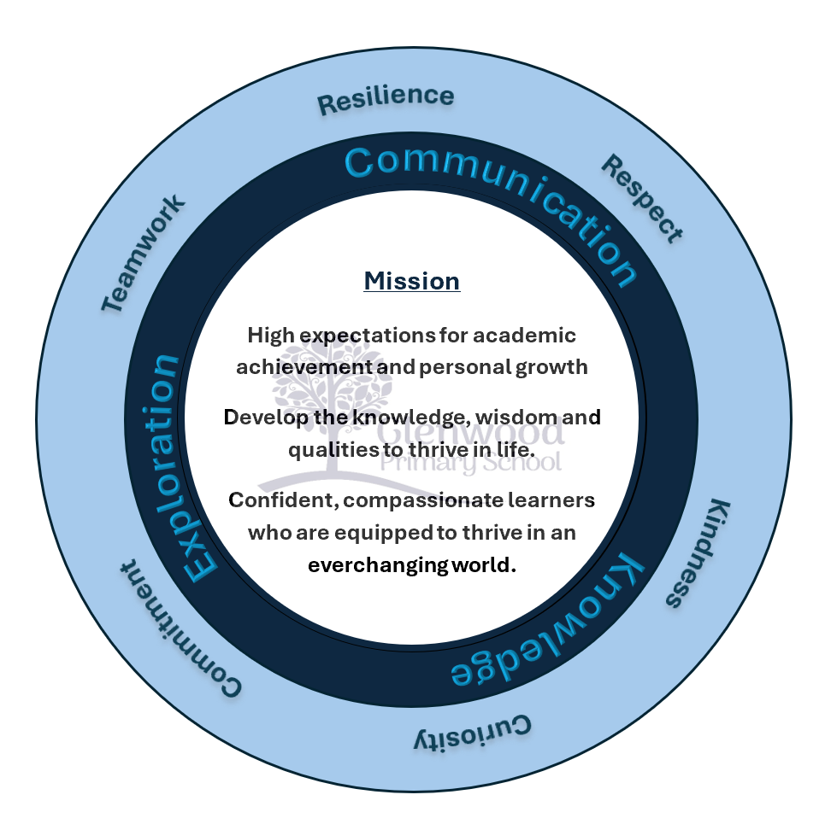
At Glenwood Primary School we are dedicated to fostering an empathetic and inclusive atmosphere where every student is valued, inspired, and challenged to achieve their fullest potential.

We help live our ethos and vision through the Glenwood Way
Move Calmly - Speak Nicely - Listen Carefully - Act Kindly - Do Your Best
Glenwood WISDOM qualities
TEAMWORK
RESILIENCE
RESPECT
KINDNESS
CURIOSITY
COMMITMENT

The Role of Learning Support Assistant (LSA)

To help raise standards through;
- Supporting the teacher – assist with the planning of learning activities, provide feedback to teacher about child’s progress, deal with incidents in line with Positive Behaviour Policy, establish professional relationships with parents.
- Supporting the pupil – Supervise and support, assist with development of PEP, Behaviour Plan and/or Risk Management Plan, set challenging and demanding expectations and promote independence, provide feedback.
- Supporting the curriculum – Undertake structured and agreed learning activities, prepare and maintain resources to meet their child’s needs, support use of ICT to develop competence and independence.
- Supporting the school – Be aware of and comply with policies, accompany staff and pupils on visits, participate in training, supervision of pupils at lunchtime.

Communication
Children with Statements must have ‘access to the assistant’ but the LSA can also work with other children in the class as they are there to support the teacher in supporting the child.
Assistants are to:
‘work under the direction of and in partnership with the teacher’ and it is ultimately the teacher who is accountable for the child’s behaviour or learning.
Therefore, good communication between the class teacher and Learning assistant is essential. It is vitally important that teachers have an initial meeting with the LSA to establish expectations for both parties and create the basis of a positive, reciprocal working relationship.
Class Teacher and LSA should discuss:
- The Class routines and rules
- The Hours the Learning assistants will work
- The expectations for the support and management of SEN pupils within the class
- Behaviour management - Consequences and rewards and who can implement these
- The yearly overview – Topics, trips etc.
- The Class timetable
- An established weekly meeting* to address the pupils progress, needs and strategies that have worked as well as preparing for the week ahead.
- Groups they will work with
*A weekly meeting needs to be timetabled for you and your assistant to talk about the week ahead. This could be on a Monday for 10-15 mins when children are engaged in an independent task such as ‘Silent Reading’.
Topics could include:
- Any issues from previous week
- What is happening in the coming week such as trips, subs coming in
- Ideas and strategies for activities ahead
- Sharing ideas, good practice
- Levels children are at and what needs to be targeted for improvement
Details from the weekly meetings can be recorded in a Daily Communication Diary which should also be used by teacher to outline anything they need the assistant to do throughout the day. This should be used by the LSA to communicate feedback on the child and report any issues that have arisen or areas that need discussed at the next meeting.
Record Keeping
The Learning Assistances will have a ‘File’ on the child/ children which is kept in the classroom that will include,
- Class timetable
- Copies of relevant policies (i.e. SEND/ Behaviour/ Safe Handling/ Health & Safety/Child Protection etc.)
- SEN Assistant guidelines information
- Child’s statement and any relevant information
- PEP’s, Behaviour plans, Risk Assessment Plans and evidence of targets being met
- Written record of incidents
- Resources
Potential Issues
- Seating - The LSA shouldn’t be placed beside the SEN pupil as this is not always conducive to their development, especially with the older children, however, there may be exceptions to this depending on the SEN pupil’s presentation in class. The LSA’s primary task is to support learning while promoting independence, good practice advocates bridging the gap between an SEN child and their ability to access the curriculum, it is not an intensive one-to-one intervention. The LSA should have her own work station set away from the child’s table.
- PEP and Behaviour plans – LSA’s can discuss with the SEN child the areas they will work on for their PEP targets. The class teacher and the LSA can then draft the PEP based on pupil’s views and learning/ behaviour needs. The LSA will have input into writing the review for their PEP and gathering evidence for this.
- Attendance – If the LSA is absent they are to contact Mr Wright and to let them know they will not be in so alternative arrangements, where possible, can be made.
- Annual Review- LSA are to be invited to Annual Reviews relating to the pupil they support and will have the opportunity to report on progress made since last review.
- Risk assessments – these will be completed with the LSA’s input and they will retain a copy for their file. This will offer guidance on their specific duties in relation to its implementation and management in line with relevant policies.
- Transitions – The LSA will supervise and support transitions to the playground /lunch hall and will be responsible for the management of the ‘Transition Plan’ when changing year groups/ schools etc.
Supporting Pupils (additional)

Classroom assistants can play an important role in supporting the child to learn by:

- fostering the participation of children;
- enabling children to become independent learners;
- maintaining children’s interest to enable repetition and reinforcement activities to take place;
- increasing children’s motivation;
- understanding the process of learning and provide scaffolding for children;
- adapting the learning environment, organising resources and supporting the classroom climate;
- assisting in maintaining the child’s self-esteem and self-confidence without the child feeling labelled by the support;
- encouraging independent learning without creating dependency;
- increasing the opportunities for social interaction and facilitating participation in group work;
- enabling children for whom English is an additional language to access the curriculum and make friends;
- setting high expectations for achievement of targets;
- valuing and celebrating the child’s progress;
- providing feedback to the teacher on potential points of difficulty.

Strategies to Encourage Interaction and Active Learning

The following strategies can be used by the classroom assistant to effectively encourage interaction and active learning:

1. S.O.U.L.
- S – Silent
- O – Observe
- U – Understand
- L – Listen

2. Participate in children’s play by:
- looking for natural play openings;
- joining in children’s play on the child’s level;
- playing in parallel with the children;
- referring one player to another;
- suggesting new ideas within ongoing play situations.

3. Encourage children’s problem solving by:
- looking for children to become involved in problem situations;
- allowing children to deal with problems and conflicting viewpoints;
- interacting with rather than managing children;
- assisting with the children to deal with unresolved conflicts.

4. Use encouragement strategies by:
- participating in children’s play;
- encouraging children to describe their efforts, ideas and products;
- acknowledging children’s work and ideas by making specific comments e.g. ‘l like the way that you said ‘thank you’ when Mary gave you the book.

5. Converse with children by:
- looking for natural openings for conversation;
- joining children at their level of conversation;
- responding to children’s conversational needs.

Providing effective feedback

When providing effective feedback to a child it is important that the LS/ classroom assistant:
- shows sensitivity to the child’s self-esteem;
- talks to the child about improving rather than correcting them, so that they can see feedback as something that is helpful and positive;
- focuses on success first, then improvement and next steps (two stars and a wish);
- links the improvement to children’s writing targets;
- offers guidance for making improvement;
- makes sure that the child contributes their thoughts and ideas about their own progress, learning needs and what to do next;
- responds to the content, word choice and sentence structure of the child’s work before commenting on the technicalities of punctuation, spelling and handwriting.

