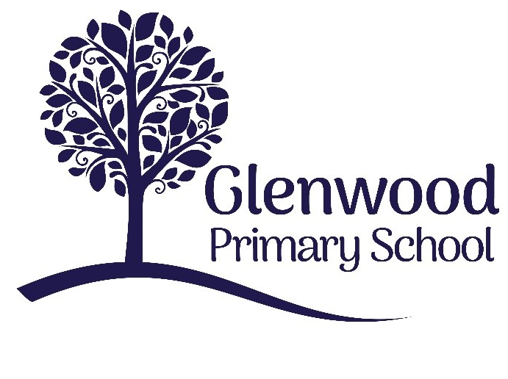

Glenwood Primary School
Music Policy

‘Together we aim to develop confident, compassionate, and resilient learners who are equipped to thrive in an everchanging world’.

Policy update: | Sept 2022
Policy to be reviewed by: | Sept 2025
Signed by Principal: |  | Date:
Signed by Chair of Governors: |  | Date:

Ethos statement
Glenwood Primary School is a nurturing and enriching environment where we foster a culture of kindness, empathy and mutual respect. Together we build a safe and caring school where everyone belongs and thrives.

Vision
At Glenwood Primary School we are dedicated to fostering an empathetic and inclusive atmosphere where every student is valued, inspired, and challenged to achieve their fullest potential.

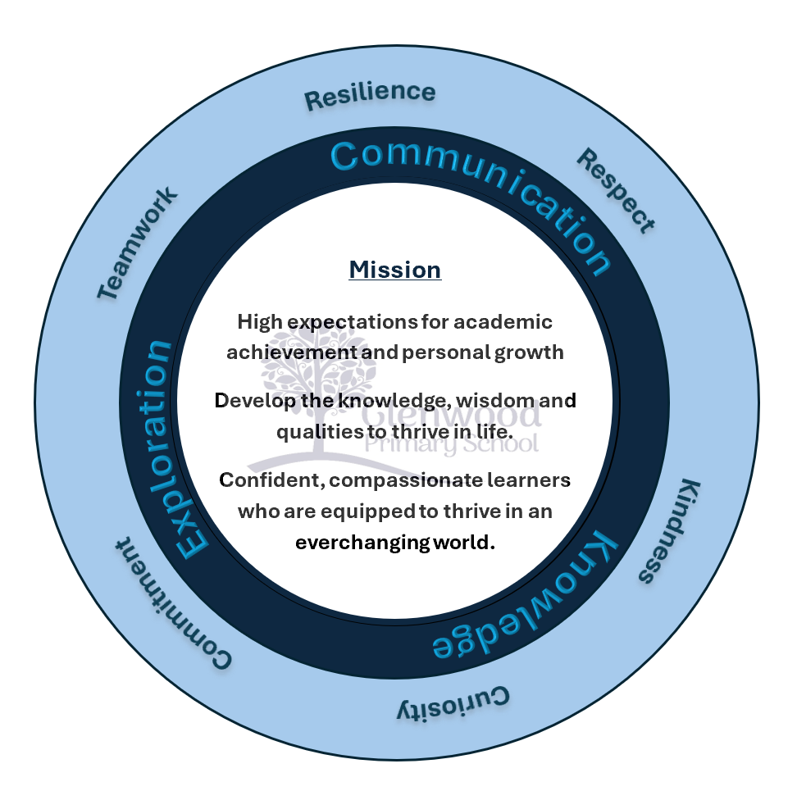

We help live our ethos and vision through the Glenwood Way
Move Calmly - Speak Nicely - Listen Carefully - Act Kindly - Do Your Best
Glenwood WISDOM qualities
TEAMWORK
RESILIENCE
RESPECT
KINDNESS
CURIOSITY
COMMITMENT

Music

Why we teach music

Children in Glenwood primary school will all have experienced some form of music at home, in the community and, for most, in a pre-school setting. We aim to build on these experiences with children continuing to have opportunities to listen to and make music.

The active involvement of pupils in listening, composing and performing activities will provide stimulation and enjoyment which will enable them to relate in a meaningful way to the world of sound and music and the way in which it is used for expressive purposes. This appreciation of music can then extend to the wider community and into adult life laying the foundation for a wider range and enriched leisure pursuits.

Aims for music

Our aim for music in Glenwood is to provide children with the experiences in which they can develop a range of concepts, attitudes and skills which constitute musical thought and behaviour.

We aim to provide experiences which will develop

﻿﻿Listening skills

﻿﻿Performing skills

﻿﻿Composing skills

In conjunction with developing these skills children will also have the opportunity to develop their social skills, self motivation, self esteem and self confidence.

Our Values

In Glenwood we aspire to the teaching of a balanced and broadly based curriculum to promote the cultural, physical, emotional, aesthetic and intellectual development of all pupils.

Important aspects of this approach are the provision of a secure and positive learning environment, the promotion of positive relationships and the encouragement of self-discipline where children are encouraged to set targets and build on their own personal successes.

Teaching Music in Glenwood Primary school

The music curriculum provides children with the opportunity to explore feelings and express themselves in ways that support or go beyond verbal communication. Music provides a context for developing creativity, self confidence and self esteem.

It has three main strands which are equally important and interdependent.

The three main areas are:

﻿﻿COMPOSING - Work creatively with sound

PERFORMING - ﻿﻿Singing and performing with simple instruments

LISTENING - Listening and responding to their own and others' music-making

All children will be encouraged to build upon their natural responses to music following the premise that all pupils are potentially musical.

Teaching Music

In teaching music we aim to

﻿﻿Enable children to understand that music is a way of expressing their thoughts, feelings and emotions

﻿﻿Enable children to understand that music is a form of communication

﻿﻿Enable children to nurture and harness their own creativity, acquire skills and develop confidence in using a range of instruments

﻿﻿Enable children to develop skills in responding to others music, and evaluating their own

﻿﻿Enable children to become independent in planning, evaluating and reviewing their work

﻿﻿Enable children to develop their full potential musically and extend their confidence, learning and skills into other curriculum areas.

﻿﻿Enable children to feel a sense of achievement and thus foster a positive experience of school in general

﻿﻿Enable children to read a variety of notes from a musical score

Music

Music lessons should

﻿﻿be thoughtfully planned and be taught regularly to ensure children can effectively build on their prior learning

﻿﻿allow children to develop their talking and listening skills in responding to their own music or that of others: Discussion of what 'story' they think the piece of music is conveying. What emotions does the composition evoke? What did they enjoy about the piece? How could improvements be made?

﻿﻿allow children, where appropriate, to take part in group work to create their own music.

﻿﻿allow children opportunity to create and perform their own music using a variety of different instruments including their voices

﻿﻿encourage respect for instruments and resources

﻿﻿where appropriate provide stimuli for children to respond to, linked to the learning taking place across the curriculum

FOUNDATION STAGE

Work Creatively with sound

Children should have opportunities to:

﻿﻿Explore vocal/body sounds e.g. high/low voice, tapping knees

﻿﻿Explore methods of making sounds e.g tapping, scraping, shaking using instruments and everyday objects

﻿﻿Talk about the sounds they make and hear e.g. high/low, long/short, fast/slow

﻿﻿Use a music corner/box to explore and create sounds e.g. sorting sounds into sets of wooden , skin or metal

﻿﻿Choose sounds to create effects or add atmosphere to parts of a story

﻿﻿Talk about sounds they hear in the environment and imitate these sounds

﻿﻿Make sounds represented by pictures e.g. hand=clap, foot=stamp

Sing and perform with simple instruments

Children should have opportunities to:

﻿﻿Listen to, join in and remember a range of rhymes, simple songs and singing games

﻿﻿Take part in singing activities as a class, a group or individual

﻿﻿Sing in a range of formal and informal situations throughout the day

Listen and respond to their own and others' music making

Children should have opportunities to

﻿﻿Listen to a variety of music, responding to the beat using appropriate actions e.g. nodding, tapping feet, clapping hands, marching

﻿﻿Listen to and respond imaginatively to short pieces of music e.g. choosing to sway, tip-toe, stride, stretch, curl

KEY STAGE 1

Work creatively with sound by investigating, experimenting. selecting and combining sounds to express feelings, ideas. mood and atmosphere

Children should opportunities to:

﻿﻿Investigate and experiment with ways of making sound e.g. using available digital resources, creating sound effects for stories, imitating sounds in the local environment and sounds in the home

﻿﻿Select sound sounds in response to a stimulus and to express mood and atmosphere e.g. high, quiet sound to represent a mouse

﻿﻿Draw pictures and patterns to represent the sounds and effects they create

Sing and perform with simple instruments to develop vocal and manipulative control

Children should have opportunities to:

﻿﻿Sing a variety of simple songs

﻿﻿Play simple instruments on their own to accompany singing

﻿﻿Begin to play instruments from memory, by ear or notation (recorder in P4)

Listen and respond to their own and others' music-making, thinking and talking about sounds, effects and musical features in music that they create, perform or listen to

Children should have opportunities to:

﻿﻿Think and talk about the sounds and effects they have created and imagined and those they hear in the local environment

﻿﻿Think and talk about simple features in songs they sing and music they listen to;

﻿﻿Use appropriate actions or movements e.g. through dance and drama

﻿﻿Listen to appropriate music and talk about the sounds in relation to loud/quiet, high/low, fast/slow and long/short

KEY STAGE 2

Work creatively with sound by creating musical stories, pictures, patterns, conversations, accompaniments and by investigating ways of preserving the music they have created

Children should have opportunities to:

﻿﻿Create stories and pictures through sound e.g. using voices and instruments

﻿﻿Create short musical patterns or musical conversations e.g. between two instruments and accompaniments

﻿﻿Investigate ways of preserving the music they have created e.g. graphic scores

Sing and perform with simple instruments from memory, by ear or from notation to develop vocal and instrumental skills

Children should have opportunities to:

﻿﻿Sing a variety of simple songs and simple rounds

﻿﻿Develop performing skills on a wider range of instruments and play simple accompaniments to songs

﻿﻿Play from memory, by ear or from notation

Listen and respond to their own and others' music-making. thinking about, talking about and discussing a variety of characteristics within music that they create, perform or listen to

Children should have opportunities to:

﻿﻿Discuss and make suggestions about their own and others' music making

﻿﻿Respond imaginatively through movement, drama and
dance

The Role of the music co-ordinator;

﻿﻿Monitor and evaluate teaching

﻿﻿Ensure the effective teaching of music

﻿﻿Offering support and advice to all staff

﻿﻿Auditing, organising and ordering music resources

﻿﻿Co-ordinating staff training

﻿﻿Organising outside agencies to come into school

﻿﻿Organise and plan for choir

﻿﻿Run an after school club

﻿﻿Ensure the musical progress and achievements of the children are celebrated

﻿﻿Ensure that there is a forum for children to perform

﻿﻿Organise hymn practice

Assessment/ Record Keeping and Reporting

Class teachers will plan activities which will continually develop pupils' musical understanding and their composing, performing and listening skills

﻿﻿Teachers assess children's work in music by observation throughout the lesson

﻿﻿Teachers will feed back to the children throughout the lesson and offer advice or praise where necessary

﻿﻿An annual report will be sent home to parents/guardians stating the progress of children in the Arts.

﻿﻿Children will have opportunity to peer assess and self evaluate their own work

Cross-Curricular Links

In Glenwood Primary School we encourage the use of music by each year group in whole school activities such as assembly, school performances and seasonal events. We recognise the importance of the contribution of music in all areas of learning.

Teachers are encouraged to identify opportunities in music activities that relate to other areas of learning.

The skills developed through music are transferable i.e.

﻿﻿Planning and evaluation

﻿﻿Self and peer assessment

﻿﻿Concentration

﻿﻿Listening

﻿﻿Discussion

﻿﻿Accuracy

﻿﻿Control

﻿﻿Self discipline

﻿﻿Observation

﻿﻿Working with others

﻿﻿Responding to others

Homework

Pupils who play recorder in school will be encouraged to practice for short periods at home.

Environment

Children will have the opportunity to perform and have their musical ability celebrated in front of an audience during performance assemblies, talent shows and seasonal plays.

All P4-P7 children will have the opportunity to join either the junior or school choirs which performs regularly throughout the year.

An after-school music club will be available through Glenwood Glee where children will have the opportunity to perform in school and in the wider community.

Provision for Special Educational Needs

Teachers are aware that some children may need constant positive reinforcements, simplified task breakdowns, adapted resource materials, simplified communications and considerations for their individual attention span.

The needs of children with physical disabilities or special educational needs will be taken into consideration through planning and differentiation.

Equal Opportunities

Teachers will ensure that equality of opportunity is provided for both boys and girls in composing, performing and listening activities.

Review

This policy will be reviewed on a 3 year cycle.

