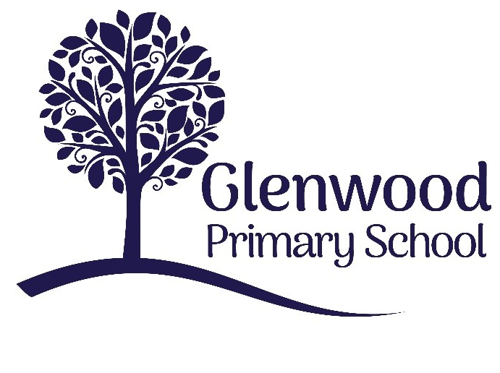

Glenwood Primary School
Positive Behaviour Policy

‘Together we aim to develop confident, compassionate, and resilient learners who are equipped to thrive in an everchanging world’.

Policy update: | Draft Sept 2023
Policy to be reviewed by: | Sept 2025
Signed by Principal: |  | Date:
Signed by Chair of Governors: |  | Date:

Ethos Statement:

Glenwood Primary School is a nurturing & enriching environment where we foster a culture of kindness, empathy & mutual respect. Together we build a safe & caring school where everyone belongs and thrives.

School Vision:

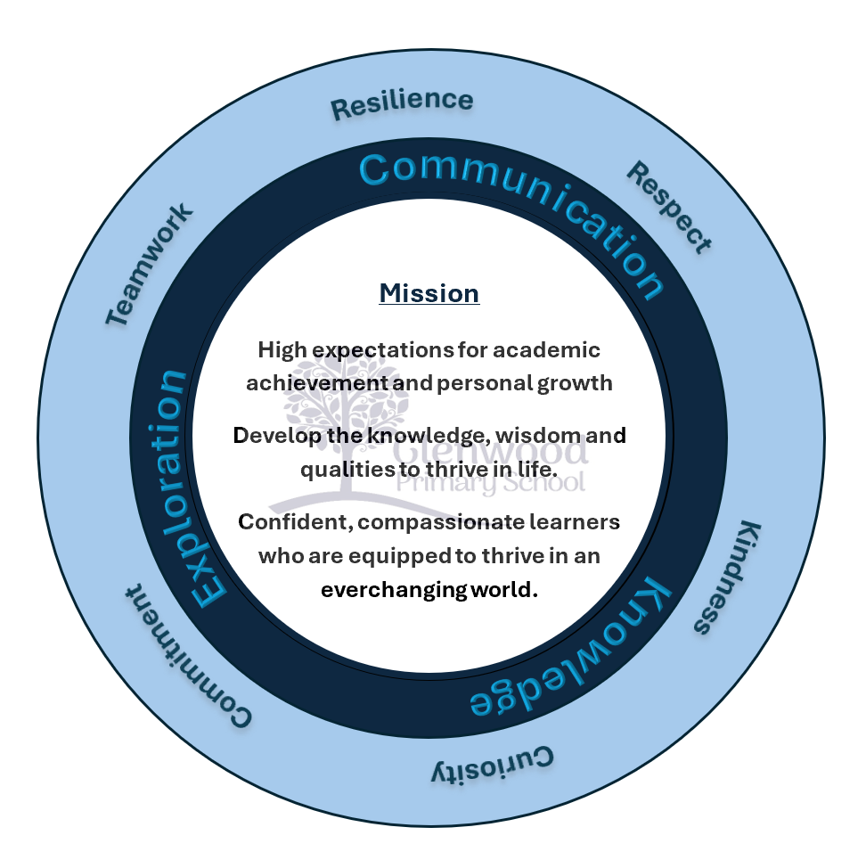
At Glenwood Primary School we are dedicated to fostering an empathetic & inclusive atmosphere where every student is valued, inspired, & challenged to achieve their fullest potential.

We help live our ethos and vision through the Glenwood Way
Move Calmly - Speak Nicely - Listen Carefully - Act Kindly - Do Your Best
Glenwood WISDOM qualities
TEAMWORK
RESILIENCE
RESPECT
KINDNESS
CURIOSITY
COMMITMENT

This Policy has been developed within the context of current legislation, policy and guidelines;

Current Legislation
- Health and Safety at Work (NI) Order (1978)
- The Children (NI) Order (1995)
- The Education (NI) Order (1998)- Articles 3&4
- Human rights Act (1998)- came into force in NI in 2000
- Welfare and Protection of Pupil’s Education and Libraries (NI) Order 2003
- The Education (2006 Order) (COMMENCEMENT NO.2) Ordr (NI) 2007
- The Education (School Development Plans) Regulations (NI0 2010
- Special Educational Needs & Disability (NI) Order (2005)
- Addressing Bullying in SCHOOLS Act (NI) 2016

DE Guidance
- Pastoral Care kin Schools: Promoting Positive Behaviour, DE 2001
- Safeguarding and Child Protection in Schools. A Guide for Schools, DE 2017

ETI
- Inspection and Self-Evaluation Framework

Mission Statement
In Glenwood Primary School we endeavour to create a nurturing, caring supportive and stimulating environment to ensure that pupils feel happy, safe and secure in school and that they are able to develop emotionally, educationally, socially and physically so that they can fully maximise their potential.
Ethos
The ethos of Glenwood Primary School is to safeguard all members of the school community, providing a caring, happy, secure, supportive and stimulating environment that allows pupils to develop educationally, socially, emotionally and physically at their own rate.
Important aspects of this approach are the maintenance of a secure environment, the promotion of positive relationships and encouragement of self-discipline. Pupil achievements and successes are celebrated and pupils are encouraged to take ownership of their role as citizens of both local and global communities.
A recognition and understanding of the importance of developing high self-esteem, self-respect and respect for others is central to establishing the environmental context of the school. There is an expectation that all adults will model and facilitate this for children. The school is characterised by being welcoming, inclusive, compassionate, stimulating and bright, non-threatening, calm, ordered and supportive of learning.

Aims of the Policy
This policy should create an environment that allows the following aims to be achieved:
- To clarify for teachers, classroom assistants, supervisory assistants, pupils and parents what is meant by ‘appropriate behaviour’ in our school.
- To provide a means for discussion and agreement on issues relating to behaviour in our school.
- To reduce the level of inappropriate behaviour in school.
- To promote learning for all pupils and make it easier for teachers to deliver the curriculum effectively
- Encourage pupil independence by accepting the need for self-discipline, self-control and taking responsibility for their own behaviour
- To encourage a positive learning environment in which we aim to raise children’s self-esteem and foster self-respect for others
- Develop the pupils’ interpersonal skills and their ability to work cooperatively with others to resolve problems and potential conflict
- To develop among staff, children and parents the sense of ‘belonging’ to the school community by reinforcing the idea that more can be achieved by everyone working together.
- To use charters as a means of upholding appropriate attitudes and provide consequences for those denying the rights of the child in line with UNICEF rights of the child.

What are the Rights of Staff, Pupils and Parents?
We feel that:
A child has the right to be educated in a safe and stimulating learning environment in which they are valued and respected. This is upheld by Article 28 of the UNRC convention.
They should be listened to and treated fairly. This is upheld by article 12 of the UNRC Convention.
Members of staff have the right to be respected, their judgements valued and to have their opinions listened to. As professionals they have the right to be treated as such and given the support of other members of staff and parents. They should be able to carry out the job of teaching in a stress-free and productive working environment, without harassment or physical/verbal abuse. All staff members have the right to privacy outside school.
Parents have the right to be respected and have the equality of treatment. Parents have right to confidentiality.

What are the Responsibilities of Staff, Pupils and Parents?
In upholding article 28 of the UNRC Convention they should not engage in behaviour which will disrupt a productive learning environment.
In upholding article 19 of the UNRC Convention they should not engage in behaviour which impinges on their own or on the safety of others.
In upholding article 29 of the UNRC Convention they should take care of their school environment by looking after their own personal belonging; have respect for school property; property belonging to the teacher or other children and the outdoor environment at school.
Teachers’ responsibilities are to:
- uphold article 3 ensuring ‘The best interests of the child’ are a top priority in all actions concerning children, in doing so they will provide a positive, safe, secure and stimulating environment in which the curriculum is delivered in a professional manner and where children are rewarded for good behaviour and achievement.
- Treat all children fairly, ensuring they are listened to and valued as individuals in order to enable them to achieve their full potential.
- Inform parents of their child’s academic and social progress and aim to create a partnership, in which teachers and parents work together.
- Collaborate together to overcome barriers to learning and ensure that the needs of those pupils on the SEN code of practice have their needs met.

A Parent’s responsibilities are to:
- ensure regular attendance, punctuality and that their child comes to school clean, tidy, well rested and ready to learn.
- Parents must uphold article 24 of the UNRC convention by ensuring that their child is provided with healthy food either as a school dinner or a packed lunch and have with them any books and equipment that may be needed.
- Ensure that homework is completed and produced on time
- Communicate effectively any information regarding their child or family circumstances to the teacher and / or Principal.
- Download the school app and sign up to Seesaw/Classdojo
- Parents should support the school to the best of their ability in all aspects of school life and act as positive role-models for their child in their relationship with the school.
When concerns arise about internal school matters parents should follow the procedures for dealing with such matters.
Pupil’s responsibilities are to:
- Be punctual, prepared and suitably equipped
- Respect the views, rights and property of others
- Work co-operatively with the other members of the school community
- Contribute to and adhere to the school’s underpinning values and principles and adhere to the Glenwood Way

Rewards and Sanctions
Staff will focus on teaching the behaviours they want to see. There will be a hierarchy of rewards and sanctions that take into account the frequency of the behaviour and the specific individual needs of the child. The school council will be consulted to provide pupil voice into the use of motivating rewards and effective sanctions. All stakeholders including classroom assistants and ancillary staff will be included in the development and promotion of rewards and sanctions.

Rewards Promoting Positive Behaviour
Staff will endeavour to ensure that rewards are as timely and immediate as possible
Rewards will:
- Provide incentive for the behaviour to be repeated
- Be varied - a range of individual and whole class incentives, as well as intrinsic and extrinsic motivators
- Include non-verbal actions e.g. smiling, thumbs up, high five, handshake
- Include verbal actions and written comments in books

Below are examples of individual and whole class rewards promoted throughout the school:
Individual Rewards | Whole Class Rewards
- Pupil of the Week  - Wonder Wonder award  - Manner of the Month award  - Recognition board  - Hot chocolate Friday  - Sticker charts  - Secret worker  - Name in the box  - Dojo dollars  - Vocal praise  - Sent to principal/vice-principal for praise  - Calm corner | - Table points  - Golden time  - Extra playtime  - Desk drumming  - Kahoot  - End of term treats

Sanctions for Unacceptable Behaviour
Efforts will be made to ensure sanctions are not seen as punishments, instead staff will focus upon achieving behavioural change. The school will endeavour to adopt a restorative approach which takes into account maintaining and restoring positive relationships.
Sanctions will:
- Take into account the age and emotional maturity of the child, and any special educational needs they may have; as well as their home background and any other relevant circumstances.
- Be applied as soon as possible in a calm, measured manner.
- Be proportionate and separate the behaviour from the child and will avoid escalating the situation
- Will not be applied to a whole class or group of pupils when it is clear they have done nothing wrong
- Will not degrade or humiliate pupils and will not involve physical force
Below are examples of individual sanctions that are implemented throughout the school when needed:
- Time out using timers
- Concentration chair
- Time owed
- Miss outs e.g. playtime
- Private restorative chats with class teachers about behaviour
- Removal from the room/sent to principal/vice-principal
In the event of more serious behavioural incidents, the school will adopt a more formal approach to sanctions. In these instances sanctions will be decided by the principal and senior leadership team and will always take into account the individual circumstances of the pupil(s) involved.

The Glenwood Way
All classes will display The Glenwood Way in their classroom. It is composed of the following behaviour guidelines:
- Act kindly
- Speak nicely
- Listen carefully
- Move calmly
Staff are able to add to the Glenwood Way to suit the aims and objectives of their classroom e.g. adding in a work ethic trope. Unit classes and
All staff will endeavour to adopt the language of The Glenwood Way when discussing behaviour with pupils and staff will be consistent in their approach of using it.
Class Behaviour Management Plan
At the start of each academic year each class teacher will devise a class charter linked to the Rights Respecting Schools award. This will include references to:
- Rights and responsibilities
- Learning behaviours
- Class rules and routines
- Class rewards and sanctions

Links to other policies
This positive behaviour policy has been written with reference and consultation with other school policies, including:
- SEN Policy
- Attendance Policy
- Safe Handling Policy
- E-safety Policy
- Safeguarding and Child Protection Policy
- Anti-bullying Policy

Policy review procedures
The policy should take into account current needs and be reflected in current practice. Collection and analysis of performance and other data (including SIMS) is an essential part of the SDP process, which requires schools to monitor and evaluate the school’s approach to: (c) promoting the health and well-being, child protection, attendance, good behaviour and discipline of pupils; This data should form the basis for the school’s Annual Report to their Board of Governors on how effectively the current Positive Behaviour Policy is, on the basis of the evidence, achieving its stated outcomes.

