

Glenwood Primary School
Policy on the Use of
Reasonable Force/Safe
Handling and Managing Challenging Behaviour.

‘Together we aim to develop confident, compassionate, and resilient learners who are equipped to thrive in an everchanging world’.

Policy update: | May 2025
Policy to be reviewed by: | May 2028
Signed by Principal: |  | Date:
Signed by Chair of Governors: |  | Date:

Ethos Statement:

Glenwood Primary School is a nurturing & enriching environment where we foster a culture of kindness, empathy & mutual respect. Together we build a safe & caring school where everyone belongs and thrives.

School Vision:

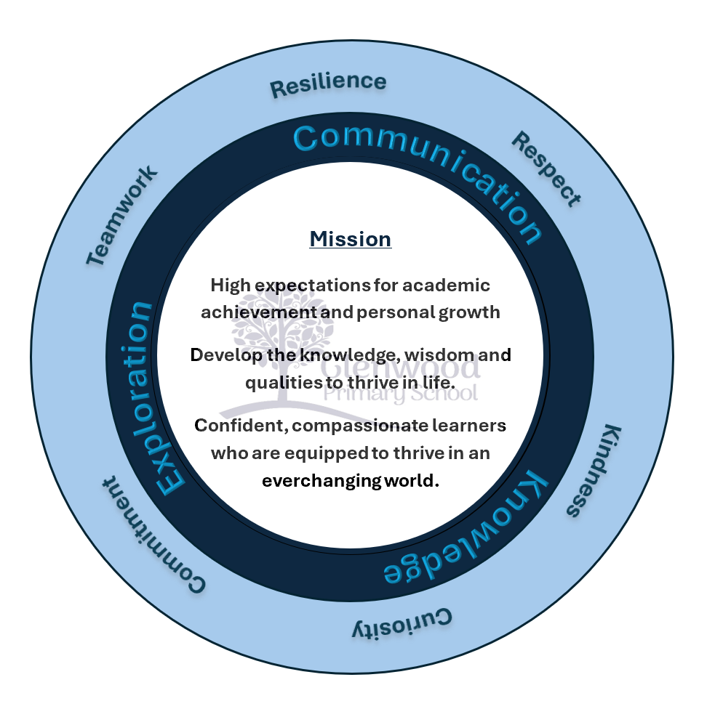
At Glenwood Primary School we are dedicated to fostering an empathetic & inclusive atmosphere where every student is valued, inspired, & challenged to achieve their fullest potential.

We help live our ethos and vision through the Glenwood Way
Move Calmly - Speak Nicely - Listen Carefully - Act Kindly - Do Your Best
Glenwood WISDOM qualities
TEAMWORK
RESILIENCE
RESPECT
KINDNESS
CURIOSITY
COMMITMENT

Principles
Glenwood Primary School believes that:
- Each child has the right to be educated in a safe and secure environment where each child’s moral, intellectual, personal, social, and emotional development is promoted.
- Parents and carers are informed and reassured that their children are being educated in a safe, caring, and respectful atmosphere.
- All staff have the right to work in a safe and secure environment.
These principles underpin our school ethos and culture.

Purposes
The following purposes underpin Glenwood Primary School’s policy and practices to:
- create a learning environment in which young people and adults feel safe.
- protect every person in the school community from harm.
- protect all pupils against any form of physical intervention, which is unnecessary, inappropriate, excessive, or harmful; and
- develop and implement guidance for staff (teaching and non-teaching) so that they are clear about the circumstances in which they might use reasonable force to restrain pupils and how such force might be applied.

Our Values
Glenwood Primary School is committed to providing an appropriate and high-quality education to all the children attending our school. We strive to ensure that Glenwood is a safe, caring, and respectful environment where all pupils have the right to:

- be educated in a safe & secure setting where they are protected from harm.
- a broad and balanced accessible academic and social curriculum
- feel valued, nurtured, and respected and are encouraged to care for one another.
- be fully included in all aspects of school life.

Part of the school’s strategic planning for improvement is to develop cultures, policies and practices that include all learners. As a Sanctuary and Rights respecting school we aim to engender a sense of community and belonging, and to offer new opportunities to all learners in a caring and safe environment.

Policy Rational & Aims:
This policy aims to reflect the ethos and values of Glenwood Primary School in its commitment to promoting positive behaviour interventions and restorative practices as well as ensuring the well-being and safety of pupils, staff, and parents. It also outlines school procedures for managing more significantly challenging behaviour which may require specific behaviour management plans on the completion of appropriate Risk Assessments and or Risk Reduction plans. We aim to;
- Establish a happy, caring, and supportive learning environment for pupils in which they can reach their potential and feel emotionally and physically safe.
- Foster positive caring attitudes towards everyone where all achievements are recognised and celebrated.
- Encourage independence and self-discipline so that each pupil will learn to accept responsibility for and understand the consequences of their behaviour.
- Model attitudes of respect, tolerance, honesty, and empathy.
- Ensure a consistent and sustained approach to behaviour throughout the school with an emphasis on early intervention.
- Ultimately protect all pupils against any form of physical intervention, which is unnecessary, inappropriate, excessive, or harmful.

Legislative Framework:
This policy has been formulated with due consideration to the following legislation:
- Children (NI) Order 1995 – duty to protect and child protection responsibilities / fulfilling responsibility.
- UN Convention on The Rights of the Child 1989 – (Articles 12, 16 and 19); UK 1991.
- Education (NI) Order 1998 (Part II Article 4(1)).
- Human Rights Act 1998 – Articles 3 and 5 of the European Convention on Human Rights.
- Health and Safety at Work Act (NI) Order 1978.
- Education and Libraries (NI) Order 2003 – Articles 17, 18, 19.

Links With Other Policies
This policy is one of the overall pastoral policies and dovetails into the school’s existing Behaviour policy, Anti-bullying policy, Child Protection policy, Special Needs policy, Health and Safety policy, Nurture Policy, ASD Policy, and Complaints policy.
It also takes account of the Staff Development and Welfare policy, the Staff Code of Conduct, Teaching, Learning and Assessment policy and other Curricular policies.

Definition of Reasonable Force
The Education (NI) Order 1998 (part II Article 4 (1)) states:
“A member of the staff of a grant-aided school may use, in relation to any pupil at the school, such force as is reasonable in the circumstances for the purpose of preventing the pupil from doing (or continuing to do) any of the following, namely:

- committing any offence.

- causing personal injury to, or damage to the property of, any person (including the pupil himself).

- engaging in any behaviour prejudicial to the maintenance of good order and discipline at the school or among any of its pupils, whether that behaviour occurs during a teaching session or otherwise.”

Based on this legal framework, the working definition of “reasonable force” is the minimum force necessary to prevent a pupil from physically harming him / herself or others or seriously damaging property but used in a manner which attempts to preserve the dignity of all concerned.

Situations covered in this policy will include:
- Planned intervention in which staff may employ, where necessary, pre-arranged strategies based upon a risk assessment and recorded within the pupils’ Personal Learning Plan and or Behaviour Support Plan; referral to Risk Assessment & Reduction plan; and
- Emergency or unplanned use of intervention/ force, which occurs in response to unforeseen events.

Practices

Preventative Strategies
Glenwood Primary School actively promotes positive behaviour management strategies thus reducing the need for the use of any form of physical intervention, except in emergency situations. Preventative strategies for inappropriate behaviour(s) are detailed in our school’s positive behaviour policy i.e. defusing and de-escalating conflict, confrontation, or aggression. There are different reward systems throughout the Key Stages and within the Specialist Provision Classes as well as incentive schemes such as ‘Pupil of the week’, ‘Wonder Worker’ and House Teams etc. Within these approaches there is a recognition of structured approaches in managing routine and communicating with our pupils about expected behaviours and presented activities. This is particularly of relevance to those pupils with learning difficulties and especially those with a diagnosis of ASD.

Existing Supports to manage and promote positive behaviour include:

- Ethos of support, reconciliation & restorative practice.

- Clear communication of rules and appropriate behaviours

- Effective routines and structured teaching approaches

- Reward Systems and effective recognition of achievement

- Consistency in dealing with behaviour/discipline difficulties.

- Positive Teaching approaches including modelling good behaviour.

- Appropriate levels of supervision at all times.

- Targets established within PLPs and/ or Risk Reduction Plans to manage and review behaviour.

- Effective monitoring and recording of pupil progress/observations.

- Effective and meaningful links with parents/guardians

- Boxall Assessments

In managing challenging behaviour, the ability, and understanding of the pupils, as well as the environmental factors which can impact on behaviour will always be considered.

Risk Assessment/ Risk Reduction Action Plan
Risk Assessment is one of our preventative strategies to minimise the risk of an incident escalating unnecessarily and will be a normal practice for our school where a pupil or a small number of pupils are known to exhibit disturbing or distressing behaviour (SBEW).

Risk assessment will be considered only for those pupils where there is a foreseeable risk and enables the school to plan and train accordingly.
Risk assessment will be considered from two perspectives.

- environmental risk assessment or
- individual risk assessment.
This should form part of the pupil’s education plan. (Appendices 1 & 2)

Procedures- Support Structures
The following Procedures have been agreed by Staff and adopted by the Board of Governors. Parents and Pupils will be informed of the schools’ procedures and support structures.

Roles and Responsibilities
We acknowledge there are many circumstances when a member of staff may have to decide between intervening/ using reasonable force, by placing themselves in a dangerous situation, or standing back and thereby allowing colleagues or pupils to face potential danger. There will always be an element of personal judgment in these decisions and there is always a possibility of someone being injured. However, it is reasonable to expect a member of staff to engage in some risk where there is evidence of danger to others and where intervention has a good chance of being effective.

Staff should not. However, put themselves in personal danger merely to safeguard property.

Reasonable force / safe handling can be used by any member of staff who is authorised by the principal to have lawful control or charge of pupils, e.g. teachers, classroom assistants, supervisory assistants. This may be on school premises or when authorised elsewhere e.g. supervision on educational trips, school sporting events, or field trips. The principal will confirm with all staff those who are authorised to be in charge of pupils at any given time.

Reasonable Force should be limited to emergency situations and used only as a last resort when all other behaviour management strategies have been exhausted and where:

- action is necessary in self-defence or because there is imminent risk of injury to another pupil or person.
- there is a developing risk of injury to another pupil or person, or significant damage to property.
- a pupil is behaving in a way that is compromising good order and discipline.

Examples that fall into the above categories are:

- a pupil attacks a member of staff, or another pupil.
- pupils are fighting.
- a pupil is causing, or at risk of causing, injury, or damage by accident, by rough play, or by misuse of dangerous materials, substances, or objects.
- a pupil is running in an area in which s/he might cause an accident likely to injure her / himself or others.
- a pupil absconds from a class or tries to leave school (Note: this will only apply if a pupil could be at risk if not kept in the classroom or at school).
- a pupil persistently refuses to obey an order to leave a classroom.
- a pupil is behaving in a way that is seriously disrupting a lesson.

Forms of Reasonable Force
When other behaviour management strategies have failed - it should be the minimum intervention or force that should reasonably be employed depending on the age, sex, physical strength, size, understanding, medical condition and any special needs of the pupil and used in a way that preserves the dignity and respect of all concerned.

The use of reasonable force / safe handling should involve a calm and measured approach at all times appropriate to the particular pupil and be in accordance with the schools’ agreed strategies. The following procedures should be adhered to at all times:

- tell the pupil to stop the inappropriate behaviour- using language in line with their understanding and communication/ receptive language skills.
- clearly state the desired/ appropriate behaviour and ask the pupil to comply.
- tell the pupil that physical intervention will take place if inappropriate behaviour continues.
- during the incident repeatedly reassure the pupil and tell him / her that physical contact will stop as soon as he / she is ready to behave appropriately.
- if the teacher, classroom assistant or supervisory assistant feels at risk, e.g. from a large or older group of pupils, send for the nearest staff support.

The forms of reasonable force that our members of staff may use will depend on the individual circumstances and are:

- separating children by safe restraint
- removing children from situations by leading them by the hand, wrist, or arm and or placing hands on the backs of elbows.
- separating pupils who are fighting, or who are about to fight.
- intercepting and stopping a pupil from absconding (blocking a pupil’s path/ using distraction techniques).
- Breakaway/ separating activities if staff member or another pupil is being grabbed.
- Protecting a pupil who is making efforts to self-harm e.g. hitting, scratching, biting themselves or headbanging. Use of Firm holding and soothing statements.
- shepherding a pupil away from negative or dangerous activities such as throwing equipment, climbing or being aggressive with others.
- using more restrictive holds (in extreme circumstances).

Every effort should be made by school staff to ensure that any use of reasonable force/ physical prompting as an agreed teaching/ support measure is communicated with parents.

Forms of Safe Handling
The forms of safe handling that our members of staff may use will depend on the individual circumstances and are:

- teaching a child to hold an adult’s arm appropriately whilst walking down a corridor or a staircase, or on a visit outside school.
- reacting instinctively to a situation by holding or restraining a child who is running onto a busy road or into a place of danger.
- physically prompting a young child as part of an educational or behaviour programme.
- assisting a child with toileting.

Health and Safety
When using reasonable force / physical intervention / restraint / safe handling, the pupil’s health and safety must always be considered and monitored. Physical interventions should involve the minimum amount of force necessary to resolve the situation and calm the pupil.

Limits on the Use of Force
The law strictly prohibits the use of force, which constitutes the giving of corporal punishment. The use of force as a punishment or to intentionally cause pain, injury or humiliation would contravene our Safeguarding and Child Protection Policy. Staff should never act in a way that might reasonably be expected to cause injury, for example by:

- holding around the neck.
- any hold that might restrict breathing.
- kicking, slapping, or punching or using any implement.
- forcing limbs against joints.
- tripping.
- holding or pulling by the hair.
- holding the pupil face down on the ground.
- staff should also avoid touching or holding a pupil in any way that might be considered indecent.

The use of reasonable force is only to be employed in exceptional circumstances or an emergency where a pupil appears to be unable to exercise self-control of emotions and whose behaviour is presenting a threat to himself / herself or others. A member of staff should not intervene in an incident without help if there is a risk that he / she may be injured or may endanger his / her life.

Record Keeping

Staff are required to record incidents of challenging or concerning behaviour in ‘CPOMS’. Staff will work to develop a picture of the behaviour through observation records and effective links with parents.

All incidents involving the use of reasonable force are recorded on our proformas ‘Pupil/ Staff Incident Forms and or Basic Incident Record Form – Appendix 3 & 4). The SENco/ Principal keeps an accurate up-to-date record of all such incidents.

In addition staff should consider completing a risk assessment for ongoing, concerning behaviour or any behaviour which presents as a ‘risk’. using observation and class monitoring. The risk assessment should aim to identify and highlight specific behaviours and those at risk from those behaviours. In order for staff to plan accordingly risk assessment will be considered only for those pupils who constitute a risk to themselves and others. A team approach should be used to complete the risk assessment and in linking it to the Pupil’s PLP and or developing an appropriate Behaviour Support Plan/ Risk Reduction Plan for pupils. Parents will be fully consulted in the development of the plan and their agreement via their signature will be sought. Relevant staff will work with SENco to finalise the agreed plan and its implementation. Any requirement for the use of Reasonable Force or Safe Handling will be cited. School staff will record and review plans on bi-annual basis or as required.

The Chairperson of the Board of Governors and the Principal will review annually all incident records. Records will be kept until the date of the child’s twenty-first birthday. Confidentiality and the young person’s right to privacy will always be respected.

The pupil’s views should also be recorded on the same day, where possible. This is reliant on pupil de-escalation, mood and engagement and may not always be possible.

The use of physical intervention can be upsetting to all concerned, therefore, it is important to ensure that staff and pupils are given emotional support and, where required, basic first-aid treatment. Immediate action should be taken to ensure that medical help is accessed for any injuries that require more than basic first aid. All injuries should be reported and recorded in accordance with the school’s procedures – parents / carers must be informed and allowed an opportunity to discuss. Where it is clear that the teacher / member of staff concerned needs further support, advice or training, the principal should take prompt action to ensure it is provided.

Contacting Parents / Carers
Parents / carers should be contacted as soon as possible, and the incident explained to them. This must also be recorded as defined in the school policy. Any complaint from a parent will be dealt with within the school’s complaints policy / procedures as detailed below.

Complaints
If an incident occurs involving the use of reasonable force / restraint by a member of staff, the procedures governing such incidents should be followed. This will include informing the parent(s) / guardian(s) of the child as outlined above. Any complaint from a parent or other will be dealt with according to the school’s Complaints Policy/ Procedure and in accordance with DE Safeguarding and Child Protection in Schools: A Guide for Schools’ 2017.

Staff who themselves are subject to physical violence or assault will be supported as appropriate. It is important to note that a member of staff should not intervene in an incident without help if there is a risk that he/ she may be injured or may endanger his/her life.

Staff Training and Development
All staff will have training in relation to ‘awareness raising’ of issues relating to the use of reasonable force/safe handling, procedures and practices relating to behaviour management and child protection policy and procedures. All staff will receive appropriate training and development, in line with the school’s Staff Development Policy, in the use of preventative strategies and approaches for managing difficult situations when they may arise.

Monitoring and Evaluation
Mr W. Wright will co-ordinate and oversee the policy and its implementation. The policy will be monitored and evaluated on an ongoing basis through consultation with pupils, staff, and parents and in line with statutory requirements or advice.

Appendix 1

Risk assessment

A small number of pupils may exhibit disaffected, disturbed, or distressing behaviour which may require some form of physical intervention by staff. To minimise the risks of incidents escalating unnecessarily due to lack of foresight, planning and training schools should carry out a Risk Assessment from 2 perspectives;

- environmental risk assessment; and
- individual risk assessment (Linked to Pupil Risk Reduction Action Plan – RRAP & Risk Management Plans RMP)

Environmental Risk Assessment

- Identify situations or locations where there is an increased risk of incidents happening.
- Analysis of past incidents to identify medium to high-risk locations.
- Staff and pupils consulted.
- Individual pupil consulted.
- Decide the appropriate type and level of supervision.
- Principal and Leadership Team to make recommendations to the Board of Governors on the type and level of supervision to minimise risk.
- Implement plan.
- Review plan.

Individual Risk Assessment

Where a school is aware that a pupil is likely to behave in a disruptive way, that may require the use of reasonable force/safe handling, the school should plan its response by:

- consulting the pupil, as appropriate;
- consulting the parents – specific action the school may need to take;
- briefing staff – what action they should be taking (may require training or guidance);
- managing the pupil – e.g. reactive strategies to de-escalate a conflict;
- ensuring that additional support can be summoned wherever possible;
- implementing plan and review;
- reviewing Plan.

Risk Reduction
Risk reduction should include:

- proactive measures to support the child effectively and prevent difficulties emerging;
- early interventions to help the child in difficult situations and avert problems; and
- planned measures to manage the child and others safely, when unavoidable difficulties arise.

Appendix 2


Incident Record Form

Completed by staff member(s) in consultation with child

Date of Incident:

Pupil’s Name: |  | Class:
Staff Involved in use of restraint: |  | Role:
Events Leading up to the Incident

Where did the incident start? |  | What was happening at the time?
Describe the event that occurred

When did the incident occur?  Date: ________________ Time: __________________ |  | Where did the incident occur?
What action was taken to try to deescalate the situation before using restraint?

What behaviour was the child presenting that warranted restraint/physical intervention (Please tick appropriate box)

At risk of injury to self or others At risk of significant damage to property

Comprising good order and discipline At risk of committing a criminal offence

What do you believe would have happened if there had been no physical intervention?

How was the pupil held? |  | How long did the pupil need to be held?
Was anybody injured Yes/No  If yes, please give details | Name of member of staff who verbally checked pupil for injury after reasonable force was applied? |  | Has the pupil been physically restrained before? Yes/ No
Implications for Future Planning

Does this pupil have an individual behaviour/education plan Yes/No
Do changes need to be made to any of the following? (Please tick appropriate box)

The environment e.g. organisation, curriculum Targets for teaching new skills

Reinforcement strategies Defusing and calming strategies

Other Please specify: _____________________________________________________

Do other agencies need to be involved in the future? Yes/No

If yes, please specify who and with what aim:

Follow up Action

Is medical intervention needed? Yes/No |  | Has the school nurse/doctor been informed? Yes/No
Please specify other recording procedures:

Accident Book Accident Form Child Protection Record

Parent/Carer informed by Telephone Letter Direct Contact

Form Completed by: |  | Post Held:
Principal’s Signature: Date:

A copy of this completed form should be given to the Chairperson of the Board of Governors.

