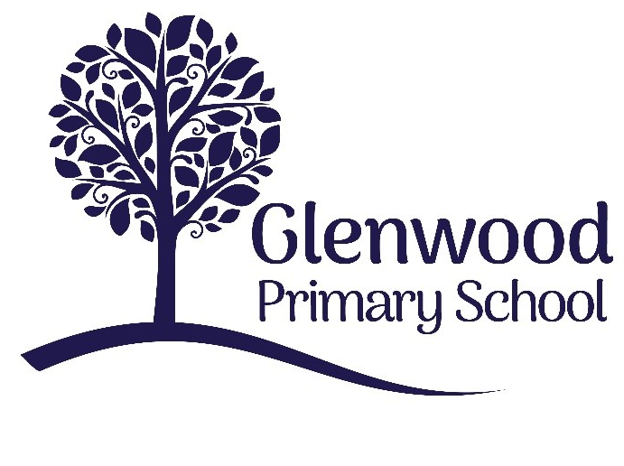

Glenwood Primary School
Relationships & Sexuality Policy

‘Together we aim to develop confident, compassionate, and resilient learners who are equipped to thrive in an everchanging world’.

Policy update: | Sept 2022
Policy to be reviewed by: | Sept 2025
Signed by Principal: |  | Date:
Signed by Chair of Governors: |  | Date:

Ethos statement
Glenwood Primary School is a nurturing and enriching environment where we foster a culture of kindness, empathy and mutual respect. Together we build a safe and caring school where everyone belongs and thrives.

Vision
At Glenwood Primary School we are dedicated to fostering an empathetic and inclusive atmosphere where every student is valued, inspired, and challenged to achieve their fullest potential.

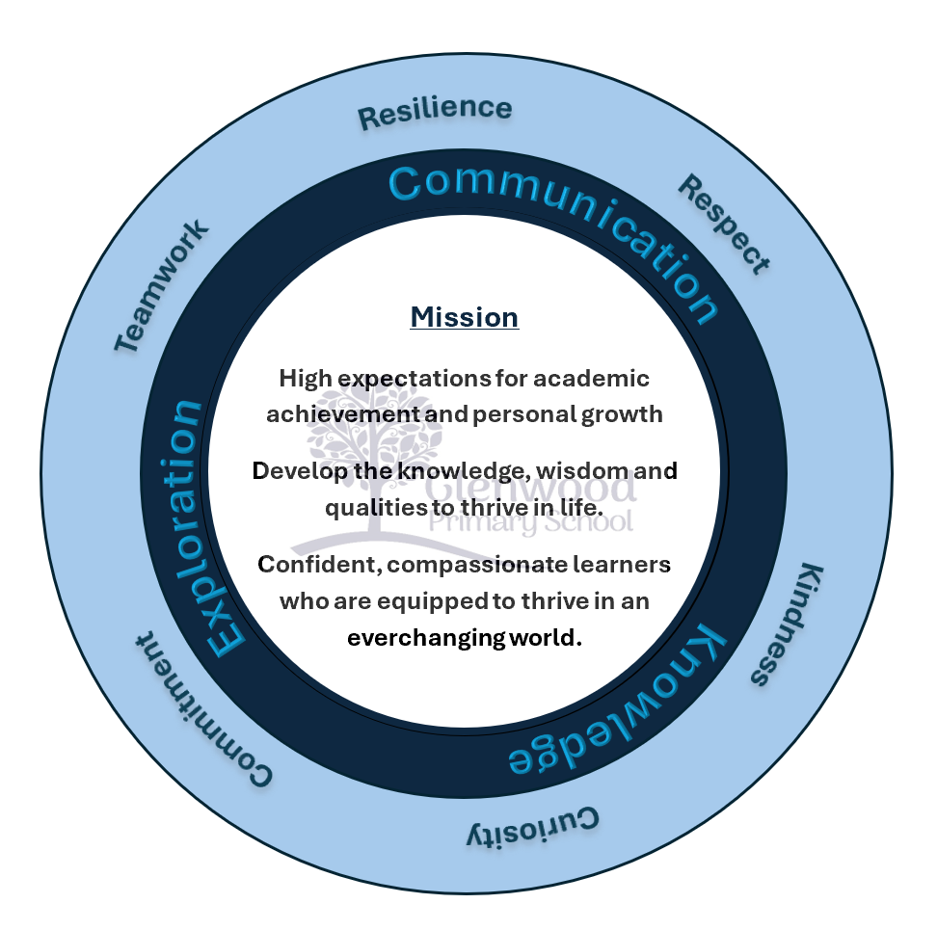

We help live our ethos and vision through the Glenwood Way
Move Calmly - Speak Nicely - Listen Carefully - Act Kindly - Do Your Best
Glenwood WISDOM qualities
TEAMWORK
RESILIENCE
RESPECT
KINDNESS
CURIOSITY
COMMITMENT

Our Values
In Glenwood Primary School we endeavour to create a nurturing, caring supportive and stimulating environment to ensure that pupils feel happy, safe and secure in school and that they are able to develop emotionally, educationally, socially and physically so that they can fully maximise their potential.
The safety of and welfare of pupils is paramount. We feel that our relationships and sexuality programme will promote that sense of wellbeing, as well as the safety and security of pupils within the school.
Glenwood Primary School is a Rights Respecting School and promotes the right of the child based on the United Nations Convention on the Rights of the Child. We believe in promoting the rights of the child (article 2); respecting the identity of all children (article 8) and that no child should be discriminated against (article 2). We also believe that children have the right to be protected from sexual abuse (article 34) and that they have a right for education to develop their own thoughts and opinions (article 29).
Glenwood Primary School Relationships and Sexuality Education (RSE) Policy is a statutory document inn accordance with Relationships and Sexuality Education Guidance:
An Update for Primary Schools
https://ccea.org.uk/learning-resources/relationships-and-sexuality-education- guidance-primary

What is Relationships and Sexuality Education?
Relationships and Sexuality Education (RSE) is a lifelong process which encompasses the acquisition of knowledge, understanding and skills, and the development of attitudes, beliefs and values about personal and social relationships and gender issues. It is about helping children to build effective relationships and learn to value themselves and others, making well-informed decisions about their lives.
At Glenwood Primary School we value the importance of RSE to help and support young people through their physical, emotional and moral development. This policy is linked closely to Personal Development and Mutual Understanding (PDMU), The World Around Us (WAU) and Religious Education (RE).

Aims and objectives of Relationships and Sexuality Education (RSE)
The aims of RSE in Glenwood Primary School are:
- To develop a loving pride in one’s family and an active association in the local community.

- To encourage pupils to examine and explore the various relationships in their lives and learn how to develop and enjoy friendships which are based on responsibility and mutual respect within the school and at home.
- To promote an appreciation of the importance of the family unit (regardless of structure / composition).
- To enhance the personal development, self-esteem and well-being of each child.
- To provide pupils with the information and skills to evaluate critically the wide range of information, opinions, attitudes and values offered today in order to make informed decisions.
- To develop their self-esteem and self-worth and in so doing take responsibility for their own behaviour and actions. Pupils learn to avoid behaviours which could be harmful to themselves and / or others.
- To acquire and develop moral/religious values and a respect for the beliefs and values held by others in the society in which we live.

Morals and Values Framework
Mindful of the positive and child-centred ethos of Glenwood Primary School, as well as the diversity of religious and cultural groups in the school, pupils are taught RSE within a framework that encourages the following:
- A respect for self.
- A respect for others.
- Equal opportunities for all.
- Commitment, trust and bonding within relationships.
- An exploration of the rights, duties and responsibilities involved in relationships.
- A sensitive and caring attitude towards the needs of others.
- Development of personal skills which help to establish and sustain healthy personal relationships.
- Honesty with self and others.
- Self-discipline.
- The difference between right and wrong.
- The responsibility for one’s own actions.
- A development of critical self-awareness for themselves and others.

RSE should:
- Be relevant, accessible and age appropriate to all young people.
- Be set in a moral framework which is inclusive with respect to culture, religion, sexual orientation and social background.

- Seek to develop and clarify values and attitudes towards gender, sexuality and relationships and to encourage respect for and empathy with the values and attitudes of others.
- Respect the diversity of cultural identity and encourage pupils to be aware of the traditions and beliefs of others, promoting respect, mutual understanding and tolerance.
- Include activities to allow both genders to talk about their interests, attitudes, emotions, concerns and feelings.

Learning outcomes
The RSE curriculum in Glenwood Primary School should enable pupils to:
- Develop a sense of self awareness, self-esteem and self-worth.
- Develop an appreciation of the dignity, uniqueness and well-being of others.
- Develop personal and inter-personal skills which help to establish and sustain healthy personal relationships.
- Acquire and use an appropriate vocabulary to discuss feelings, gender, growth and development.
- Become aware of the variety of ways in which individuals grow and change.
- Develop a critical understanding of external influences on lifestyles and decision making.

Skills
The RSE curriculum in Glenwood Primary School should enable pupils to develop:
- Communication skills – putting one’s own views forward clearly and appropriately; listening to others’ points of view; handling and resolving conflict peacefully.
- Decision making and problem solving skills – for sensible and responsible choices; making moral judgements about what to do in actual situations.
- Inter-personal skills – for managing relationships confidently and effectively; for developing as an effective group member or leader.
- Practical skills – for everyday living; for supporting others; for future parenting.

Confidentiality
The classroom is an open environment and confidentiality cannot be maintained. Therefore, staff and pupils are not encouraged to talk about their personal relationships or experiences during class discussions.

The Role of the Teacher
- Teachers cannot promise confidentiality.
- Teachers provide general educational advice to all pupils as part of the curriculum. This general advice can be given to pupils individually or within group situations.
- Teachers can provide all pupils with information about where, and from whom, they can receive confidential advice and support.
- Teachers encourage young people, where possible, to discuss their concerns with parents or guardians.
- Only appropriate medical professionals should give medical advice to pupils.
- Any disclosures that might suggest a pupil is at risk is reported as outlined in the Safeguarding and Child Protection Policy

How will we achieve our aims?
Children in Glenwood Primary School will learn on a day-to-day basis from the respectful example set by all adults in their lives.

At home:
As first educators, parents are expected to lay the foundations for all acceptable patterns of behaviour, leading by example, and sharing with school the joint task of bringing the child through primary school with a balanced understanding of life and a healthy appreciation of the human relationships they form in years to come.

At school:
- The positive climate and constructive everyday interactions between pupils and staff, both inside and outside the classroom.
- The messages we give out to children thorough religious celebrations, assemblies, discussions, workshops etc.
- The encouragement we give and the standards we uphold in terms of sportsmanship, fair play, accepting decisions and taking both winning and losing in the same spirit.
- The respect we have for and show to all members of our community

Equal Opportunities
To ensure that the learning experiences are effective, positive and relevant to all pupils, the RSE programme should be developmental, accessible and be appropriate to the age and maturity of the pupils. It should meet the needs of gender and be a positive experience for all participants.
Boys and girls are encouraged to work with each other and gain an understanding of each other’s perspectives. However, there will be times that teachers or outside professionals will work with single gender groups e.g. P7 Love for Life programme, to explore puberty

related physical and emotional changes in both boys and girls. The programme of RSE delivered will be accessible to all pupils regardless of age, culture, disability, sexual orientation, gender or social class.

Links to other policies
- PDMU
- WAU
- Safeguarding and Child Protection
- Pastoral Care
- Positive Behaviour
- Anti-bullying
- Health Education
- Drugs Education
- SEN
- E-Safety and Acceptable Use of the Internet

Roles and responsibilities
- Board of Governors – examines and ratifies the school’s RSE Policy.
- Principal – co-ordinates the school’s approach to RSE and consults with the Board of
Governors, staff, pupils, parents / carers, and health professionals.
- Staff – provide a link and have a complementary role with parents / carers and deliver
the school’s RSE programme within the context of the NI Curriculum.

RSE Programme in Glenwood Primary School
RSE is delivered in a holistic, cross curricular way, ensuring that teaching is at all times appropriate to the maturity and understanding of the pupils. Teachers will ever be alert to the personal and emotional circumstances of the pupils. RSE will include the physical and emotional changes that occur at puberty but will not include sex education.

Curriculum organisation and delivery
The following outline teaching programme illustrates the topics covered through the delivery of the NI Curriculum in Glenwood Primary School. Many of the aspects included below are also part of the Health Education curriculum, PDMU, RE, the World Around Us, PE, Drama or in reaction to specific situations, in P7 ‘Love for Life’ programme and NSPCC activities.
Topics and themes are often repeated at regular intervals. The sequence in which ideas are presented below is not intended to imply an exact teaching order.

FOUNDATION STAGE AND KEY STAGE 1
Myself
- Myself – how I grow, feed, move and use my senses; caring for myself, for example, hygiene, sleep exercise.
- Naming parts of the body (basic) – developing an agreed language for our bodies.
- Being myself – I am unique, my self-esteem, self-confidence, independence, respect and caring for myself.
- Similarities and differences between myself and others, for example, uniqueness, fingerprints, different rates of growth.
- An introduction to the stages of human development – changes as we grow, for example, baby, child, teenager, adult, mother / father, grandparents.
- Recognising moods, feelings and concerns and developing a language and an appropriate manner of expressing them, for example: what do I do if I feel sad or angry?
- Personal likes and dislikes.

My Relationships
- My family, special people in my life – what they do for me and what I do for them. (Teachers should be sensitive to different family situations).
- Friendships, getting on with each other, for example, communicating, playing together, listening, co-operating and sharing.
- Ageing – how do we know that things are alive, dead, young and old?
- Loss and mourning (when appropriate) – death of a person or a pet (situations of individual pupils must be taken into account prior to dealing with this issue).
- Respect and caring for family members and friends, for example, caring for a new baby.
- Dealing with bullying.
- Personal safety – simple skills and practices to maintain personal safety.
- The difference between good and bad touches.
- Realise that adults and older children are not always friends; the potential danger of relationships with strangers or acquaintances.
- Strategies which pupils might use to protect themselves from potentially dangerous situations.

My Community / Environment
- Awareness of different types of families and the roles of individuals within families.
- Keeping safe, for example, dangerous places, dangerous situations, the adults who will help, 8 how to get help from others.
- Rules at home, at school and in the community.
- Respect and caring for people in the community, for example, elderly people.

KEY STAGE 2
Myself
- My body, how it works and how to keep it healthy.
- The physical, social and emotional changes that occur during puberty (P7 girls and boys).
- Myself and my peers – different rates of growth and physical development, maturity.
  - Valuing and respecting myself, identifying personal strengths and weaknesses.
- Feelings, for example, things that make me happy, sad, excited, embarrassed, angry, scared; expressing our feelings, showing love and affection.
- Making choices – the influences on me and the consequences of actions for oneself and others.
- Distinguishing between right and wrong.
- Secrets – knowing the difference between good and bad secrets; what to do about bad secrets.

My Relationships
- Identifying the positive traits of friendship and their corresponding values.
- Differences and similarities in people; the need to respect other people’s views,
emotions and feelings.
- Families and how they behave – what family members expect of each other. (Teachers should be sensitive to different family situations).
- The meaning of friendship; making and maintaining friendships and social relationships, for example, identifying and understanding pressures and influences, taking account of other people’s point of view.
- Handling difficult situations, for example, teasing, bullying, death of a family member.
- The meaning of relationships within families, between friends and in the community.
- Behaviour – what constitutes appropriate and non-appropriate physical contact.
- Identifying dangers and risks within relationships.
- Being assertive in defending individual rights and beliefs.
- People who can help pupils when they have anxieties, concerns or questions.

My Community / Environment
- Appreciation of the family in relation to the school and the wider community.
- Cultural differences in families and family relationships, when appropriate.
- Using agencies which can support families and individuals in different circumstances, when needed.
- Messages and images about health, from the media, internet, family and peers when they arise.

SELECTION OF TEACHING RESOURCES
The selection of teaching resources will be:
- Consistent with the school’s RSE policy and the aims and objectives of the RSE
programme;
- Consistent with the school’s morals and values framework;
- Appropriate to pupils’ age, level of understanding and maturity;
- Factually correct and respectful of its audiences;
- Likely to appeal to pupils in terms of appropriate language level, images, attitudes and values, maturity, contexts and situations, and the knowledge required;
- Complementary to the existing programmes which the school offers.

TEACHING RSE – THE CLASSROOM ENVIRONMENT
The value of human life and the uniqueness of each individual will be at the heart of our RSE teaching. In Glenwood Primary School we believe it is essential that teachers create a classroom environment which is supportive, where self-esteem is fostered and where the pupils feel valued and affirmed. The climate of the classroom needs to promote mutual respect and the dignity of each individual. It is important to create an atmosphere in the classroom which allows all pupils to feel comfortable to express opinions and feelings in a secure and safe manner and to explore issues which may be sensitive and personal. Every effort should be made to ensure that the whole group is at ease, with pupils showing respect for each other and realising their responsibilities to each other. By encouraging consideration of a range of issues, attitudes and beliefs pertinent to the topics covered. Ground rules should be agreed to help to minimise embarrassment and encourage the respect of each other’s opinions. Realistic scenarios, case studies, role- play, drama, videos and stories can be used to enable pupils to discuss issues without personal disclosure.
Important considerations are the:
- Degree of trust, respect and positive regard for pupils;
- Relationships between the teacher and pupils, and between the pupils themselves;
- Need for clear expectations, goals and learning objectives;
- Use of teaching and learning methods which involve pupils actively in their own learning and encourage the consideration of attitudes and values and the ability to make informed and healthy decisions.

Terminology
Professionals will use the correct biological terms for part of the body.

Specific Issues Family Status
Pupils will be encouraged to appreciate the value of family life. We acknowledge the different family units that are represented in school and will endeavour to treat all situations sensitively.

Withdrawal from RSE
RSE in Glenwood Primary School is taught across the curriculum and it is not possible to separate the lesson content. However, when Primary 7 receive the puberty information parents will be informed that the lesson is taking place and they will have the option to withdraw their child from this should they wish.

Sensitive Issues
There will be no direct teaching of issues such as homosexuality, AIDS, contraception etc. However, if these issues are raised by pupils, the teachers will address them sensitively. RSE will include the physical and emotional changes that occur at puberty but will not include sex education.

Use of Visitors
Where appropriate, we may use the skills and expertise of outside agencies and professionals. Where this occurs, the school will be satisfied that contributions from informed outsiders are an integral part of the whole programme and in harmony with the aims and ethos of the school.
Any Health Professionals and Visitors who are invited to deliver aspects of the curriculum will be required to provide an overview of the content and teaching methods to the principal and class teacher. A member of staff will remain in the lesson throughout.

Staff Training
Training needs will be considered and will be accessed using the Education Authority, Public Health Agency and / or other appropriate health agencies. Where outside agencies are used for training purposed, their remit will be clear and will reflect the ethos of the school.
Examples of events and activities to support the curriculum for the delivery of RSE:
- Love for Life workshops.

- NSPCC – assembly and workshops with P6 and P7.
- Visitors to assembly – ministers, charity workers etc.
- Class assemblies and other school performances.
- Pupil of the Week.
- School prize day.
- Visits to local post primaries.
- School visits.
- P7 residential.
- Safer Internet Day activities
- Anti-bullying week – class and assembly activities.
- First Aid – specific needs of individual children recognised.
- Healthy breaks.
- P1 induction.
- School council and ECO council.
- Inclusion and diversity – CEFR plans.
- Charity work – Cash for Clobber, Southern Area Hospice, Cancer research.
- Parent consultations

Supporting Children Who Exhibit Gender Variant Behaviours
In cases where a child has a strong ‘persistent, consistent and insistent’ cross gender identity and difficulty functioning without being able to express that identity, staff are advised to work with parents, support groups and relevant health professionals to determine what psychological support and practical assistance the child needs.
Glenwood Primary School will make all decisions in the best interests of the child, taking account of any risks and the need to protect the child from the negative reaction of others. When the school is asked to make more significant changes (e.g. changing a child’s name or pronoun), or has any questions or concerns, they will contact the EA Equality and Human Rights Team.

