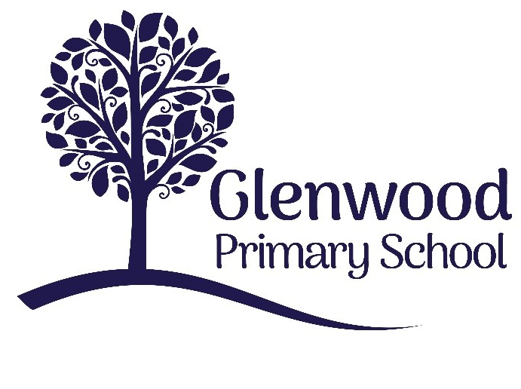

Glenwood Primary School
E-Safety Policy

‘Together we aim to develop confident, compassionate, and resilient learners who are equipped to thrive in an everchanging world’.

Policy update: | November 2025
Policy to be reviewed by: | November 2026
Signed by Principal: |  | Date:
Signed by Chair of Governors: |  | Date:

Ethos Statement:

Glenwood Primary School is a nurturing & enriching environment where we foster a culture of kindness, empathy & mutual respect. Together we build a safe & caring school where everyone belongs and thrives.

School Vision:

At Glenwood Primary School we are dedicated to fostering an empathetic & inclusive atmosphere where every student is valued, inspired, & challenged to achieve their fullest potential.
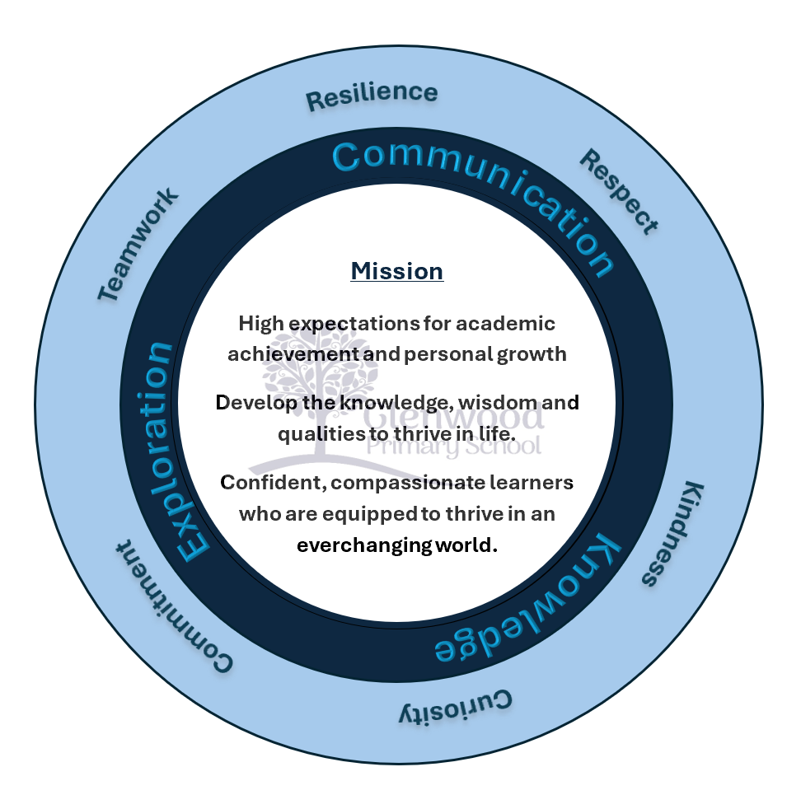

We help live our ethos and vision through the Glenwood Way
Move Calmly - Speak Nicely - Listen Carefully - Act Kindly - Do Your Best
Glenwood WISDOM qualities
TEAMWORK
RESILIENCE
RESPECT
KINDNESS
CURIOSITY
COMMITMENT
Introduction
This E-Safety Policy sets out the commitment of Glenwood Primary School to safeguarding and promoting the welfare of all pupils through the safe and responsible use of digital technologies. The policy ensures that pupils, staff, parents, and visitors understand their roles in maintaining a secure online environment. It aligns with the Department of Education (Northern Ireland) guidance, including Safeguarding and Child Protection in Schools, Keeping Children Safe in Education, and the Education Authority’s E-Safety Guidance.
Glenwood Primary School recognises that technology is an integral part of modern education and daily life. While it offers significant educational benefits, it also presents potential risks such as exposure to inappropriate content, cyberbullying, online grooming, and data breaches. This policy aims to mitigate these risks through education, supervision, and robust procedures.
Aims
- To safeguard pupils and staff from online harm, abuse, and exploitation.
- To promote responsible, respectful, and ethical use of digital technologies.
- To educate pupils about online safety, digital citizenship, and data privacy.
- To ensure compliance with relevant legislation, including the Data Protection Act 2018 and UK GDPR.
- To establish clear procedures for responding to e-safety incidents.
- To foster a culture of openness where pupils feel confident to report concerns.
Scope
This policy applies to all members of the school community who have access to or use the school’s digital systems, including:
- Pupils
- Teaching and non-teaching staff
- Governors
- Parents and carers
- Visitors, contractors, and volunteers
It covers all forms of digital communication and technology use, including:
- School computers, tablets, and interactive whiteboards
- Personal devices used on school premises
- Internet access, email, and cloud-based platforms
- Social media, messaging apps, and online learning tools

Roles and Responsibilities
The Board of Governors
- Ensures that the school has effective e-safety policies and procedures in place.
- Reviews the policy annually and monitors its implementation.
- Supports the Principal and staff in promoting a safe digital environment.
The Principal
- Has overall responsibility for e-safety within the school.
- Ensures that the E-Safety Policy is implemented and regularly reviewed.
- Ensures that staff receive appropriate training and resources.
- Reports serious e-safety incidents to the Board of Governors and relevant authorities.

The ICT Coordinators
- Lead on e-safety education, awareness, and incident management.
- Monitor the use of digital technologies and reports concerns to the Principal.
- Maintain records of e-safety incidents and actions taken.
- Liaise with external agencies such as the Education Authority, PSNI, and CEOP when necessary.
- Keep up to date with emerging online risks and best practices.
Staff
- Model safe and responsible online behaviour at all times.
- Use school ICT systems in accordance with the Acceptable Use Policy (AUP).
- Supervise pupils when using digital devices or accessing the internet.
- Report any e-safety concerns or incidents immediately to the E-Safety Coordinator.
- Ensure that online learning platforms and digital resources are age-appropriate and secure.
Pupils
- Follow the school’s Acceptable Use Policy.
- Use technology responsibly, respectfully, and for educational purposes only.
- Report anything that makes them feel uncomfortable or unsafe online.
- Protect personal information and respect the privacy of others.
- Understand that online actions have real-world consequences.
Parents and Carers
- Support the school’s approach to e-safety and reinforce safe online behaviour at home.
- Monitor their child’s use of technology and social media.
- Attend e-safety information sessions provided by the school.
- Report any online concerns involving pupils to the school.

Education and Training
Pupils
E-safety education is embedded across the curriculum and delivered through:
- ICT and Personal Development and Mutual Understanding (PDMU) lessons.
- Assemblies, workshops, and themed events such as Safer Internet Day.
- Lessons on topics including cyberbullying, online privacy, digital footprints, misinformation, and online gaming safety.
- Age-appropriate discussions about consent, respect, and online relationships.
Staff
- Receive regular training on e-safety, safeguarding, and data protection.
- Are updated on emerging online risks, such as new apps, scams, or harmful trends.
- Participate in annual refresher sessions and professional development opportunities.
Parents and Carers
- Are provided with guidance on supporting children’s online safety at home.
- Receive newsletters and updates on current online risks.
- Are invited to attend workshops and information evenings.
Acceptable Use of Technology
- All users must sign and adhere to the school’s Acceptable Use Policy.
- School devices and networks are monitored for inappropriate use.
- Pupils are not permitted to access social media or gaming sites during school hours.
- Personal devices may only be used with staff permission and under supervision.
- Staff must use school-approved communication channels for all pupil interactions.
- The use of USB drives or external storage devices is restricted to prevent malware and data breaches.
Managing Online Incidents
- All e-safety incidents are recorded and investigated by the ICT Coordinator / Designated/Deputy Designated teacher for Child Protection.
- Serious incidents are referred to the Principal and, where appropriate, to external agencies such as the PSNI, CEOP, or the Education Authority.
- The school follows safeguarding procedures for any incident involving potential harm to a child.
- Evidence (e.g., screenshots, messages) is preserved securely for investigation.
- Parents are informed of incidents involving their children, unless doing so would place the child at further risk.
Use of CPOMS for Recording and Monitoring
- Glenwood Primary School uses CPOMS, a secure online safeguarding and record-keeping system, to log all e-safety incidents.
- Staff record incidents promptly, attaching any relevant evidence such as screenshots, messages, or reports.
- The system automatically alerts relevant members of staff, including the Child Protection team.
- CPOMS enables the school to monitor recurring incidents, identify patterns of concern, and ensure timely intervention.
- All records are stored securely in compliance with data protection legislation and are accessible only to authorised staff.
Data Protection and Privacy
- Glenwood Primary School complies with the UK GDPR and the Data Protection Act 2018.
- Personal data is stored securely and only shared when legally required.
- Staff are trained in data handling and confidentiality.
- Pupils are taught about protecting personal information online and understanding privacy settings.
- Digital images and videos of pupils are only used with parental consent and for educational purposes.
Cyberbullying
- Cyberbullying is treated with the same seriousness as face-to-face bullying.
- The school’s Anti-Bullying Policy outlines procedures for managing incidents.
- Pupils are educated about the impact of online bullying and how to seek help.
- Support is provided to both victims and perpetrators, including counselling and restorative approaches.
Remote Learning and Online Communication
- Online learning platforms are approved, secure, and monitored by the school.
- Staff use only school-approved accounts and communication tools.
- Video conferencing follows safeguarding protocols, including appropriate dress, background, and supervision.
- Pupils are reminded of online etiquette and privacy during remote sessions.
- Parents are encouraged to supervise online learning at home.
Monitoring and Filtering
- The school uses filtering and monitoring software via the C2K network to block harmful or inappropriate content.
- Attempts to bypass filters are treated as breaches of the Acceptable Use Policy.
- The effectiveness of filtering systems is reviewed annually.
Monitoring and Review
- The E-Safety Policy is reviewed annually by the Principal, ICT Coordinators, and Board of Governors.
- Updates are made in response to technological developments, new risks, or changes in legislation.
- Feedback from staff, pupils, and parents is considered in each review.

Related Policies
- Child Protection and Safeguarding Policy
- Anti-Bullying Policy
- Data Protection Policy
- Acceptable Use Policy
- Behaviour Policy
- ICT Policy

